

**Unit:**

**Analysis, Design and Implementation**

**Assignment title: Weight Tracker**

**March 2018**

**Important notes**

• Please refer to the Assignment Presentation Requirements for advice on how to set out your assignment. These can be found on the NCC Education *Campus*. Click on Policies and Advice in the left-hand menu and look under the Advice section.

• You must read the NCC Education documents ‘What is Academic Misconduct? Guidance for Candidates’ and ‘Avoiding Plagiarism and Collusion: Guidance for Candidates’ and ensure that you acknowledge all the sources that you use in your work. These documents are available on *Campus*. Click on Policies and Advice in the left-hand menu and look under the Policies section.

• You **must** complete the **‘Statement and Confirmation of Own Work’**. The form is available on *Campus*. Click on Policies and Advice in the left-hand menu and look under the Policies section.

• Please make a note of the recommended word count. You could lose marks if you write 10% more or less than this.

• You must submit a paper copy and digital copy (on disk or similarly acceptable medium). Media containing viruses, or media that cannot be run directly, will result in a fail grade being awarded for this assessment.

• All electronic media will be checked for plagiarism.





Student Declaration

I have read and understood NCC Education’s Policy on Academic Dishonesty and Plagiarism.

I can confirm the following details:

|  |  |
| --- | --- |
| Student ID/Registration number: | 00155430 |
| Name: | Apurba Debnath |
| Centre Name: | Daffodil International Academy |
| Module Name: | Analysis, Design and Implementation |
| Module Leader: | Nasimul Kader |
| Number of words: | 6627 |
| I confirm that this is my own work and that I have not plagiarized any part of it. I have also noted the assessment criteria and pass mark for assignments. | |
| Due Date: | 05 February, 2018 |
| Student Signature: | Apurba Debnath |
| Submitted Date: | 08 February, 2018 |

Table of Contents

Task-1: 5

Candidate class list: 5

Final class list: 5

Additional class list: 6

Reason for choosing candidate class list: 7

Reason for selecting some final class list form the candidate class list: 8

Reason for creating additional class list: 9

Class diagram: 10

Class diagram of the system: 11

Task-2: 12

Activity diagram of the system: 12

Task-3: 13

Use case diagram of the system: 13

Use case description: 14

Task-4: 16

Code architecture: 16

Hibernate configuration: 16

Sample code of “Hibernate Reverse Engineering Wizard”: 16

Sample code of session factory of “weightTrackerUtil.java” class: 17

Sample code of hibernate mapping of User.hbm.xml file in “weightTrackerPojo” package: 18

Use of Inheritance: 19

Data Access Object(Dao): 20

Sample code of common parameterized generic class “weightTrackerDao.java”: 20

Use of Polymorphism: 21

The common parameterized generic class “weightTrackerDao.java” also override other “Dao” classes. 22

Model: 23

View: 25

Controller: 27

Use of Encapsulation: 29

User Input: 31

System Output: 37

Coupling and Cohesion: 39

Daily Report: 41

Line Chart of report: 44

Task-5: 48

System implementation description: 48

*Home Page:* 48

*Trainee Registration page:* 49

Course Registration page: 61

Meal Registration page: 75

Exercise Registration page: 87

Daily log page: 100

Daily Meal page: 109

Daily Exercise page: 124

Daily Measurement page: 139

Daily Report page: 153

Periodic Report page: 155

# 

# Task-1:

# Candidate class list:

The given Class list are chosen as Candidate class list:

* User
* Meal
* Exercise
* Dailylog
* Course
* DailyMeasurement
* ActivityLevel
* Trainer

# Final class list:

The given Class list are chosen as Final class list

* User
* Meal
* Exercise
* Dailylog
* Course
* DailyMeasurement

# Additional class list:

The given Class list are chosen as Additional class list:

* Exercisedailylog
* Mealdailylog
* WeightTrackerDao
* Report
* WeightTrackerUtil
* UserDao
* MealDao
* ExerciseDao
* DailylogDao
* CourseDao
* DailyMeasurementDao

# Reason for choosing candidate class list:

* **User**: I have chosen User as a candidate class in order to store and retrieve all user’s data from the database.
* **Meal:** I have chosen Meal as a candidate Class in order to store and retrieve all meal’s data from the database.
* **Exercise:** I have chosen “Exercise” as candidate class in order to store and retrieve all exercise’s data from the database.
* **Dailylog:** I have chosen “Dailylog” as candidate class in order to store and retrieve all daily log’s data from the database.
* **Course:** I have chosen “Course” as candidate class in order to store and retrieve all course’s data from the database.
* **DailyMeasurement**: I have chosen “DailyMeasurement” as candidate class in order to store and retrieve all daily measurement’s data from the database.
* **ActivityLevel:** I have chosen “ActivityLevel” as candidate class in order to store and retrieve all activity’s data from the database.
* **Trainer:** I have chosen “Trainer” as candidate class in order to store and retrieve all trainer’s data from the database.

# Reason for selecting some final class list form the candidate class list:

* **User:** I have chosen User as a final class list form the above candidate class list in order to store and retrieve all user’s data from the database.
* **Meal:** I have chosen Meal as a final class list form the above candidate class list in order to store and retrieve all meal’s information from the database.
* **Exercise:** I have chosen Exercise as a final class list form the above candidate class list in order to store and retrieve all exercise’s information from the database.
* **Dailylog**: I have chosen Dailylog as a final class list form the above candidate class list in order to store and retrieve all daily log’s information with activity level information from the database. So that, I didn’t take “ActivityLevel” as a class finally.
* **Course:** I have chosen Course as a final class list form the above candidate class list in order to store and retrieve all course’s information with trainer information from the database. So that, I didn’t take “Trainer” as a class finally.
* **DailyMeasurement:** I have chosen DailyMeasurement as a final class list form the above candidate class list in order to store and retrieve all daily measurement’s information from the database.

In order to creating this web application, I have required to create some additional class list. These are given below:

# Reason for creating additional class list:

In order to creating this web application, I have required to choose some additional class list. These are given below:

* **Exercisedailylog**: This class is created for building up the link or relation between two database table exercise and dailylog. And also store and retrieve information from these two table as primary key and foreign key bases.
* **Mealdailylog**: This class is created for building up the link or relation between two database table meal and dailylog. And also store and retrieve information from these two table as primary key and foreign key bases.
* **WeightTrackerDao**: This class is created as a generic java class and implements it to all “Dao” classes.
* **UserDao**: I have created this class for delete, update, find all user information and get all report data from database.
* **MealDao**: I have created this class for delete, update, find all user information.
* **ExerciseDao**: I have created this class for delete, update, find all user information.
* **DailylogDao**: I have created this class for delete, update, find all user information.
* **CourseDao**: I have created this class for delete, update, find all user information.
* **DailyMeasurementDao**: For delete, update, find all user information.
* **Report**: This class is created for generating report.
* **WeightTrackerUtil**: This class is created for getting session factory.

# Class diagram:

The class diagram is a model which represent the structure of a system. It also shows the relationship between classes, objects, attributes and operations.

I have drawn the Class diagram of this system. The screenshot is given below.

# Class diagram of the system:

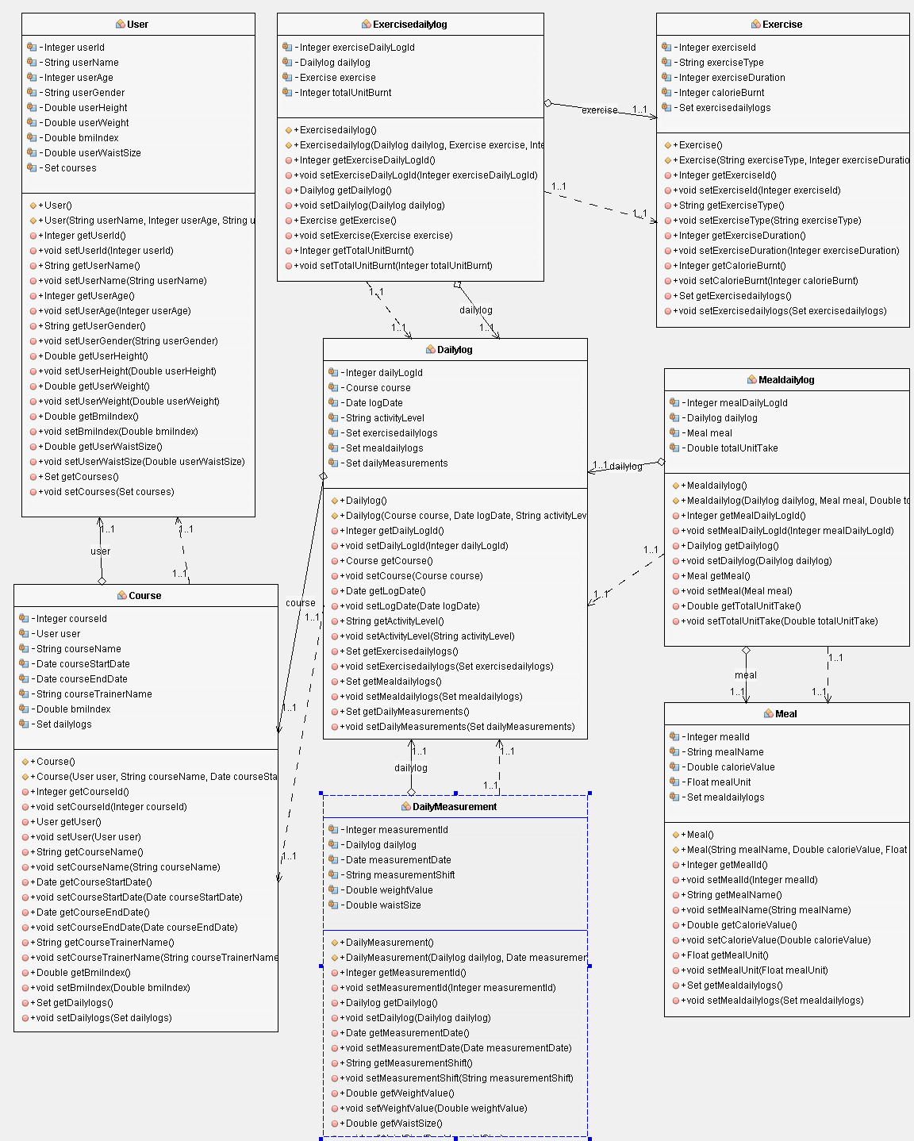

Figure No.1: Class diagram of the system.

# Task-2:

# Activity diagram of the system:

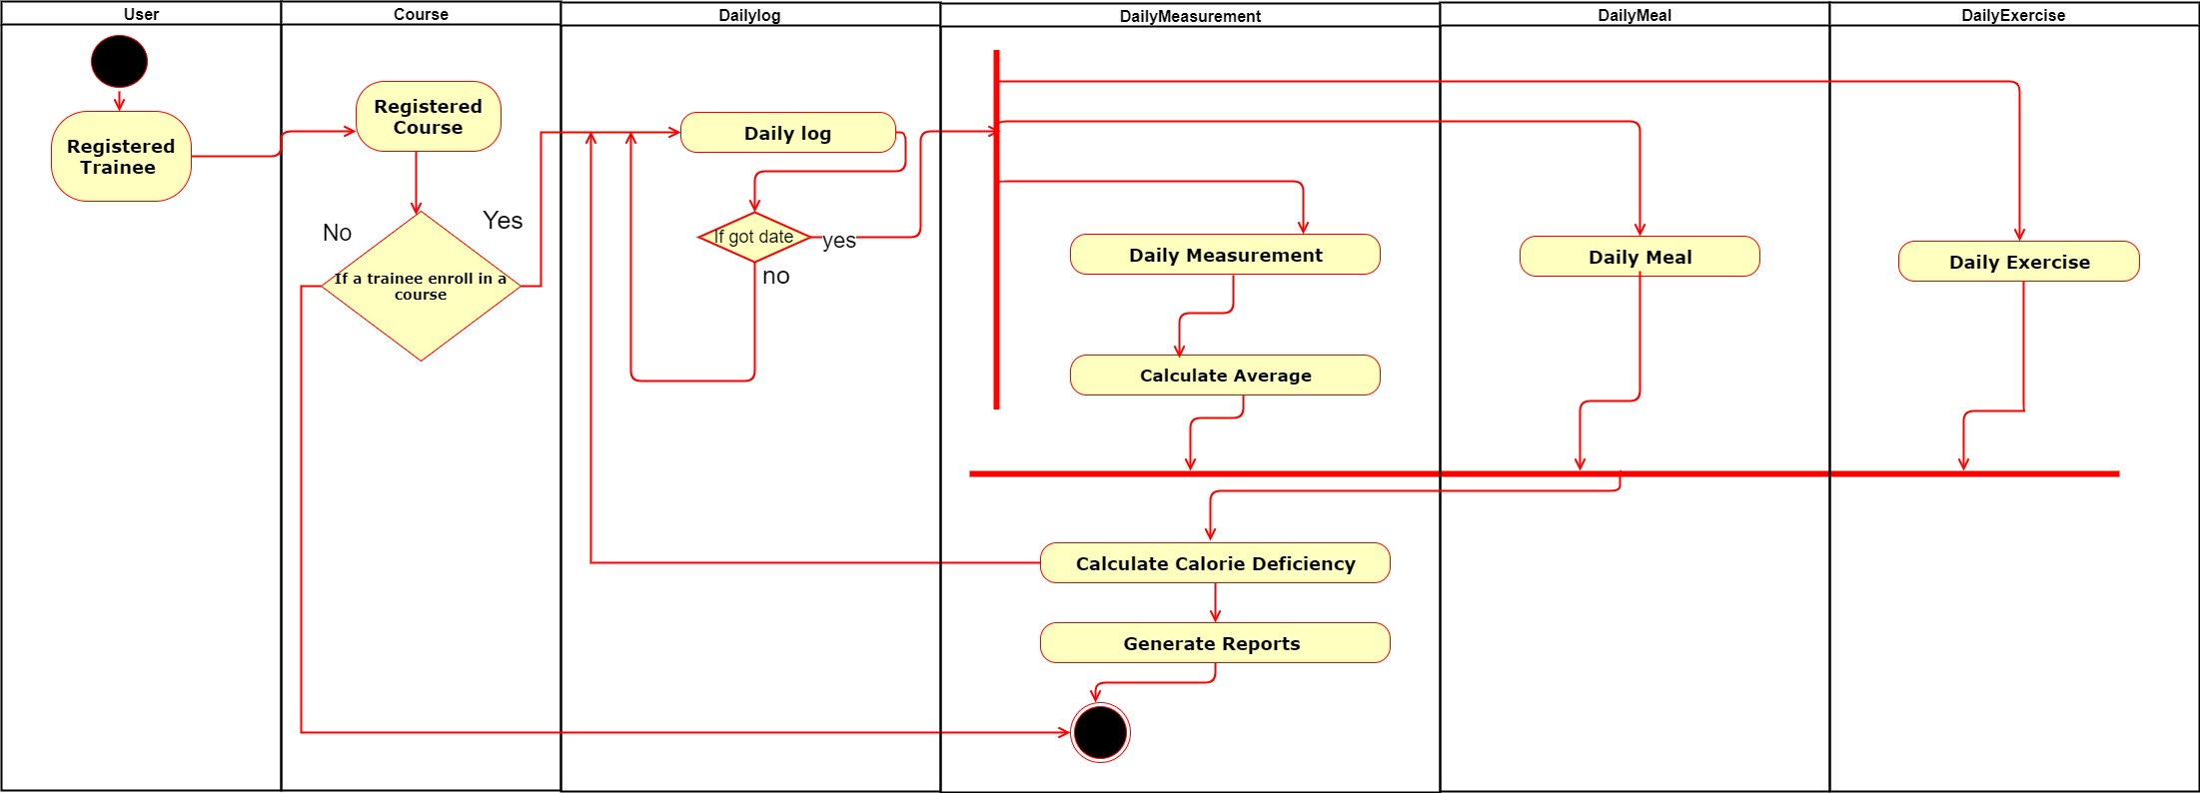

Figure No.2: Activity diagram of the system.

# Task-3:

# Use case diagram of the system:

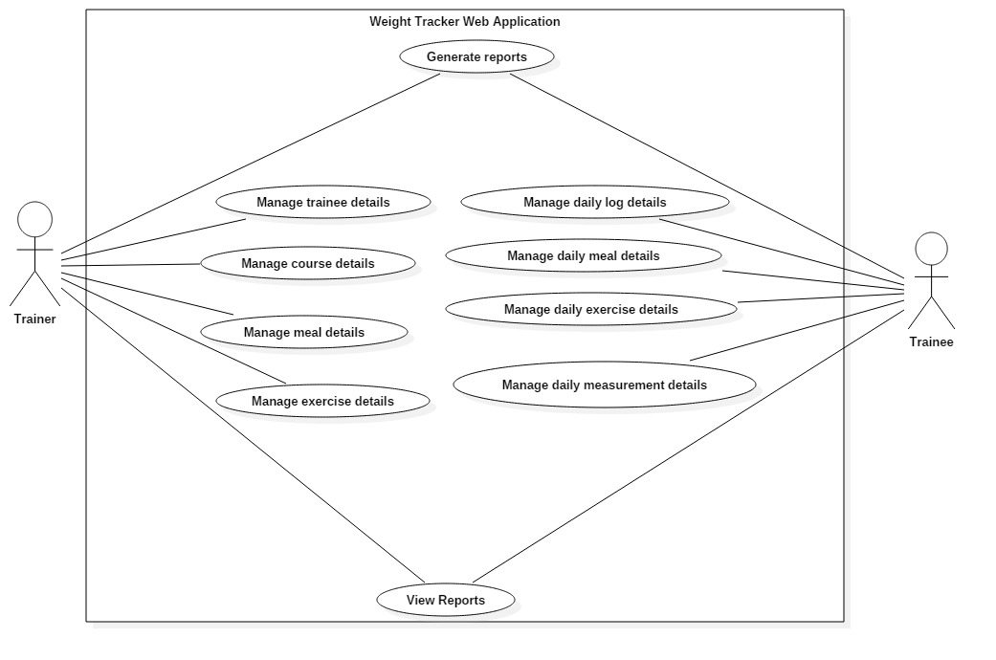

Figure No.3: Use case diagram of the system.

# Use case description:

Actor trainer’s use cases:

* **Manage trainee details:** The actor trainer will manage the all trainee information which means trainer can save, delete, find, update and show the trainee details.
* **Manage course details:** The actor trainer will manage the all course information which means trainer can save, delete, find, update and show the all course details.
* **Manage meal details:** The actor trainer will manage the all meal information which means trainer can save, delete, find, update and show the all meal details.
* **Manage exercise details**: The actor trainer will manage the all exercise information which means trainer can save, delete, find, update and show the all exercise details.

Actor trainer’s use cases:

* **Manage daily log details:** The actor trainee will manage the all daily log information which means trainee can save, delete, find, update and show the all daily log details.
* **Manage daily meal details:** The actor trainee will manage the all daily meal information which means trainer can save, delete, find, update and show the daily meal details.
* **Manage daily exercise details:** The actor trainee will manage the all daily exercise information which means trainer can save, delete, find, update and show the daily exercise details.
* **Manage daily measurement details**: The actor trainee will manage the all daily measurement information which means trainer can save, delete, find, update and show the daily measurement details.
* **View report:** The actor trainer and trainee both can view report.
* **Generate report:** The actor trainer and trainee both can generate report.

# Task-4:

# Code architecture:

I have used **MVC design pattern** in order to making this web application.

In order to **making this MVC design pattern**, I have used **JSF frame work** as the frame work of my web application and **PrimeFace as the JSF component suite** and also used **Apache Tomcat server** 8.0.27.0 as the server.

## Hibernate configuration:

I have configured hibernate with my system database. In that case, I have also used “Hibernate Reverse Engineering Wizard”. I have also created “HibernateUtil.java” class named “weightTrackerUtil.java” as the factory pattern and using this factory pattern, I have also made a session factory for hibernate.

## Sample code of “Hibernate Reverse Engineering Wizard”:

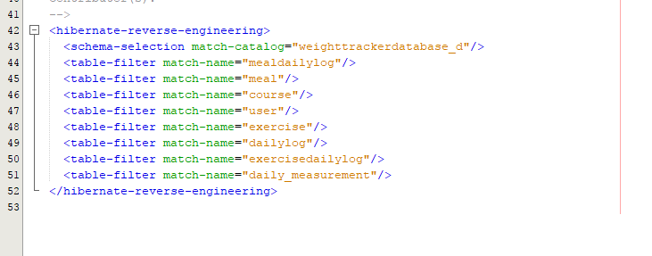

Figure No.5: Sample code of “Hibernate Reverse Engineering Wizard”.

## Sample code of session factory of “weightTrackerUtil.java” class:

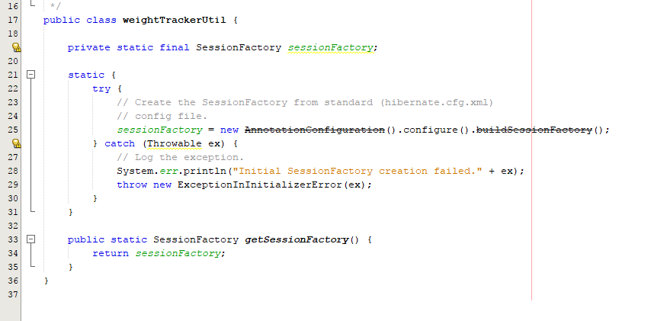

Figure No.6: Sample code of session factory of “weightTrackerUtil.java” class.

I have also used a ORM (Object plus Relational Mapping) policy in “weightTrackerPojo” package. Here, I have used object with relational mapping methodology. I have created every class as model called pojo and in order to mapped those classes, I have created some hbm.xml files for those specific classes.

## Sample code of hibernate mapping of User.hbm.xml file in “weightTrackerPojo” package:

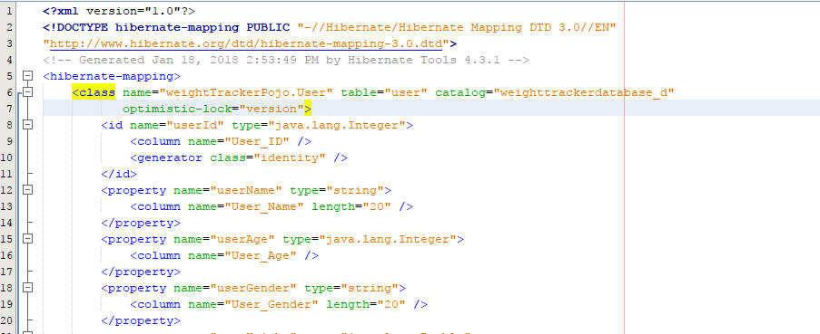

Figure No.7: Sample code of hibernate mapping of User.hbm.xml file.

## Use of Inheritance:

Here, I have used “HAS-A” relationship. In order to create this “Has-A” relationship, I have created one instance of a class between another class. Thus, I have used “Inheritance” relationship among this code architecture. I have created a parameterized generic class as generic Dao (Data Access Object) named “weightTrackerDao.java” in order to create all “Data Access Object services”. Here, I have given an example of “MealDao” which extends the common generic class “WeightTrackerDao” and use the instance of that parameterized common class.

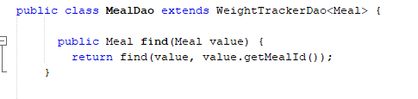

Figure No.8: Sample code of Inheritance.

## Data Access Object(Dao):

After hibernate configuration and mapping files, I have created a parameterized generic class as generic Dao (Data Access Object) named “weightTrackerDao.java” in order to create all “Data Access Object services”. In order to create the all data access object, I have created this “Generic Dao (Data access object) as a common “Dao”. I have created those “Dao” classes for using the hibernate. This “Generic Dao” can take session from session factory and it can also implement any object related to this “Generic Dao” class. I have extended and dynamically override this “generic Dao” class in order to customize all methods as my needs.

## Sample code of common parameterized generic class “weightTrackerDao.java”:

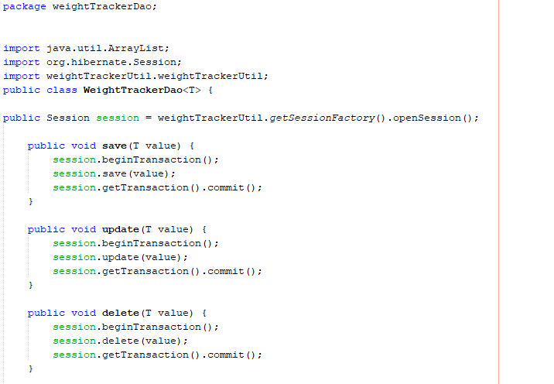

Figure No.9: Sample code of common parameterized generic class.

Sample code of common parameterized generic class “weightTrackerDao.java” which extends other “Dao” classes, such as “ExerciseDao” class.:

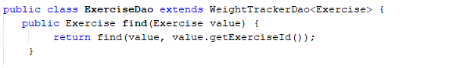

Figure No.10: Sample code of common generic class extends other “Dao” class.

## Use of Polymorphism:

I have used the polymorphism process during the use of parameterized generic class called “weightTrackerDao.java” in other “Dao (Data access object)” classes. I have created this “weightTrackerDao.java” as a common “Dao” and created an instance of that class. After that, I have used that instance in other “Dao” by extending and overriding that class. I have also override everything as my need when I created any “Specific Dao” class from that common parameterized generic class. Thus, I have used polymorphism in my code architecture.

The common parameterized generic class “weightTrackerDao.java” also override other “Dao” classes.

The sample code of “ExerciseDao.java” class is given below.:

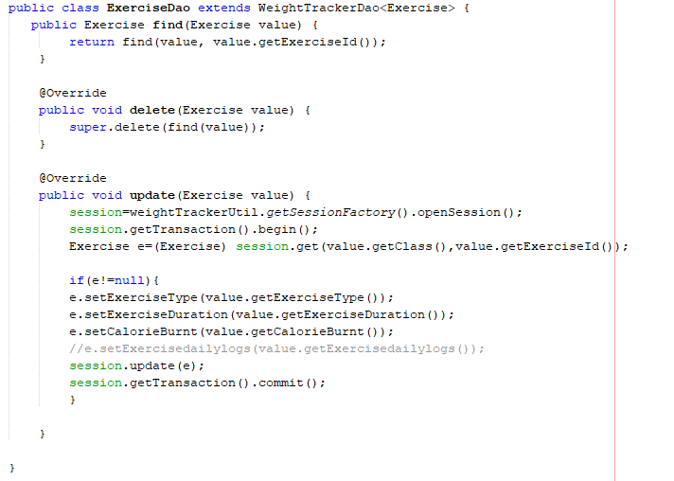

Figure No.11: Sample code of Polymorphism.

## Model:

Here, I have created “weightTrackerPojo” package as the model of the code architecture. It includes hbm.xml file and all the classes as my system database. I have created these classes and hbm.xml files using the hibernate configuration process.

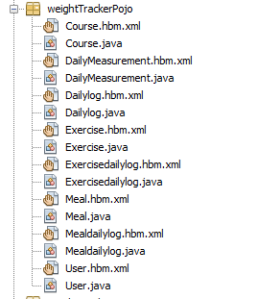

Figure No.12: The package “weightTrackerPojo” contains all the model classes.

Sample code of “Course.java” as model class and it’s “. hbm.xml” file.

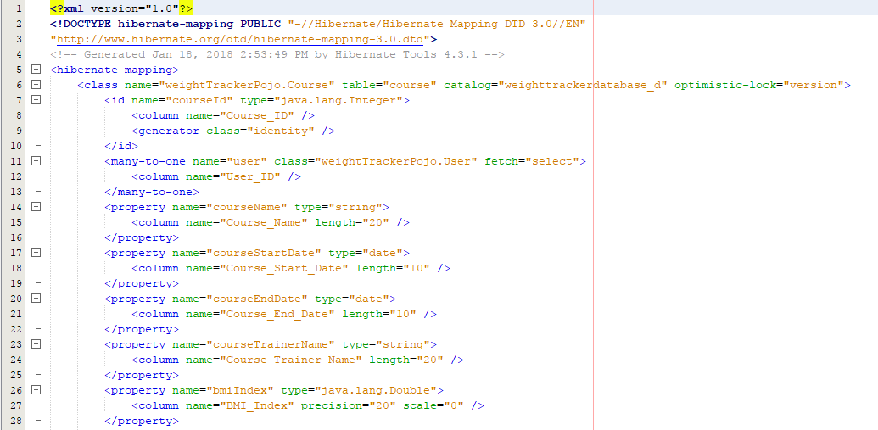

Figure No.13: Sample code of “Course.hbm.xml”.

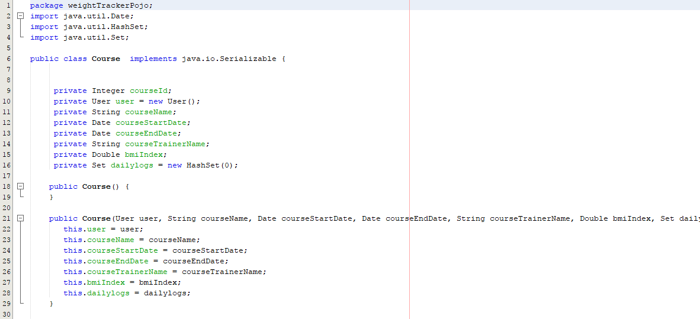

Figure No.14: Sample code of “Course.java” as a model class.

## View:

In order to create the view of my web application, I have used xhtm and JSF components. Here, I have created a master page and then I have created all client pages using that master page and also created a specific link between the specific page with this master page. The screenshot of all these package is given below:

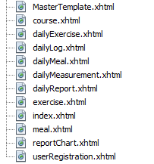

Figure No.15: The view part and all the xhtml file of the application.

Sample code of “MasterTemplate.xhtml” as the master page and it’s client page.

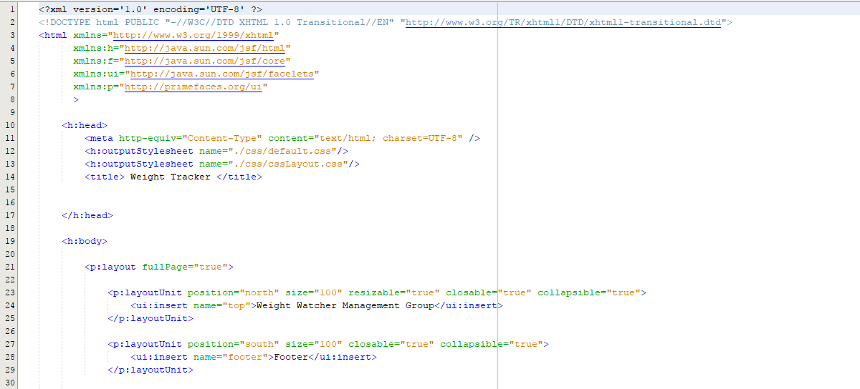

Figure No.16: Sample code of “MasterTemplate.xhtml” as the master page.

Sample code of client page “UserRegistration.xhtml”:

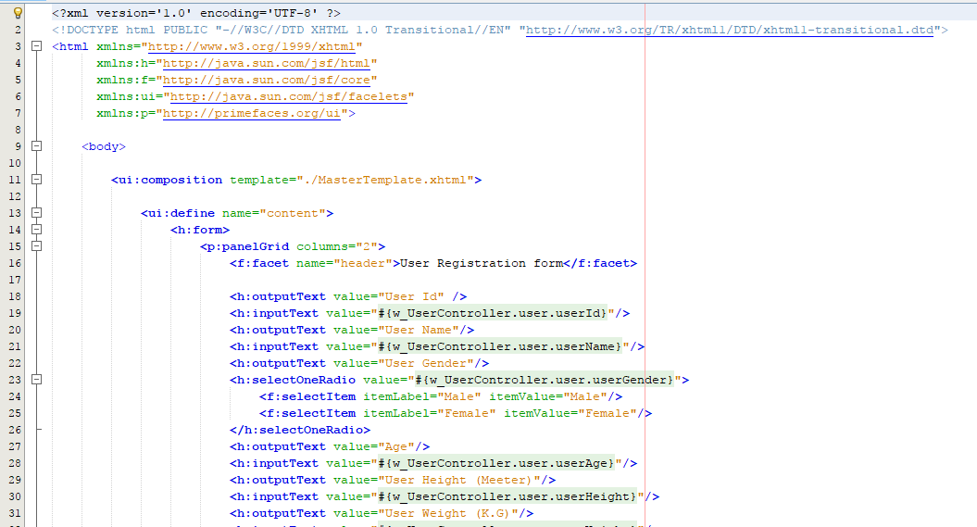

Figure No.17: Sample code of client page “UserRegistration.xhtml”.

## Controller:

I have used the JSF Manage bean as the class in order to create the controller of my code architecture. Here, I have also used all the model or pojo classes in order to create the specific controller for that specific class into “weightTrackerController” package. I have binned all the data of the specific managed bean class with the GUI and also called all the methods as their need.

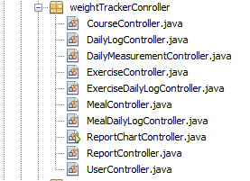

Figure No.18: The package “weightTrackerController” contains all the controller classes.

The sample code of “UserController.java” managed bean class:

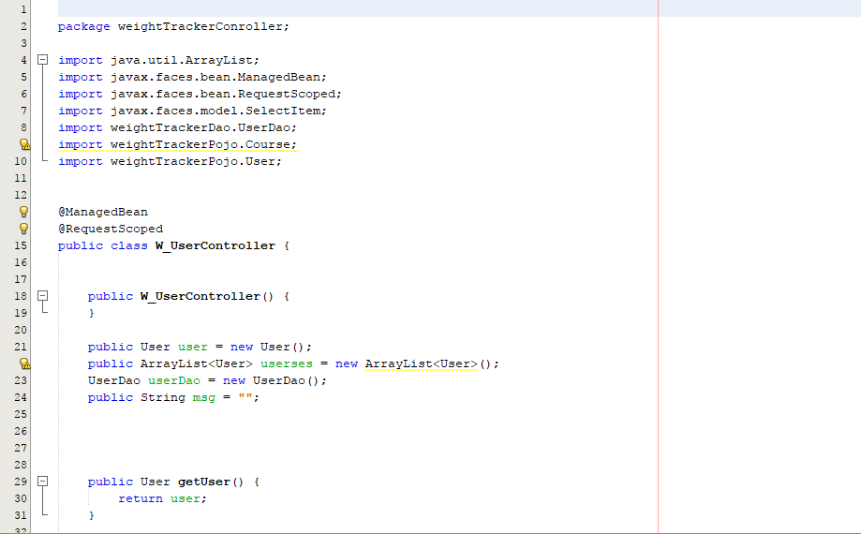

Figure No.19: The sample code of “UserController.java” managed bean class.

I have created some methods in this managed bean class:

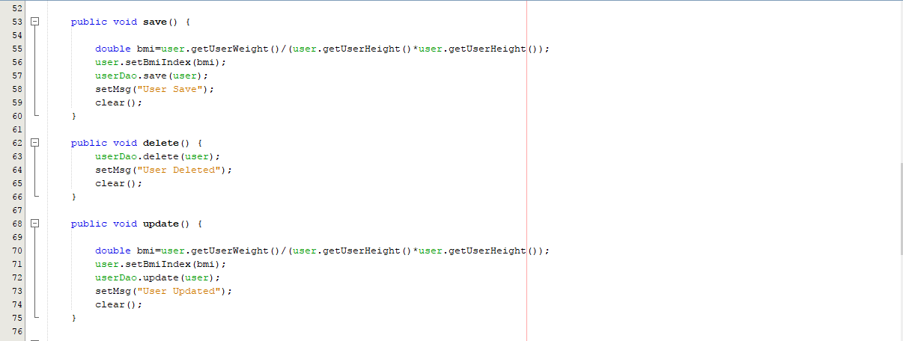

Figure No.20: The sample code of “UserController.java” managed bean class.

## Use of Encapsulation:

I have declared everything as private and also used set, get methods in my every classes of the “weightTrackerPojo” package. I have also used this policy for “report.java” class. Thus, I have used encapsulation in my code architecture.

Declared everything as private in “Dailylog.java” class:

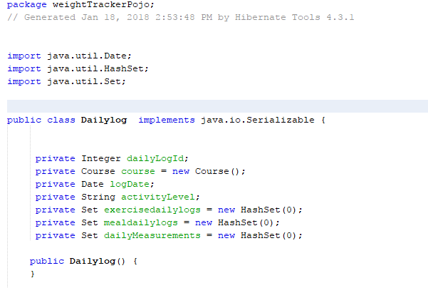

Figure No.21: Sample code of encapsulation.

Sample code of set and get methods for creating encapsulation of that “Dailylog.java” class:

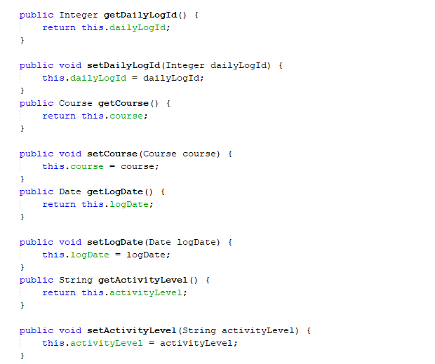

Figure No.21: Sample code of set and get methods for creating encapsulation.

## User Input:

In order to make the user input, I have used **“XHTML and JSF components”.** I have binned all the data **with the specific managed bean class with the GUI** and also **called all the methods as their need**. Here, I have used “EL Expression Deferred Binding” for using the binding process in a page.

I have used “<h:selectOneRadio/>” as radio button. The sample code is given below:

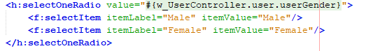

Figure No.22: Sample code of radio button.

I have used “<h:inputText/>” as input text and “<h:outputText>” as output text. The sample code is given below:

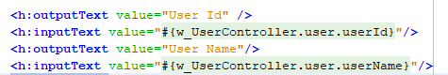

Figure No.23: Sample code of input and output text.

I have used “<h:form>” as form creation and “<p:panelGrid/>” component as panel creation. The sample code is given below:

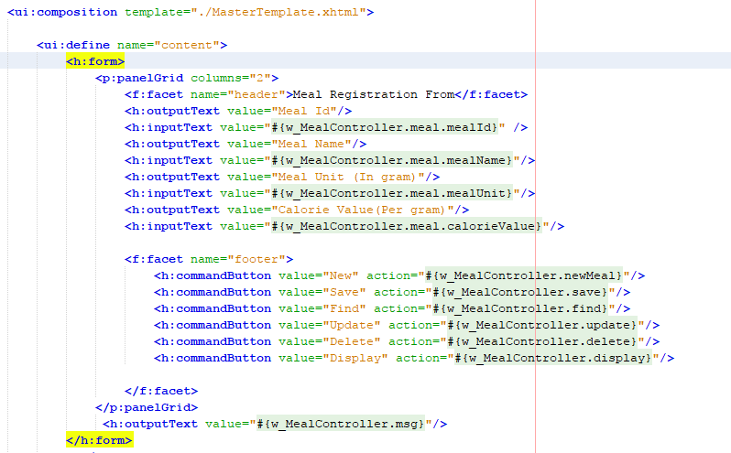

Figure No.24: Sample code of form and panel grid components.

I have used “<p:dataTable>” component as table creation:

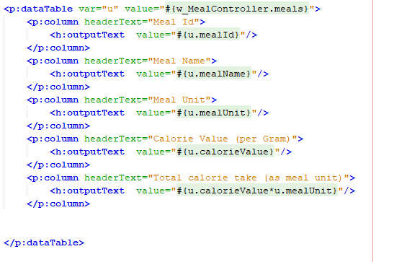

Figure No.25: Sample code of data table.

I have used “<p:selectOneMenu>” component as combo box. The sample code is given below:

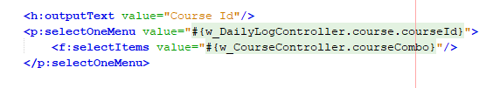

Figure No.26: Sample code of “selectOneMenu” as a combo box.

I have used “<p:calendar>” component as calendar for date selection. The sample code is given below.:



Figure No.27: Sample code of “Calendar” as a date chooser.

I have called save, delete, update, find, display and clear methods for getting their action in xhtml file. The sample code is given below:

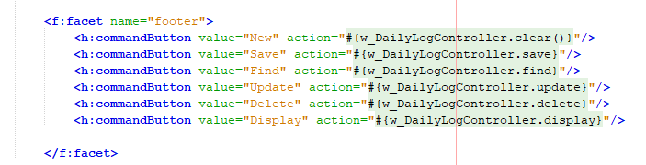

Figure No.28: Sample code for calling all specified action for specific button.

The sample code for **“save”** action in W_DailyLogController.java. The screenshot is given below:

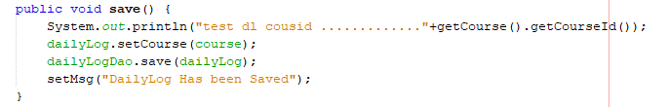

Figure No.29: Sample code for “Save” method.

The sample code for **“Clear”** action in W_DailyLogController.java. The screenshot is given below:

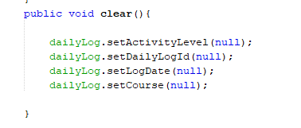

Figure No.30: Sample code for “Clear” method.

The sample code for **“New”** action in W_DailyLogController.java. The screenshot is given below:

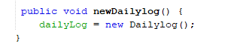

Figure No.31: Sample code for “New” method.

The sample code for “courseCombo” method for getting the values of course in the combo Box. The screen shot is given below.:

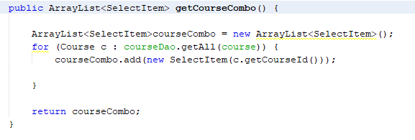

Figure No.32: Sample code for “courseCombo” method.

## System Output:

In order to handle the output, I have used all the classes of “weightTrackerPojo” package called model. I have send all the data form these model to database and retrieve and display that information using all the specified “Dao” class of the hibernate. I have called all the essential methods of user output from the specified controller class of my code architecture.

I have called save, delete, update, find, display and clear methods for getting their action in xhtml file. The sample code is given below:



Figure No.33: Sample code for calling all specified action for specific button.

The sample code for **“Find”** action in W_DailyLogController.java. The screenshot is given below:

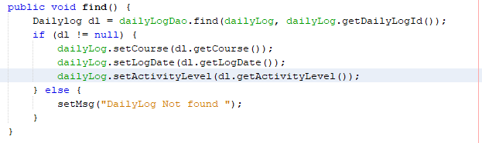

Figure No.34: Sample code for “Find” method.

The sample code for **“Delete”** action in W_DailyLogController.java. The screenshot is given below:

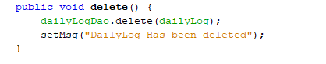

Figure No.35: Sample code for “Delete” method.

The sample code for **“Update”** action in W_DailyLogController.java. The screenshot is given below:

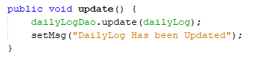

Figure No.36: Sample code for “Update” method.

The sample code for **“Display”** action in W_DailyLogController.java. The screenshot is given below:

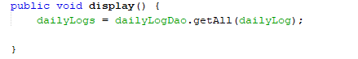

Figure No.37: Sample code for “Display” method.

## Coupling and Cohesion:

By use of **common generic “Dao” class**, I have just used all other “Dao” classes without much effort. I just have to call the instance of the generic “Dao” class called **“weightTrackerDao.java”** in other “Dao” classes for the specific need. This **parameterized generic class** has **extended in other “Dao” classes**. I have kept all the common work in this common generic class and every specified work in the specific “Dao” class. By using this, common parameterized generic class as generic “Dao” called “weightTrackerDao.java”, I have **maximized the cohesion** and **gradually the coupling has minimized also**.

Sample code of common generic “**weightTrackerDao.java**” class:

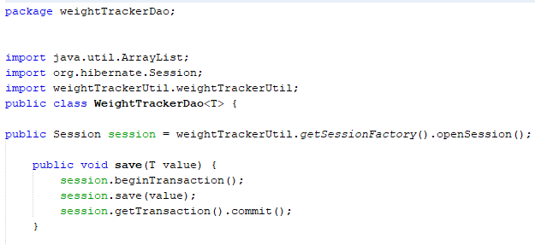

Figure No.38: Sample code for common generic “**weightTrackerDao.java**” class.

The example of code for “UserDao.java” class which extends “WeightTrackerDao”:

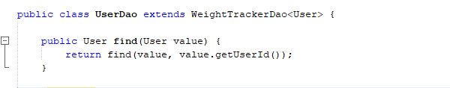

Figure No.39: Sample code of “UserDao.java” class.

The example of code for “MealDao.java” class which extends “WeightTrackerDao”:

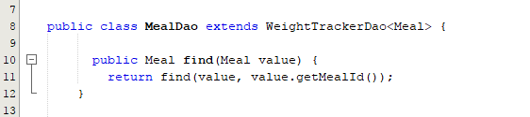

Figure No.40: Sample code of “MealDao.java” class.

The example of code for “ExerciseDao.java” class which extends “WeightTrackerDao”:

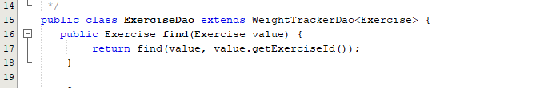

Figure No.41: Sample code of “ExerciseDao.java” class.

## Daily Report:

In order to create the report, I have created a class called “report.java” in “weightTrackerReport” package and also created a controller called “ReportController.java” in “weightTrackerController” package. I have used this “ReportController.java” manage bean class and bind a “sql query” in “UserDao.java” class and then retrieve all the data from the database as the “sql query” and display it as a report on the GUI.

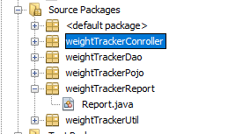

Figure No.42: The “weightTrackerReport” package.

Sample code of “Report.java” class as model:

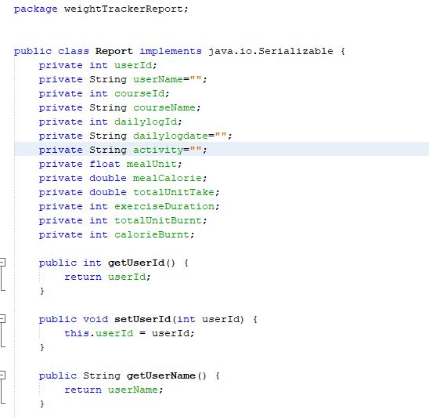

Figure No.43: The sample code of “Report.java” class.

The sample code for “ReportController.java” as managed bean class:

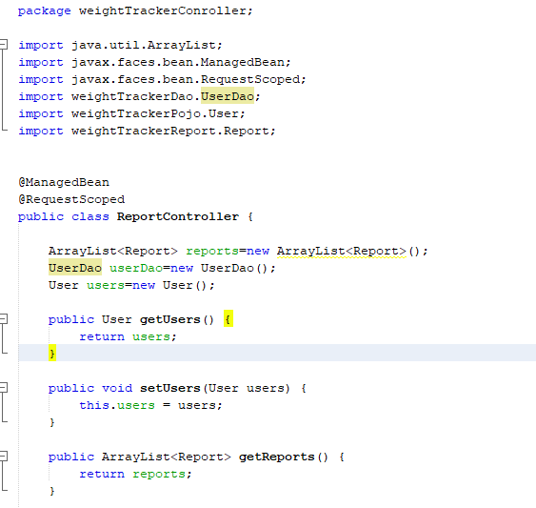

Figure No.44: The sample code for “ReportController.java” as managed bean class.

## Line Chart of report:

In order to making this chart, I have used a line chart model as the system report. I have created an object or instance of the line chart series class and use that object as my need. I have also used a “P-Chart” in order to create this chart model. I have created a “xhtml” file in “P_View” package for displaying this chart model as **“periodic report”.**

Object creation of “LineChartModel” class:

The sample code is given below:

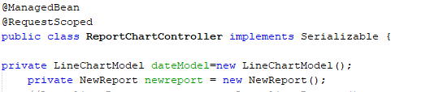

Figure No.45: The object creation of “LineChartModel” class.

The sample code of “LineChartModel” as a method “createDateModel()” in “ReportChartController.java”.

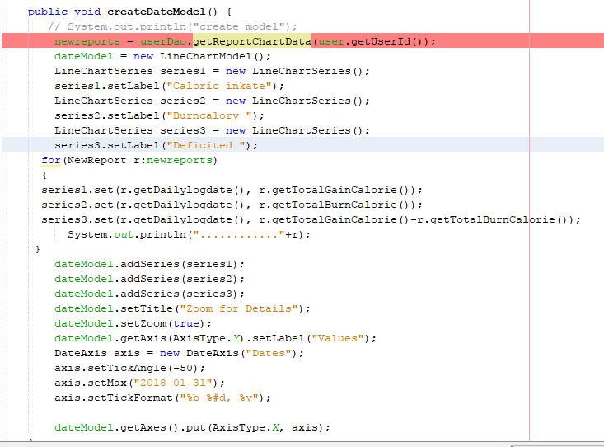

**Figure No.46:** The sample code of “createDateModel()” as a method.

The sample code of “reportChat.xhtml” file for displaying this chart.

The screenshot is given below:

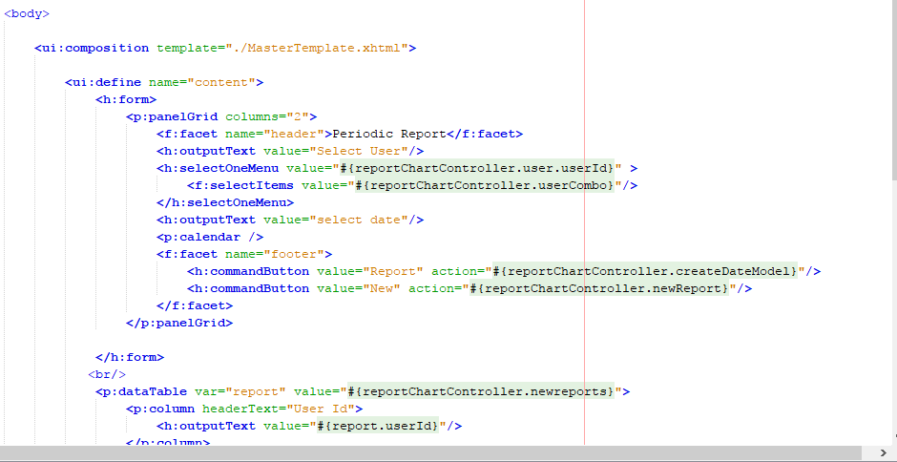

**Figure No.47:** The sample code of “reportChat.xhtml” file for displaying this chart.

I have also created an **instance** of **“LineChartSeries”** class as my need.

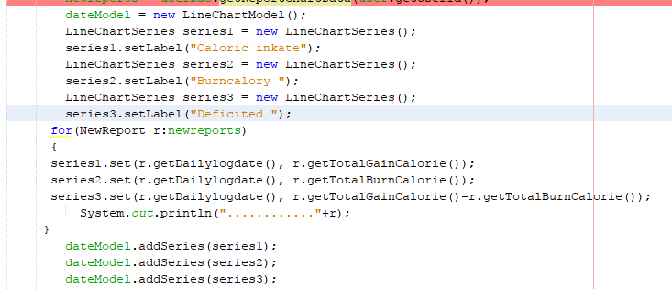

**Figure No.48:** Instance called **“series1”** of “LineChartSeries”.

# Task-5:

I have completed the implementation codes. I have provided the detail source code in a .zip file.

## System implementation description:

## Home Page:

When user will click on “Home” button, this home page will show to the user. The home page is working perfectly. The screenshot is given below:

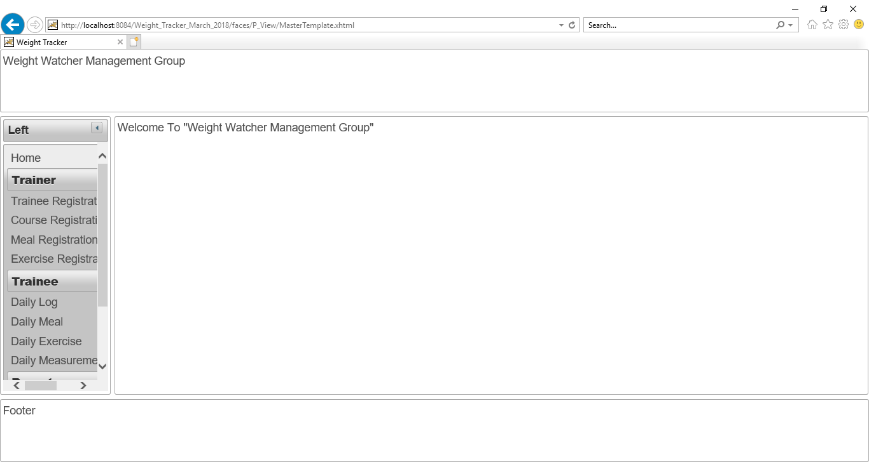

Figure No.49: The view of “Home Page”.

## Trainee Registration page:

When the user will click on “**Trainee Registration**” button, this **trainee Registration page** will show to the user. The **trainee Registration page** is working perfectly. The screenshot is given below:

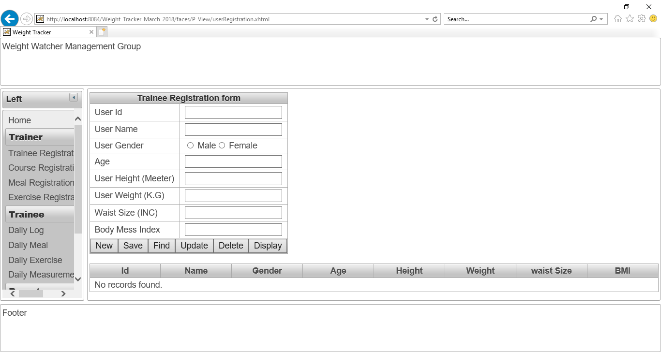

Figure No.50: The view of “**Trainee Registration page**”.

Checking “Save” button of “Trainee Registration form”:

The user name “Rubby” and his all details is given as input in order to save data.

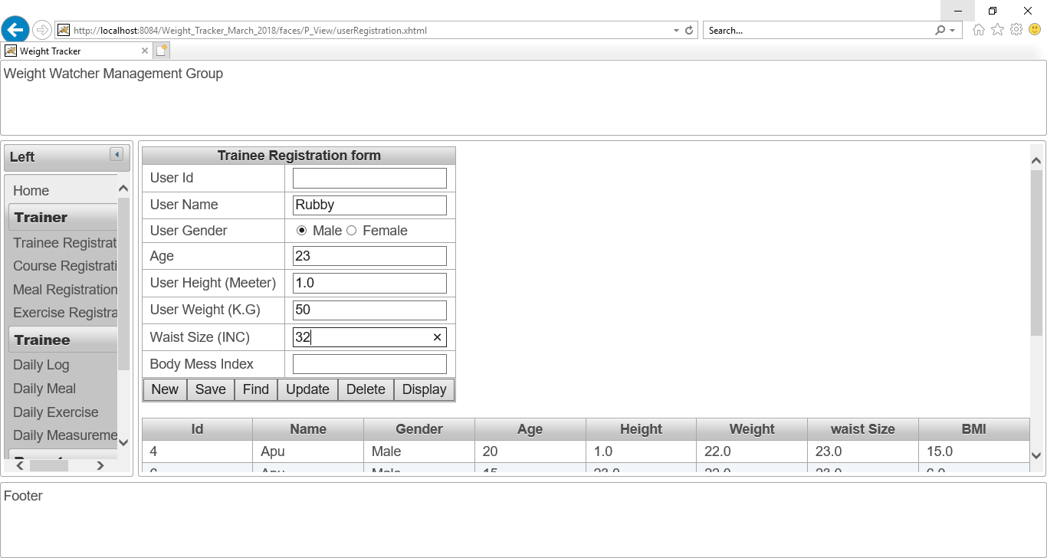

Figure No.51: Checking “Save” button of “Trainee Registration form”.

The “save” action is working perfectly. The user details of “Rubby” is saved perfectly and also **calculate “BMI index” of that user**. The screenshot is given below:

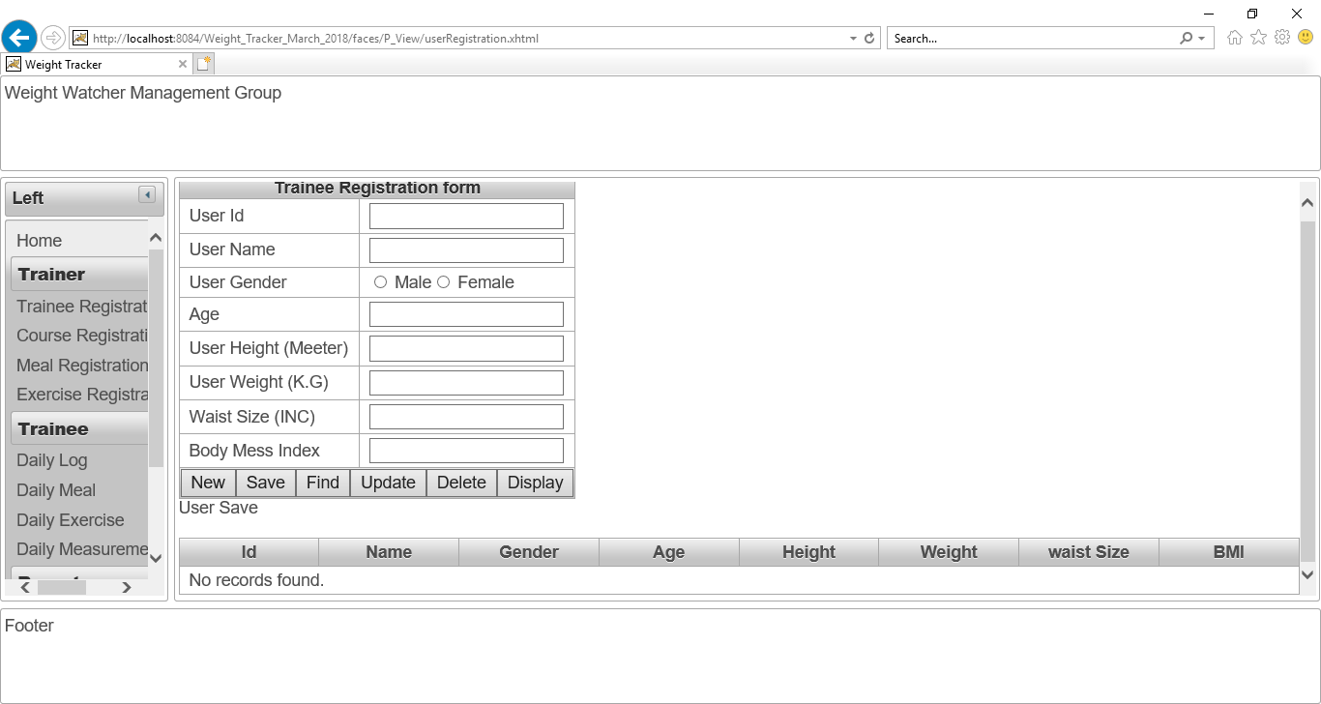

Figure No.52: The all user data has been saved.

**Checking “Display” button of “Trainee Registration form”:**

After clicking on “Display” button, all the details of user “Rubby” has shown. So, the “Display” button is working perfectly. The screenshot is given below:

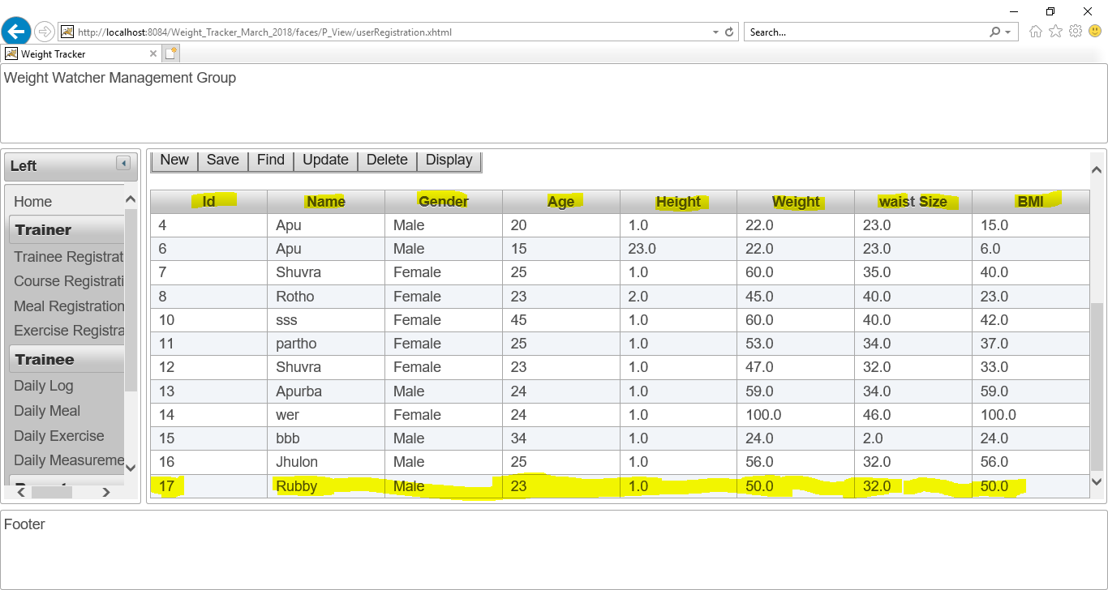

Figure No.53: The all user data has been saved and displayed and calculated BMI index also shown.

**Checking “Find” button of “Trainee Registration form”:**

When I have written the “user Id” as 17 and click on “Find” button, all the details of “Rubby” has shown. So, the find button is working perfectly. The screenshot is given below:

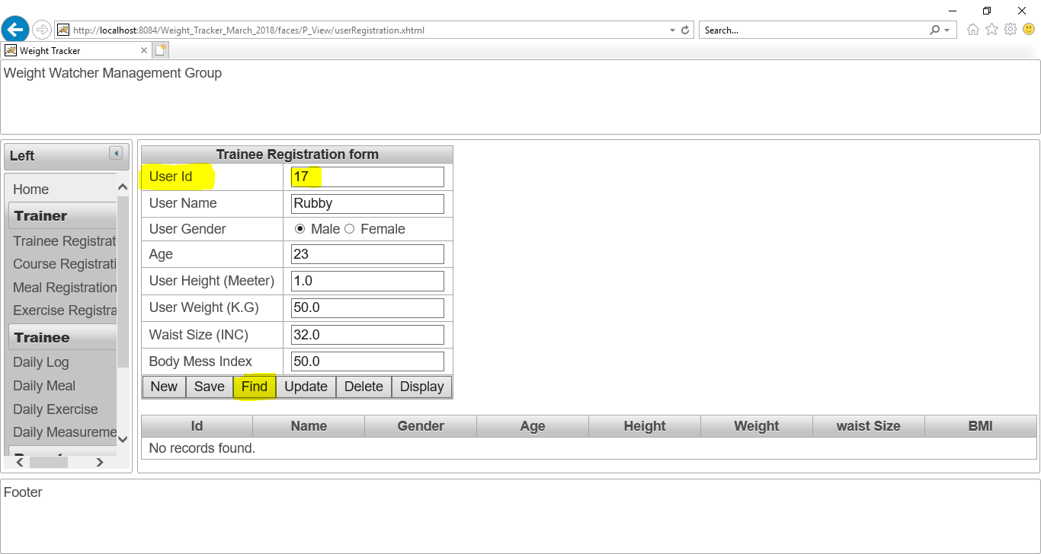

Figure No.54: Checking “Find” button of “Trainee Registration form”.

**Checking “Update” button of “Trainee Registration form”:**

**I have changed the age of user “Rubby” as 25.**

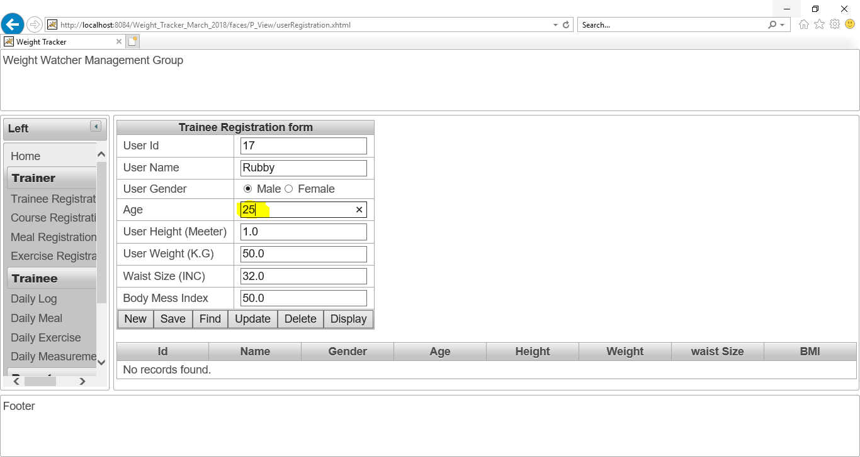

Figure No.55: Checking “Update” button of “Trainee Registration form”.

After click on “Update” button. The age has updated. The “Update” button is working perfectly. The screenshot is given below:

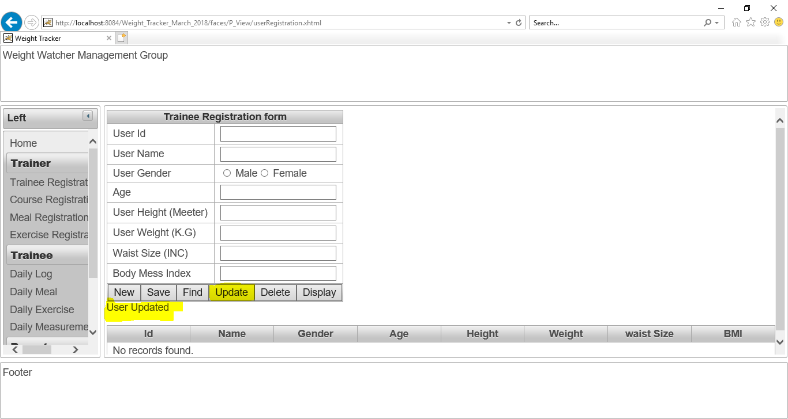

Figure No.56: Checking “Update” button of “Trainee Registration form”.

The updated detail of that user is given as screenshot:

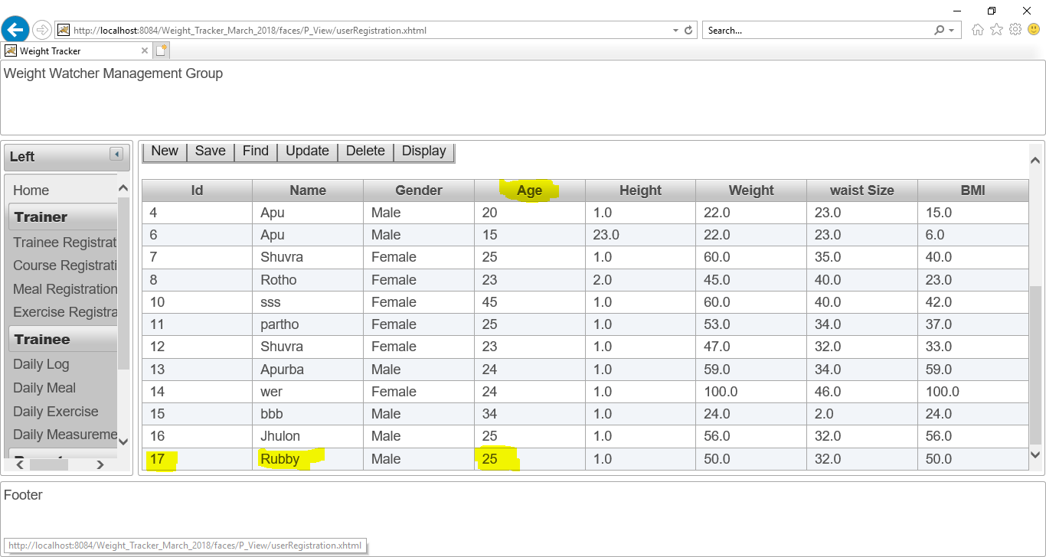

Figure No.57: Checking “Update” of “Trainee Registration form”.

**Checking “Delete” button of “Trainee Registration form”:**

Now, I want to delete “User ID” 4 from database in order to checking “Delete” action is working or not.

I have written 4 as User Id and clicked on “Delete” button. The delete button is working perfectly. The screenshot is given below:

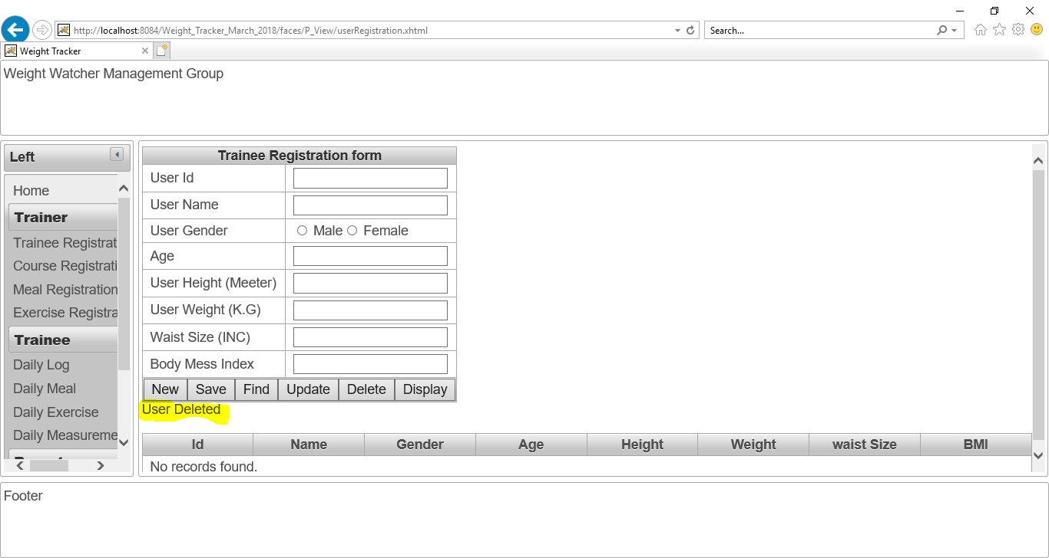

Figure No.58: Checking “Delete” of “Trainee Registration form”.

Now, all user data is shown for proving this delete action. Now, there is no user Id 4. The screenshot is given below:

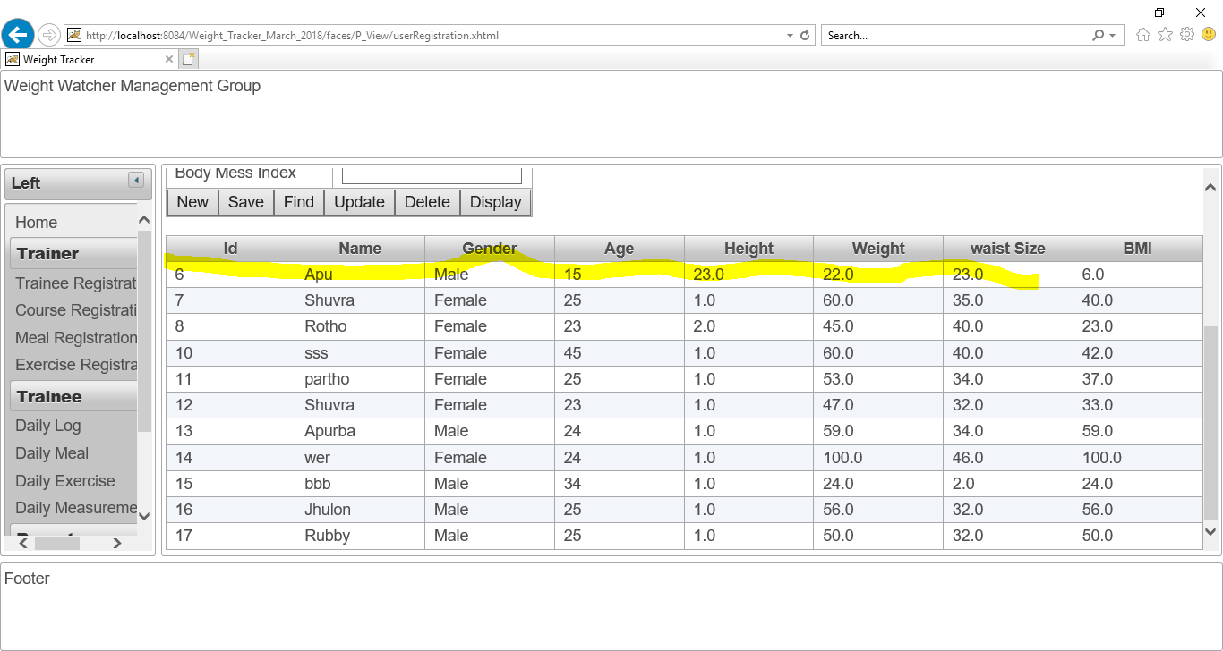

Figure No.59: there is no user Id 4 in trainee registration details.

Checking “New” button of “Trainee Registration form”:

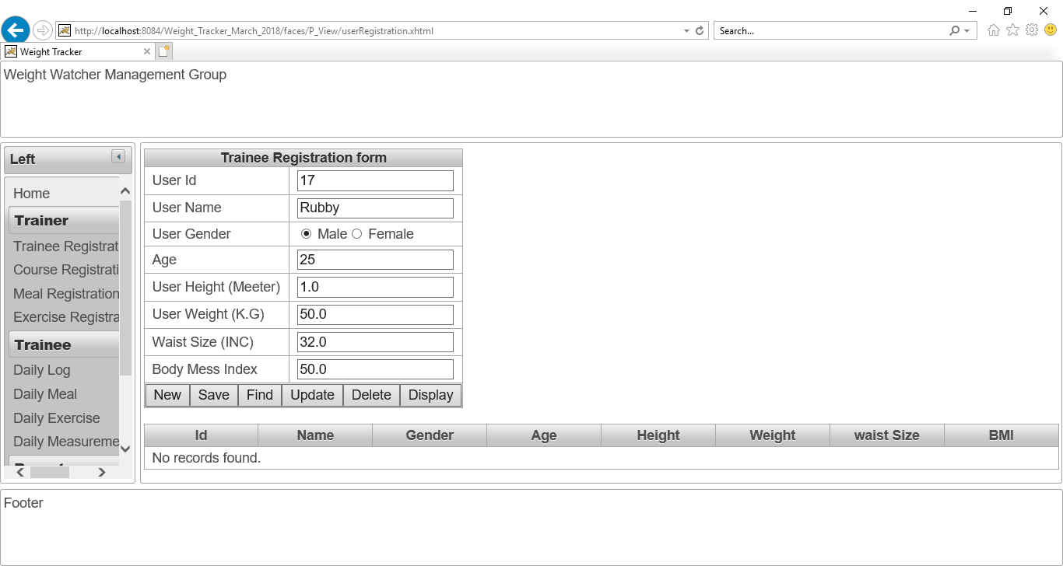

Figure No.60: Checking “New” of “Trainee Registration form”.

After click on “New” button, all data is cleared. The screenshot is given below:

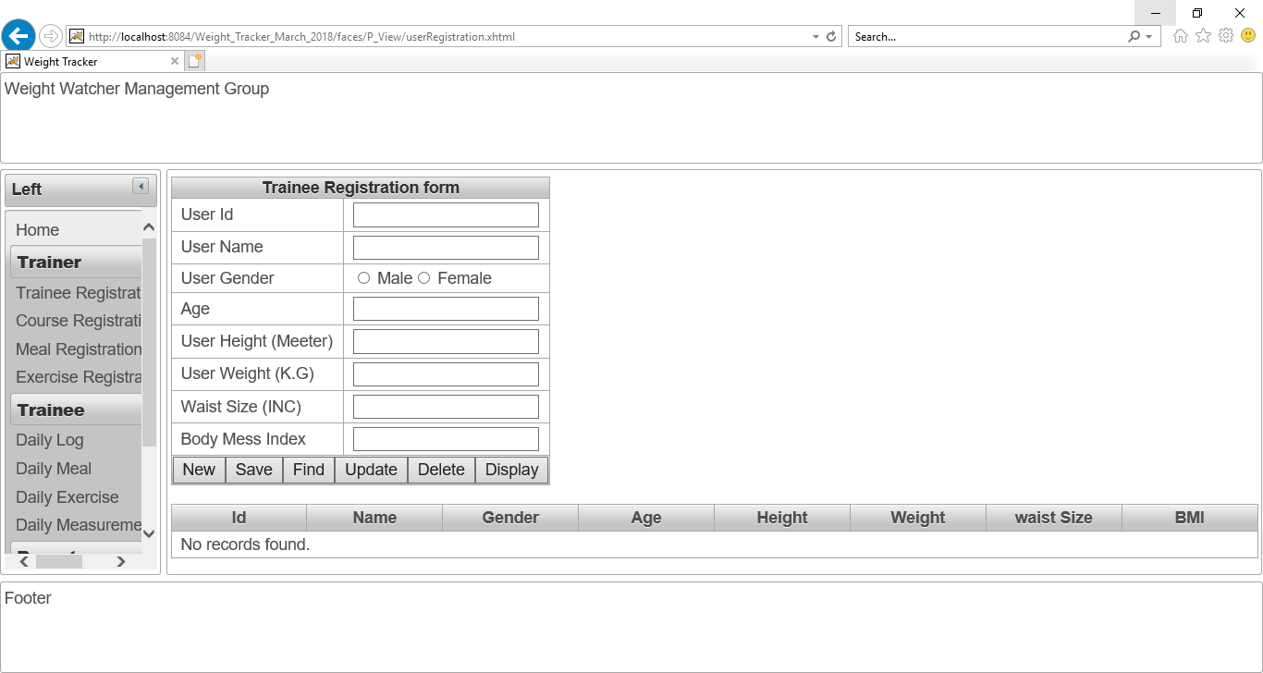

Figure No.61: After click on “New” button, all data is cleared.

## Course Registration page:

When the user will click on “**Course Registration**” button, this **course Registration page** will show to the user.

The **course Registration page** is working perfectly. The screenshot is given below:

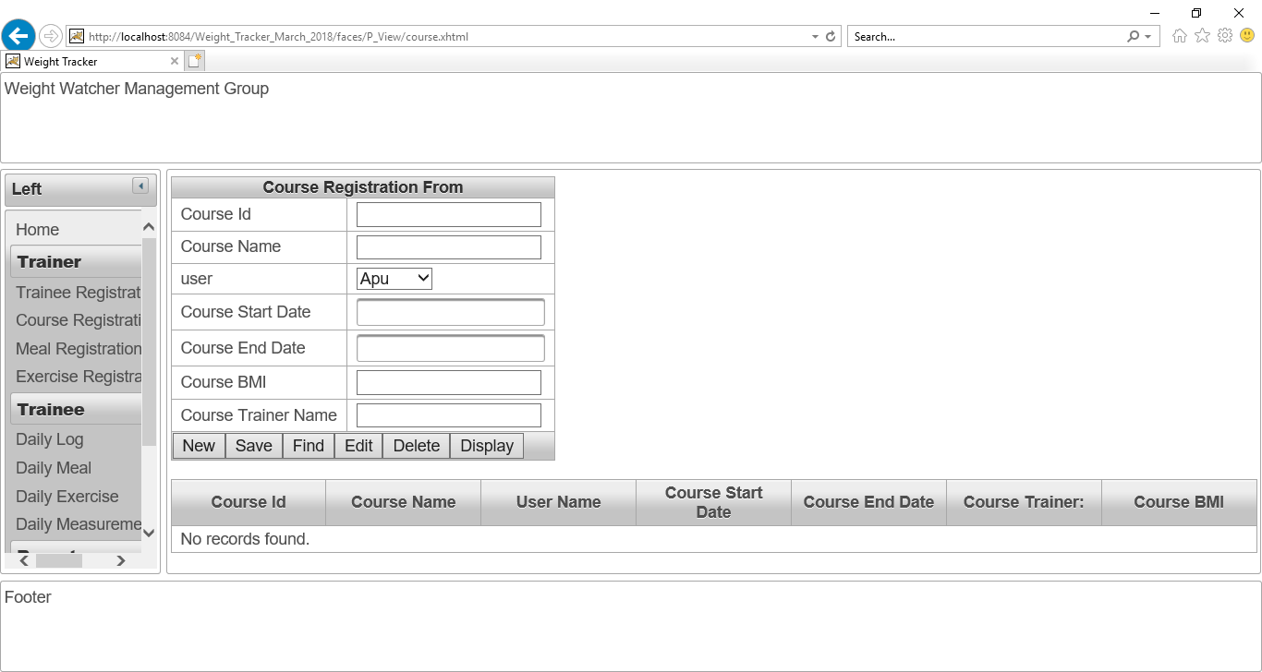

Figure No.62: The “Course Registration page” is working.

The user list is successfully shown in the “User” combo Box. The screenshot is given below:

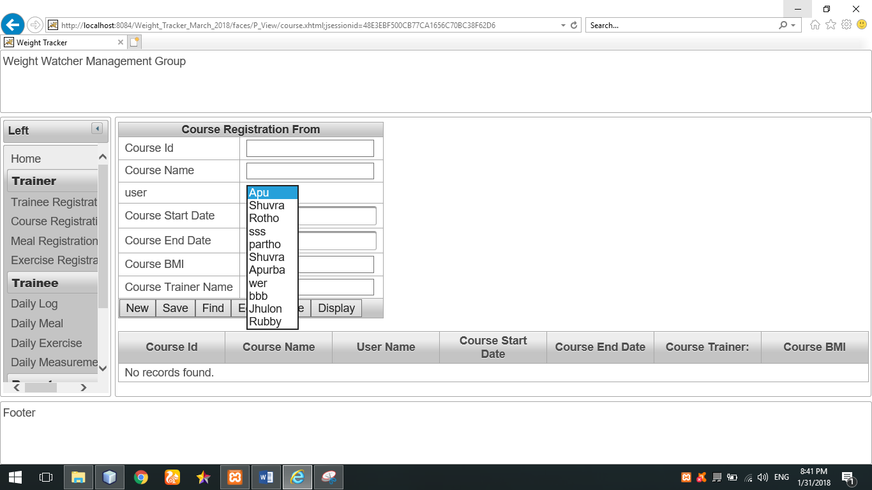

Figure No.63: The user list is successfully shown in the “User” combo Box.

**Checking calendar for date selection:**

Calendar for date selection is working perfectly. The screenshot is give below:

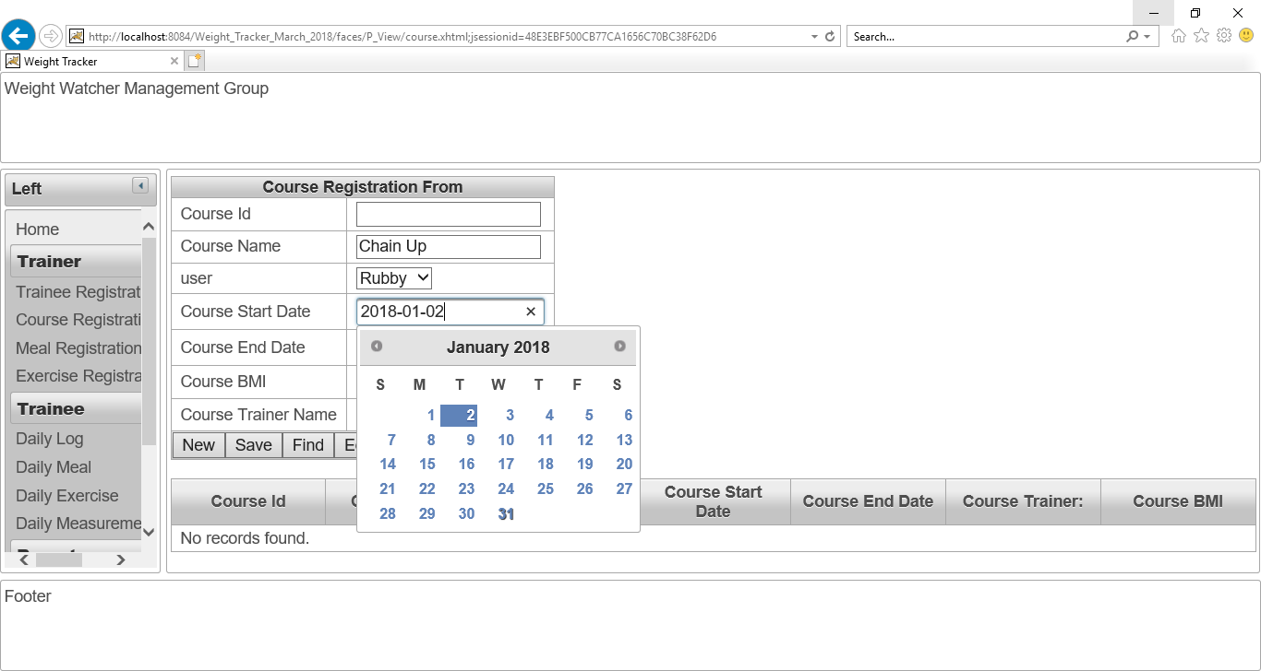

Figure No.64: Calendar for date selection is working perfectly.

**Checking “Save” button of “Course Registration page”:**

The course name “Burble” and his all details is given as input in order to save data.

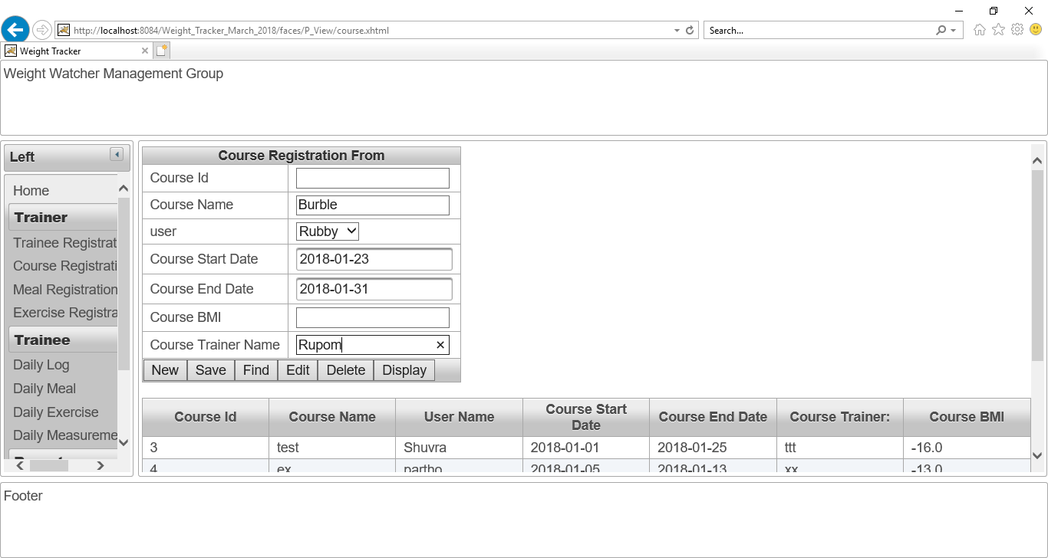

Figure No.65: Checking “Save” button of “Course Registration page”.

After that, I have clicked on save button in order to save these above data.

The course’s data has been saved. The screenshot is given below:

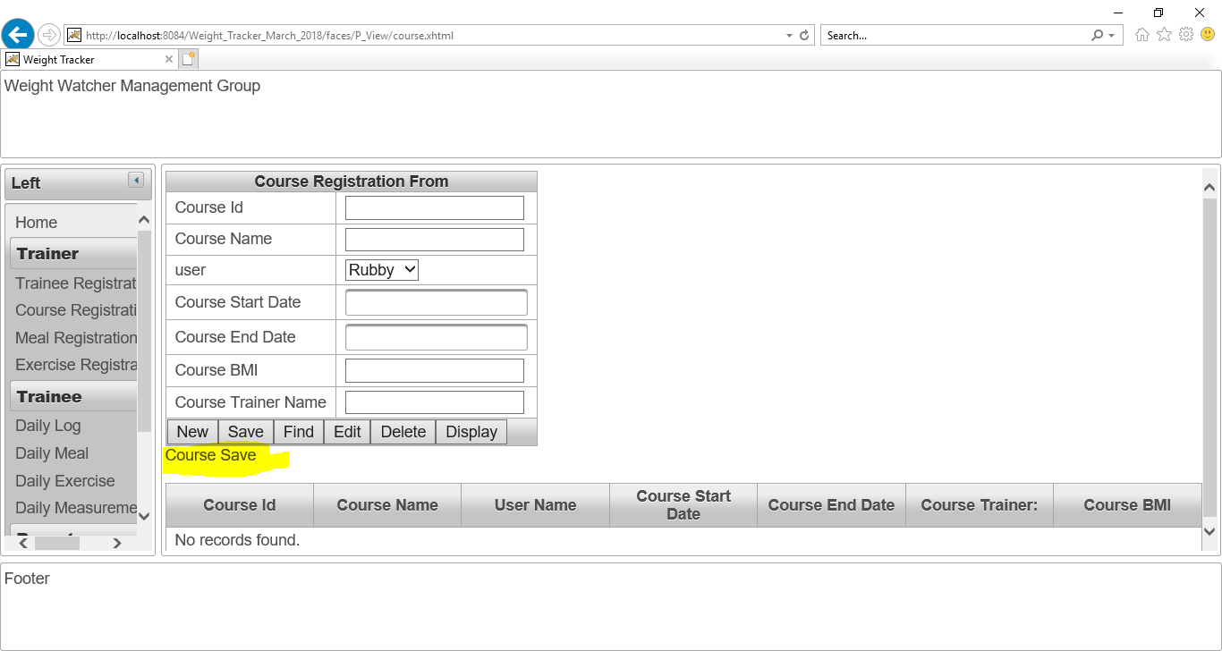

Figure No.66: The course’s data has been saved.

**Checking “Display” button of “Course Registration page”:**

After clicking on “Display” button, all the details of course “Chain Up” for “Rubby” has shown.

The “Display” button is working perfectly and the course “BMI Calculation” also shown. The screenshot is given below:

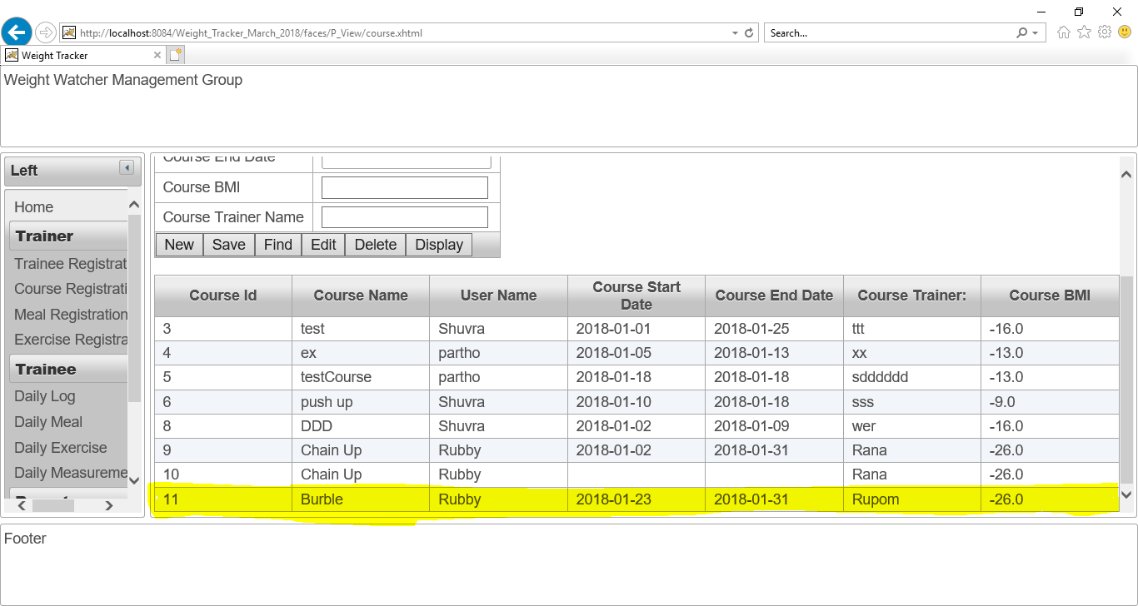

Figure No.67: The course’s data and it’s BMI calculation’s result has been saved also.

**Checking “Find” button of “Course Registration page”:**

I have written 9 as course Id and then click on “Find” button. The find button is working perfectly. The screenshot is given below:

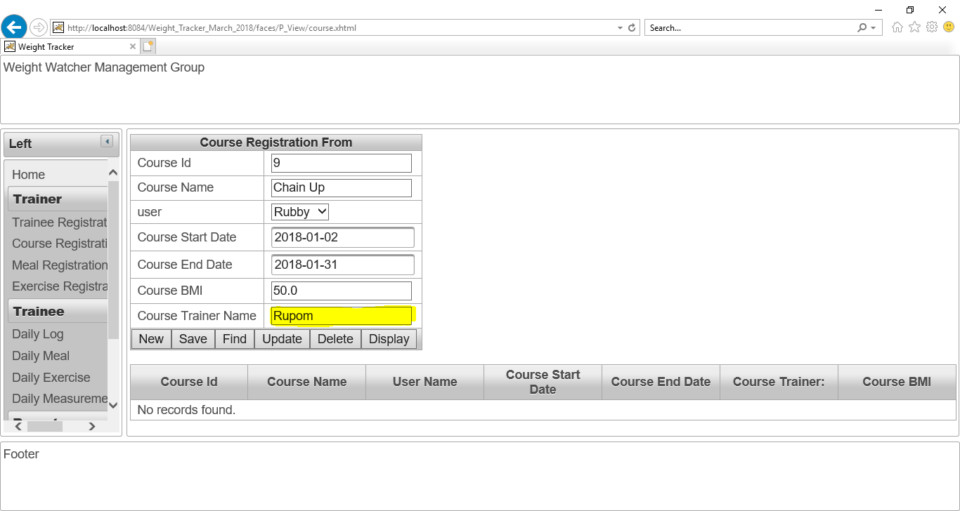

Figure No.68: Checking “Find” button of course registration form.

**Checking “Update” button of “Course Registration page”:**

I have changed the course trainer name as “Rana” instead of “Rupom” and then click on update button.



Figure No.69: Checking “Update” button of course registration form.

After click on “Update” button. The trainer name has updated. The “Update” button is working perfectly. The screenshot is given below:

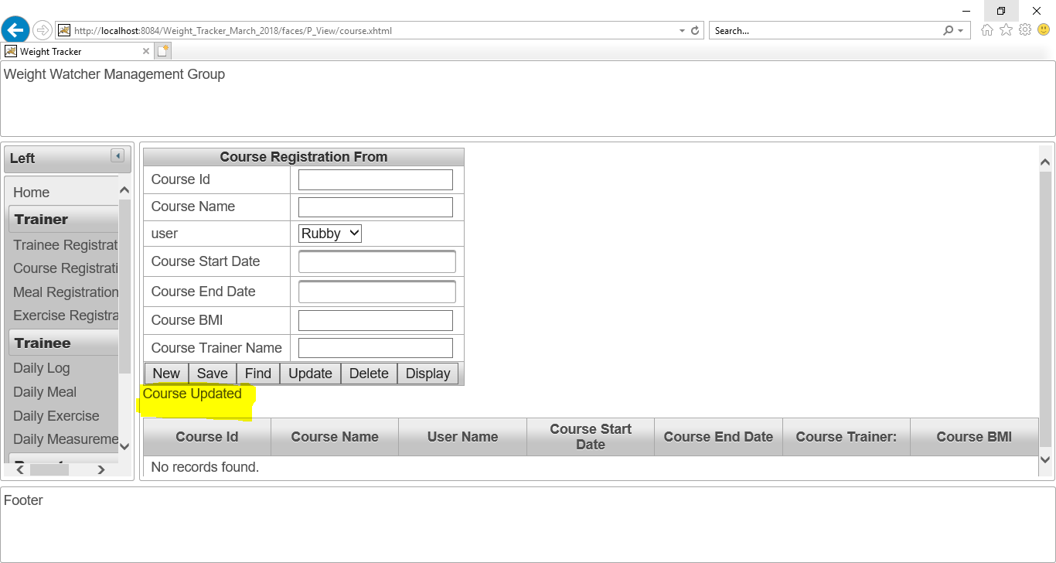

Figure No.70: Checking “Update” button of course registration form.

**The updated detail of that user is given as screenshot:**

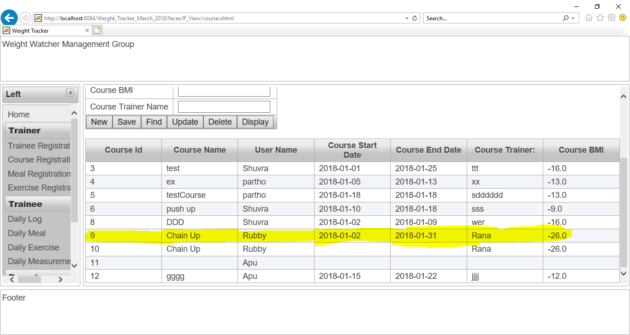

Figure No.71: Checking “Update” button of course registration form.

**Checking “Delete” button of “Course Registration page”:**

Now, I want to delete “Course ID” 3 from database in order to checking “Delete” action is working or not.

I have written 3 as “Course ID” and clicked on “Delete” button. The delete button is working perfectly. The screenshot is given below:

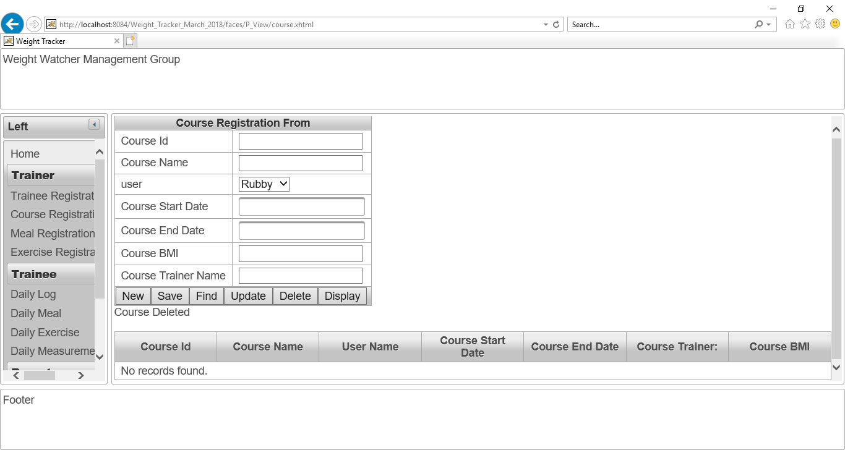

Figure No.72: Checking “Delete” button of course registration form.

Now, all course data is shown for proving this delete action. Now, there is no “Course Id” 3. The screenshot is given below:

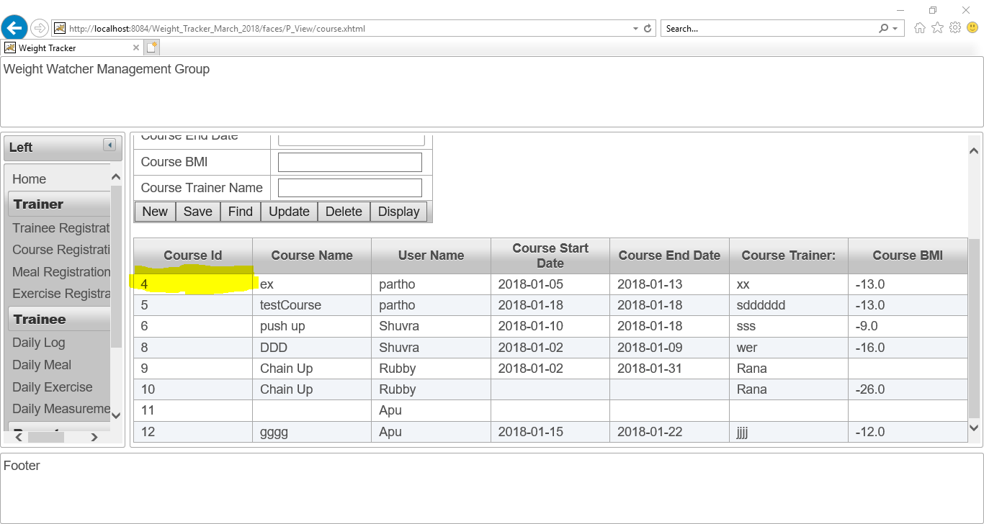

Figure No.73: Checking “Delete” button of course registration form.

**Checking “New” button of “Course Registration page”:**

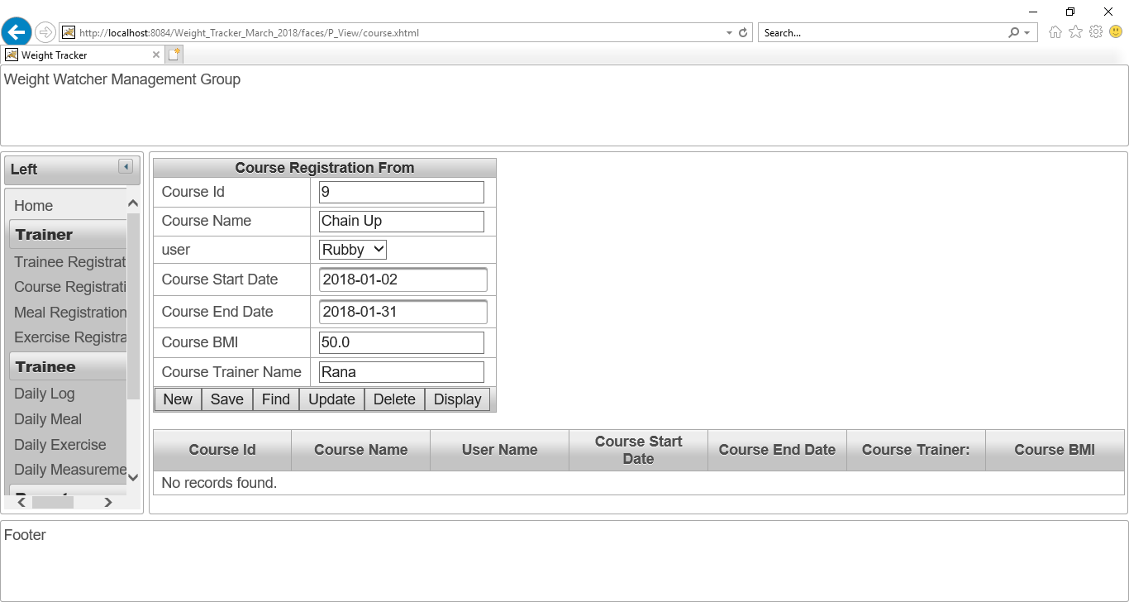

Figure No.74: Checking “New” button of course registration form.

**After click on “New” button, all data is cleared. The screenshot is given below:**

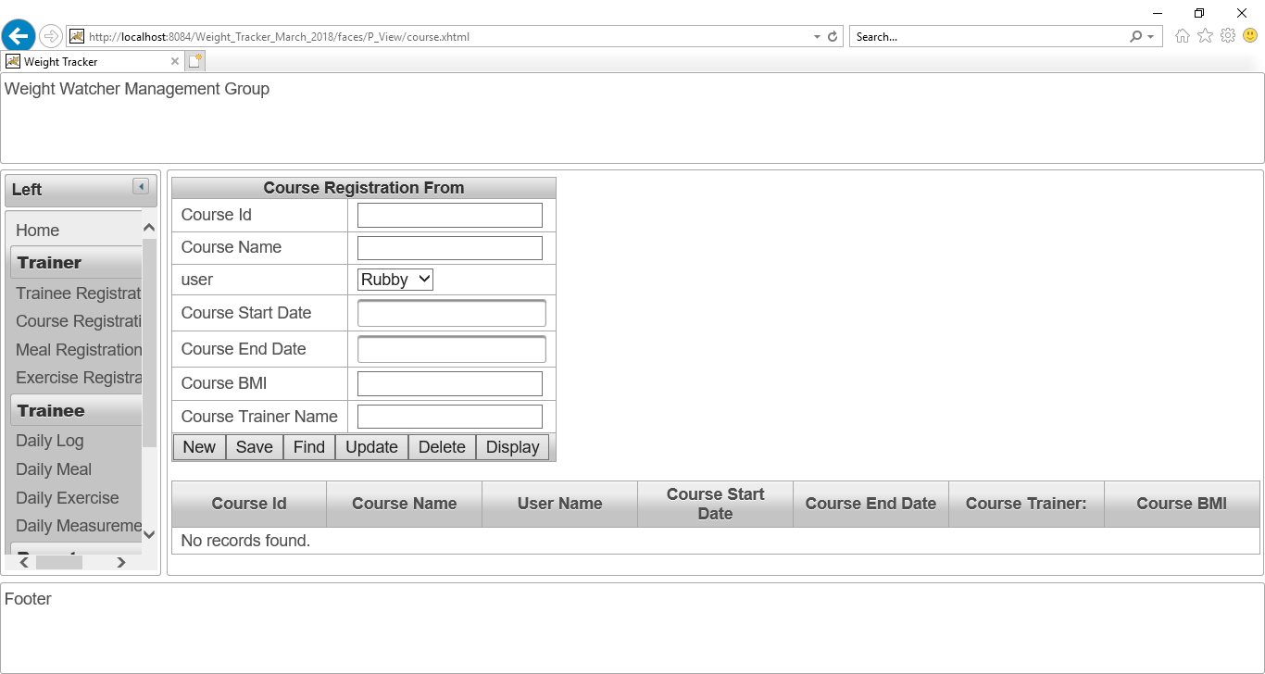

Figure No.75: Checking “New” button of course registration form.

## Meal Registration page:

When user will click on “**Meal Registration page**” button, this “**Meal Registration page”** will show to the user. The “**Meal Registration page”** is working perfectly. The screenshot is given below:

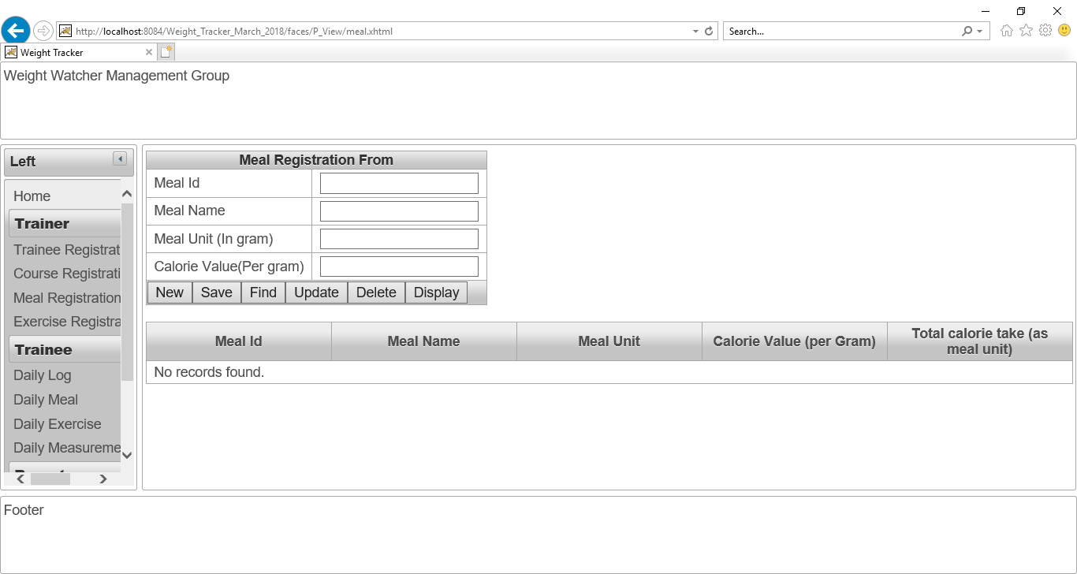

Figure No.75: The view of “Meal Registration Page”.

**Checking “New” button of “Meal Registration page”:**

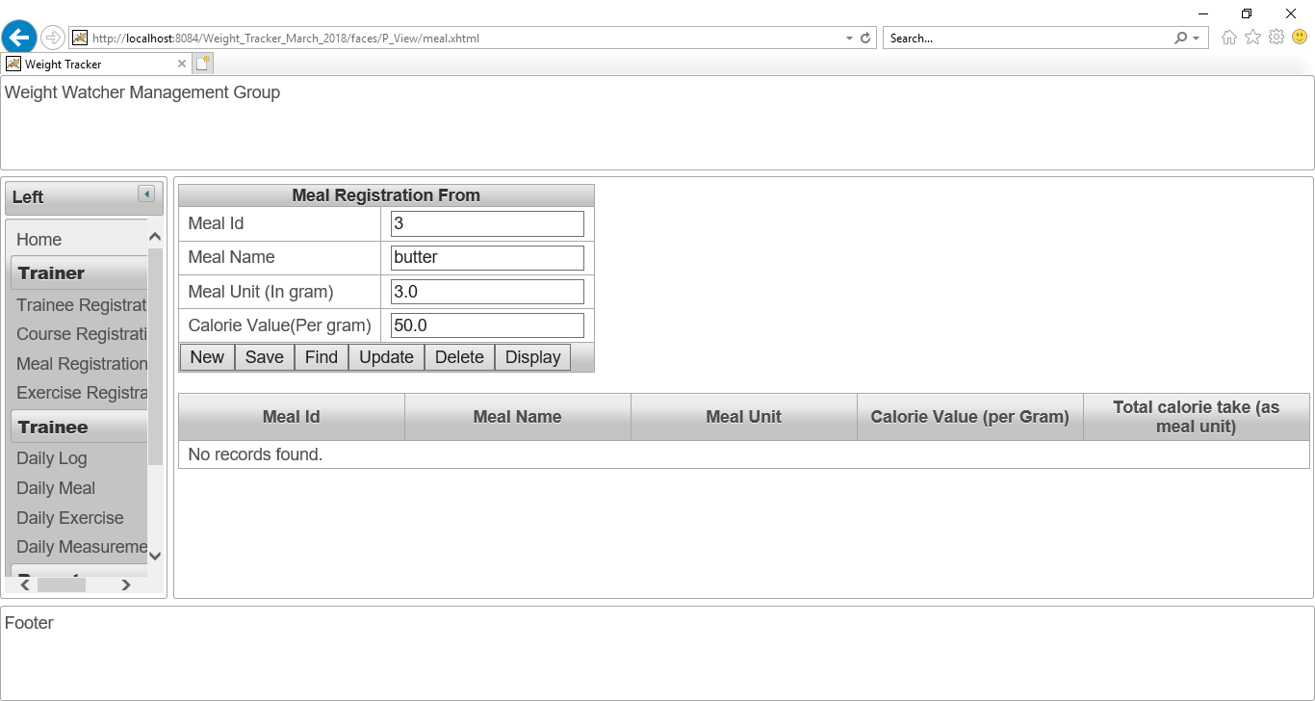

Figure No.76: Checking “New” button of “Meal Registration page”.

**After click on “New” button, all data is cleared. The screenshot is given below:**



Figure No.77: Checking “New” button of “Meal Registration page”.

**Checking “Save” button of “Meal Registration page”:**

The meal name “chicken” and his all details is given as input in order to save data and also calculate total calorie take as meal unit.

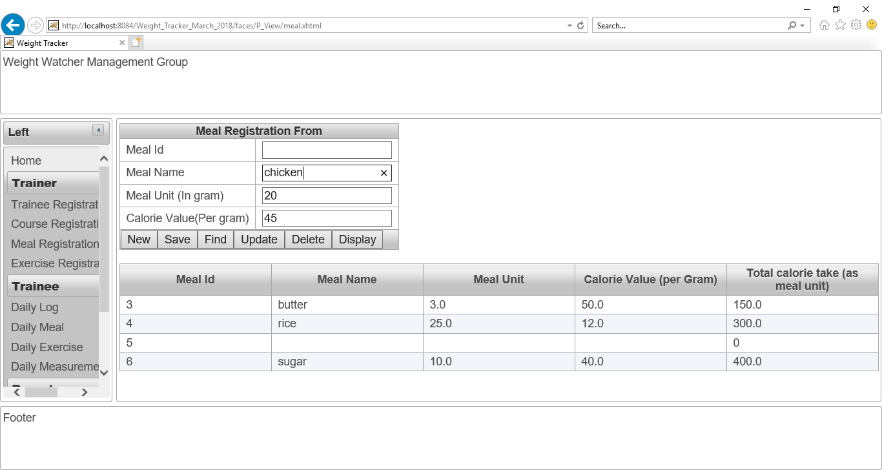

Figure No.78: Checking “Save” button of “Meal Registration page”.

After that, I have clicked on save button in order to save these above data.

The meal’s data has been saved. The screenshot is given below:

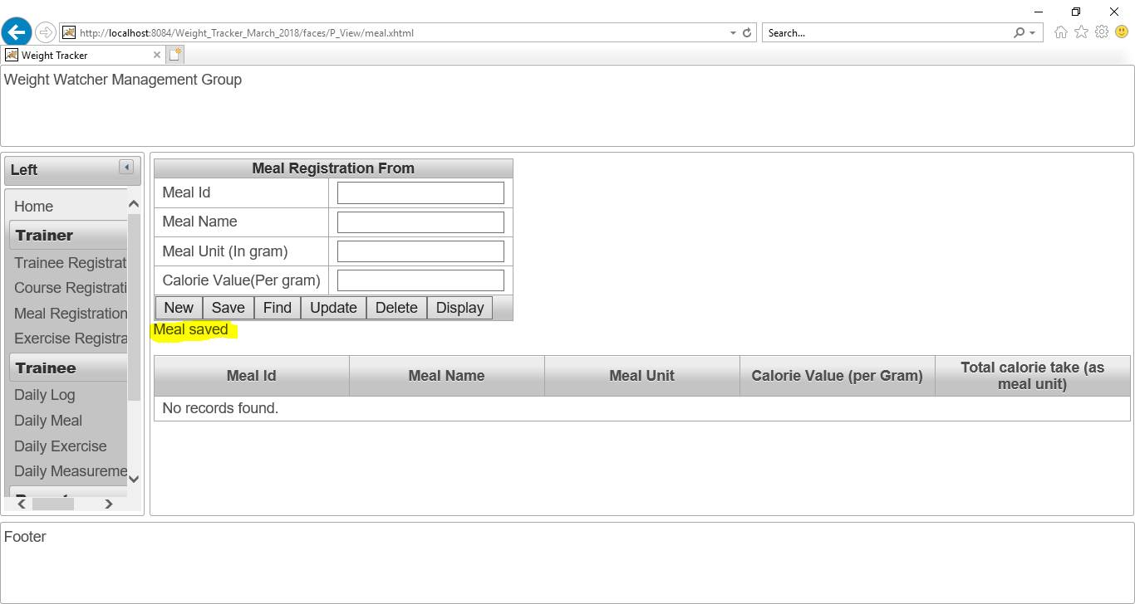

Figure No.79: Checking “Save” button of “Meal Registration page”.

**Checking “Display” button of “Meal Registration page”:**

After clicking on “Display” button, all the details of meal “chicken” has shown.

The “Display” button and the calorie calculation is also working perfectly and **Total calorie take as meal unit** also displayed. The screenshot is given below:

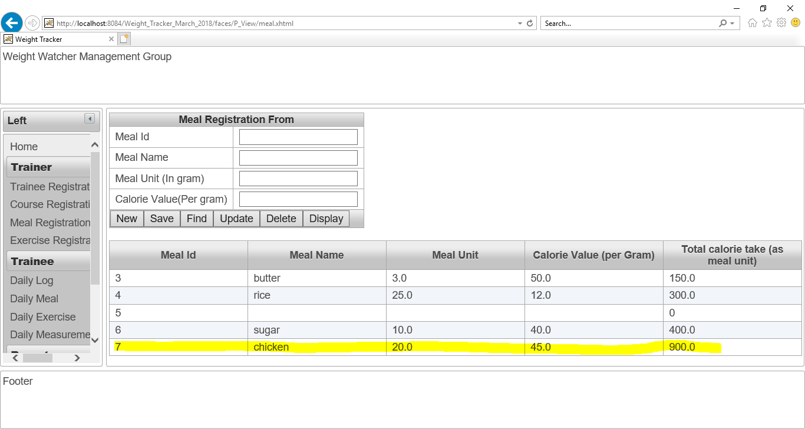

Figure No.80: Checking “Display” button of “Meal Registration page”.

**Checking “Find” button of “Meal Registration page”:**

I have written 7 as meal Id and then click on “Find” button. The find button is working perfectly. The screenshot is given below:

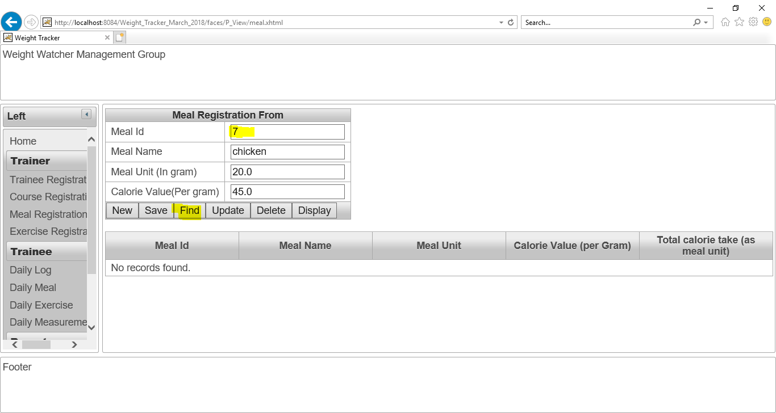

Figure No.81: Checking “Find” button of “Meal Registration page”.

**Checking “Update” button of “Meal Registration page”:**

I have changed the meal unit as “25g” instead of “20g” and then click on update button.

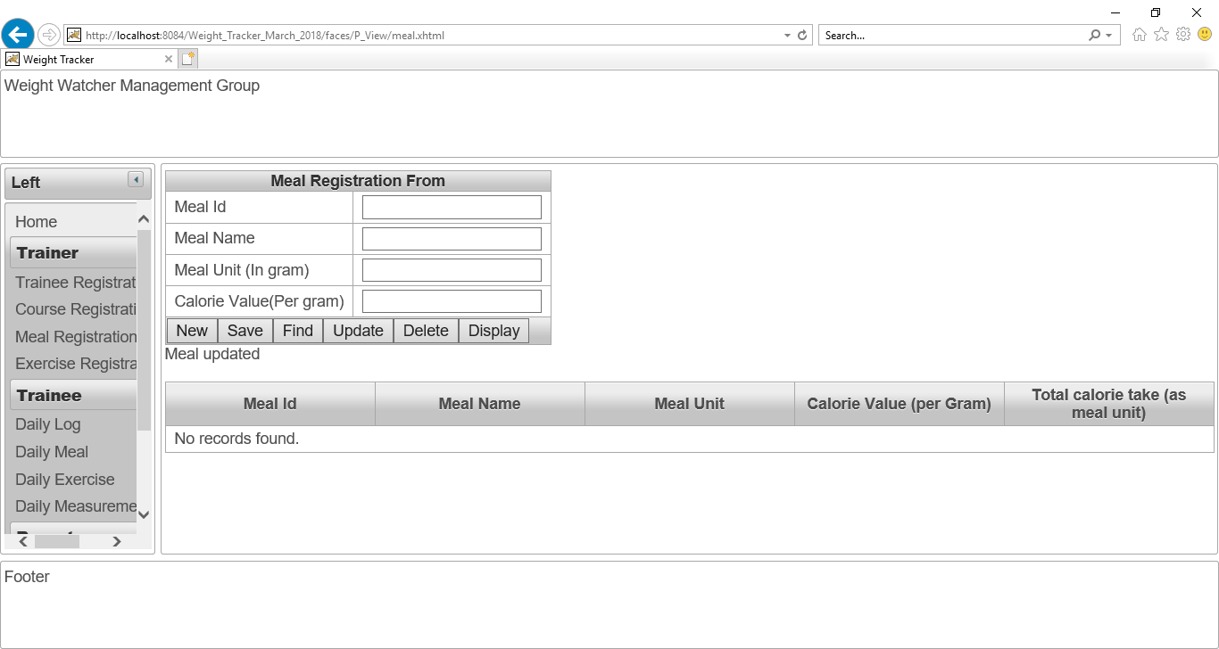

Figure No.82: Checking “Update” button of “Meal Registration page”.

After click on “Update” button. The meal unit has updated. The “Update” button is working perfectly. The screenshot is given below:

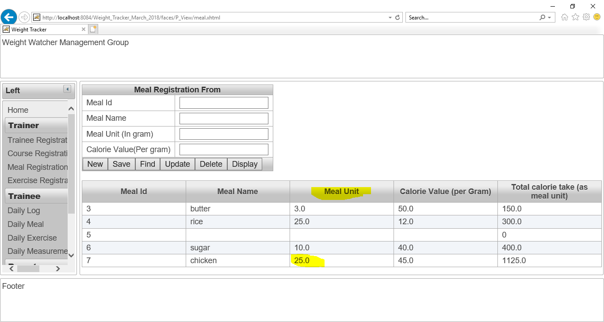

Figure No.83: Checking “Update” button of “Meal Registration page”.

**Checking “Delete” button of “Course Registration page”:**

Now, I want to delete “Meal ID” 6 from database in order to checking “Delete” action is working or not.

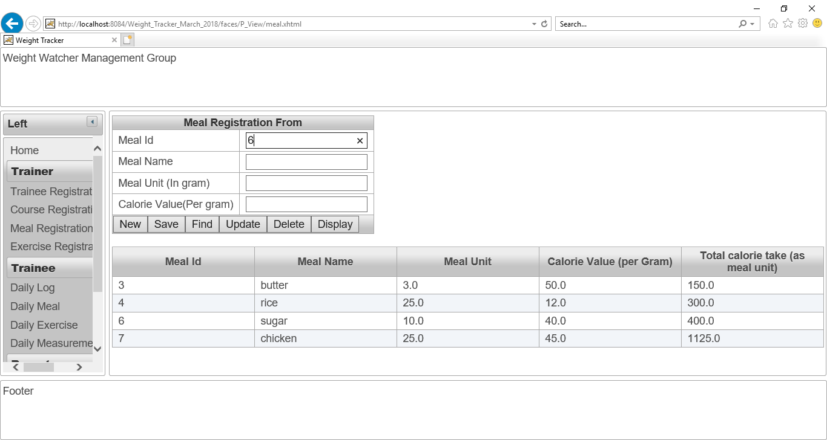

Figure No.84: Checking “Delete” button of “Meal Registration page”.

I have written 6 as “Meal ID” and clicked on “Delete” button. The delete button is working perfectly. The screenshot is given below:

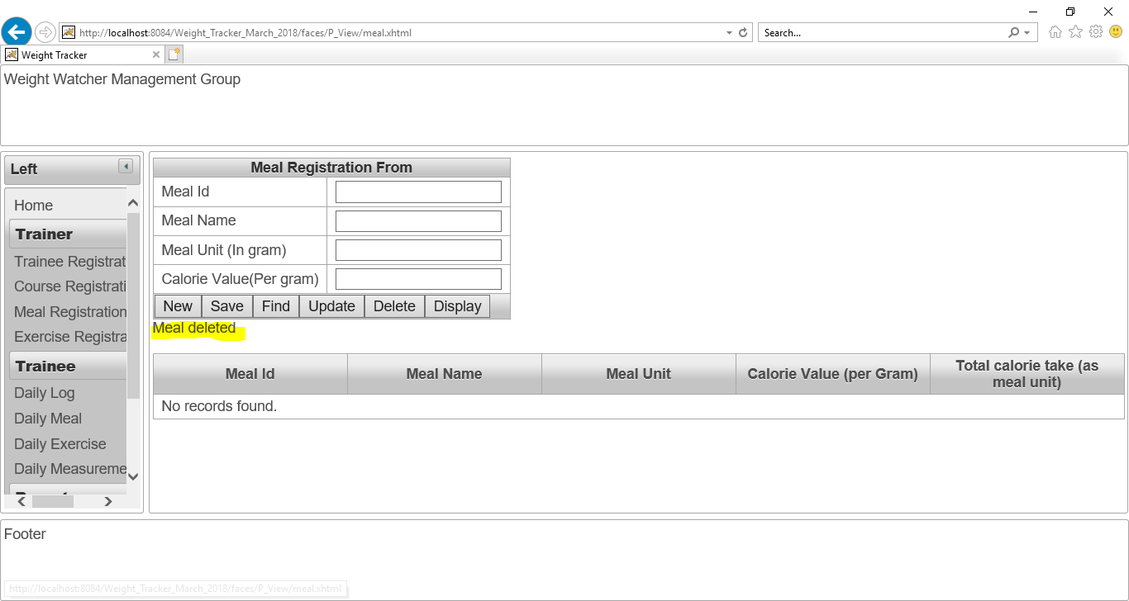

Figure No.85: Checking “Delete” button of “Meal Registration page”.

Now, all meal data is shown for proving this delete action. Now, there is no “Meal Id” 6. The screenshot is given below:

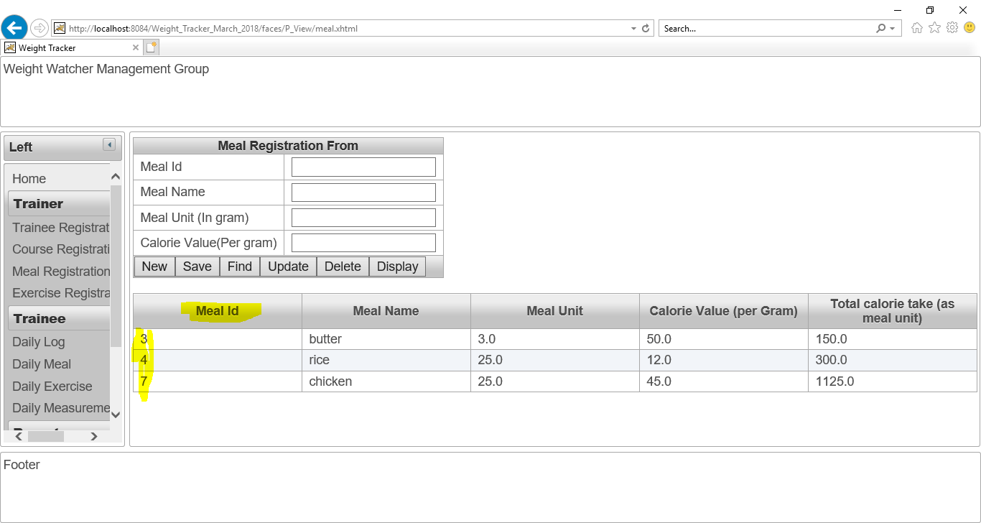

Figure No.82: Checking “Delete” button of “Meal Registration page”.

## Exercise Registration page:

**Checking “New” button of “Exercise Registration page”:**

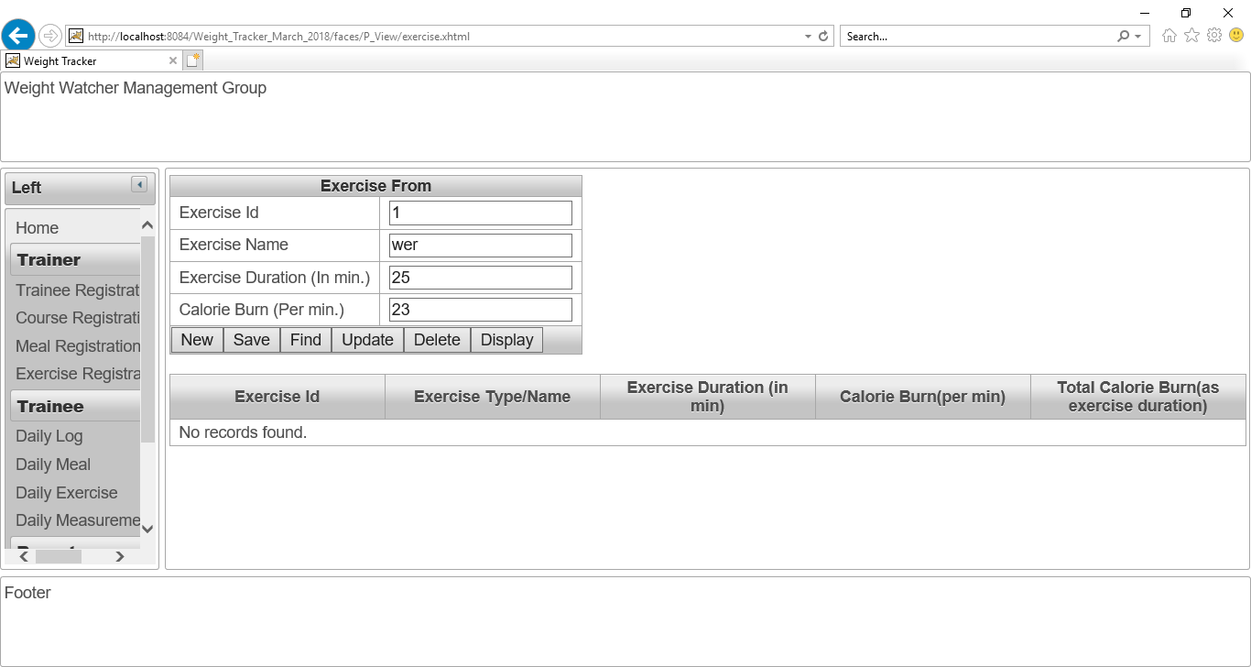

Figure No.83: Checking “New” button of “Exercise Registration page”.

After click on “New” button, all data is cleared. The screenshot is given below:

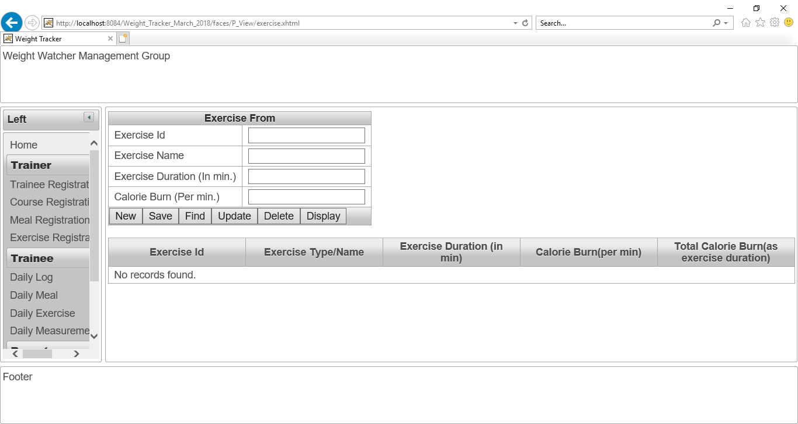

Figure No.84: Checking “New” button of “Exercise Registration page”.

**Checking “Save” button of “Exercise Registration page”**

The exercise name “Scating” and his all details is given as input in order to save data.

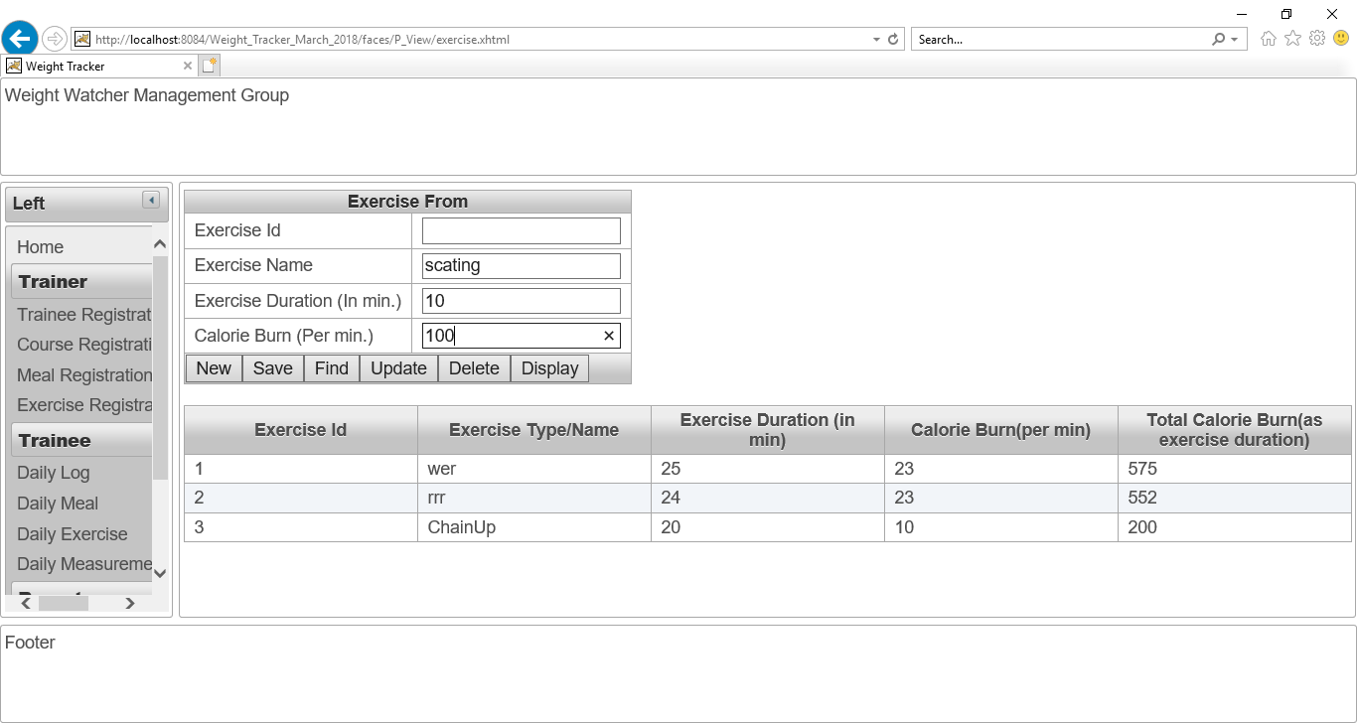

Figure No.85: Checking “Save” button of “Exercise Registration page”.

After that, I have clicked on save button in order to save these above data.

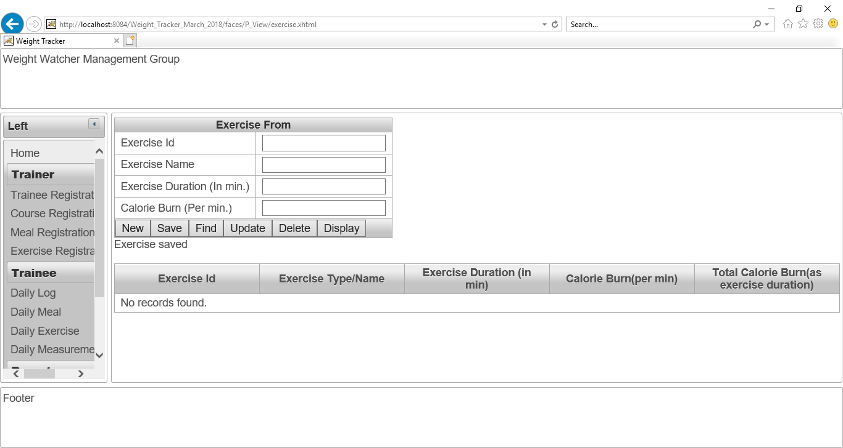

Figure No.86: Checking “Save” button of “Exercise Registration page”.

The exercise’s data has been saved and also calculate total calorie burn as exercise duration is also displayed. The screenshot is given below:

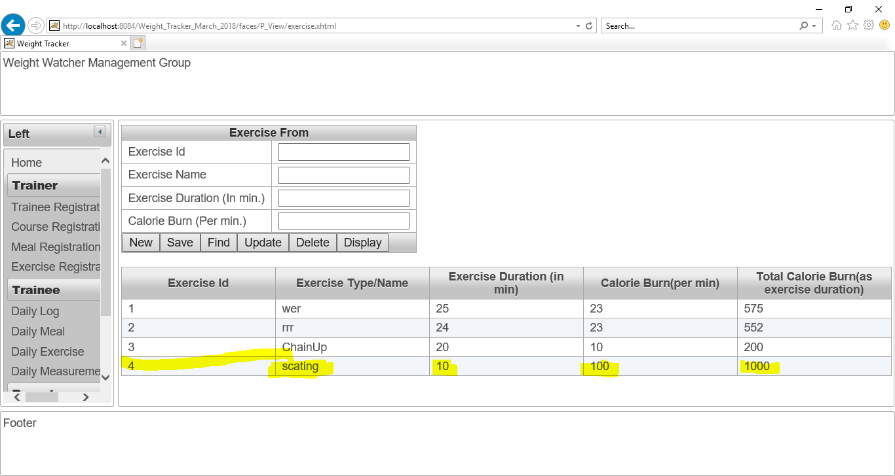

Figure No.86: Checking “Save” button of “Exercise Registration page”.

**Checking “Find” button of “Exercise Registration page”:**

I have written 4 as exercise Id and then click on “Find” button. The find button is working perfectly. The screenshot is given below:

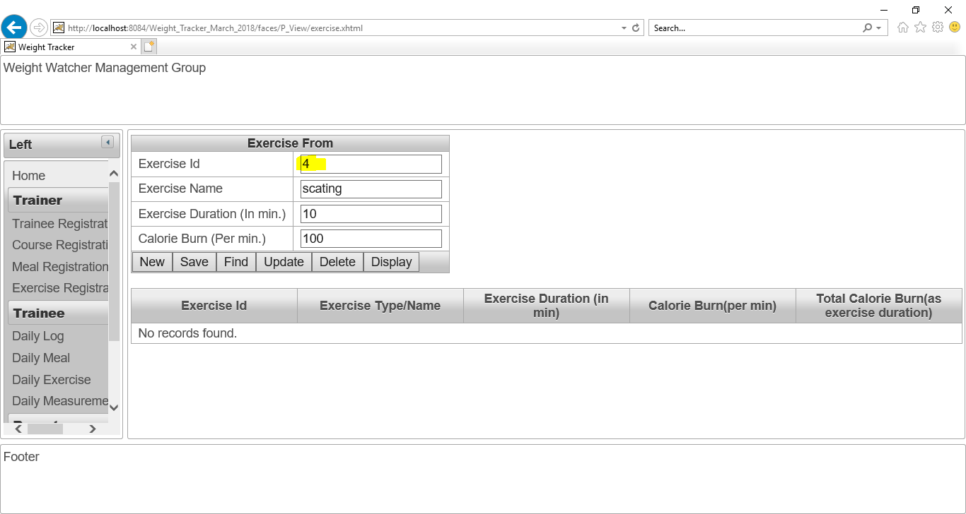

Figure No.87: Checking “Find” button of “Exercise Registration page”.

**Checking “Display” button of “Exercise Registration page”:**

After clicking on “exercise” button, all the details of exercise have shown.

The “Display” button is working perfectly. The screenshot is given below:

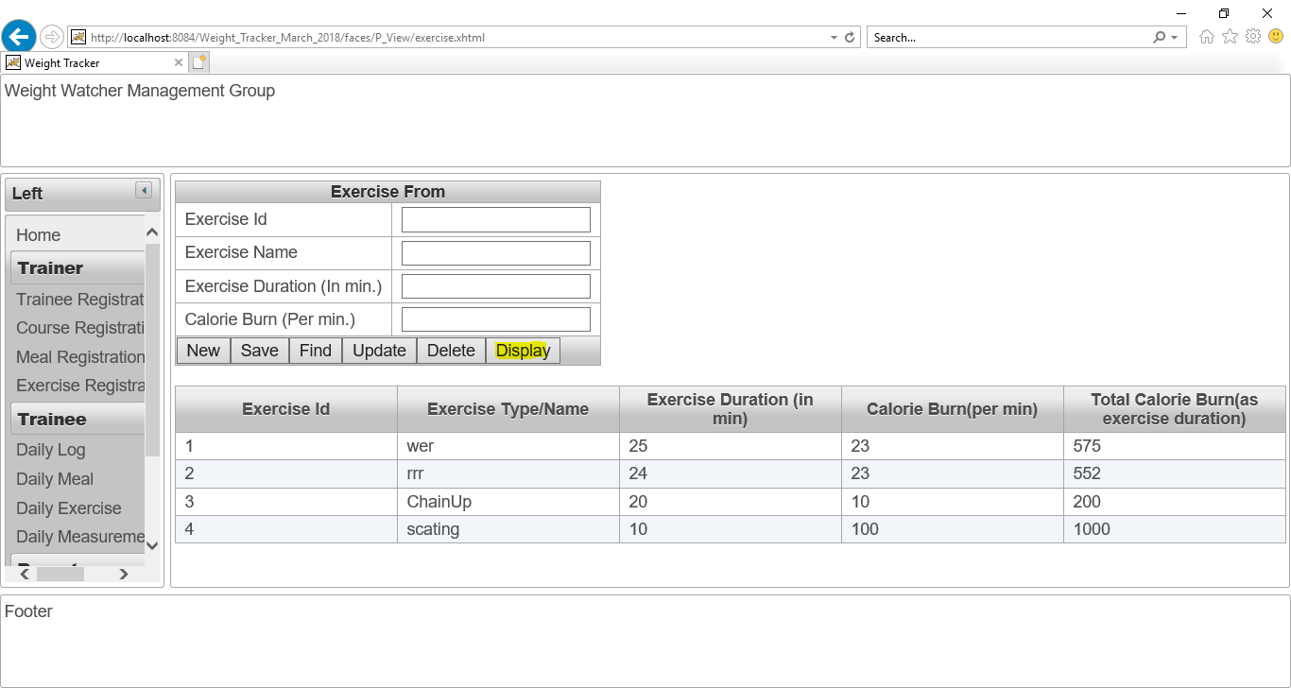

Figure No.88: Checking “Display” button of “Exercise Registration page”.

**Checking “Update” button of “Exercise Registration page”:**

I have changed the exercise duration as “20” instead of “10” and then click on update button.

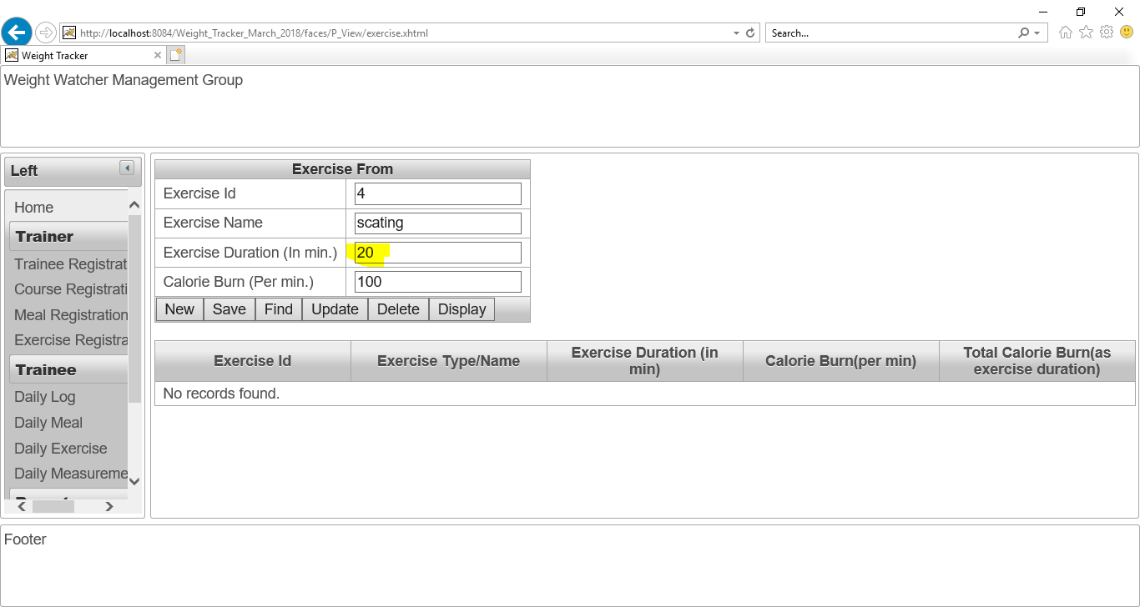

Figure No.89: Checking “Update” button of “Exercise Registration page”.

After click on “Update” button. The exercise duration has updated. The “Update” button is working perfectly. The screenshot is given below:

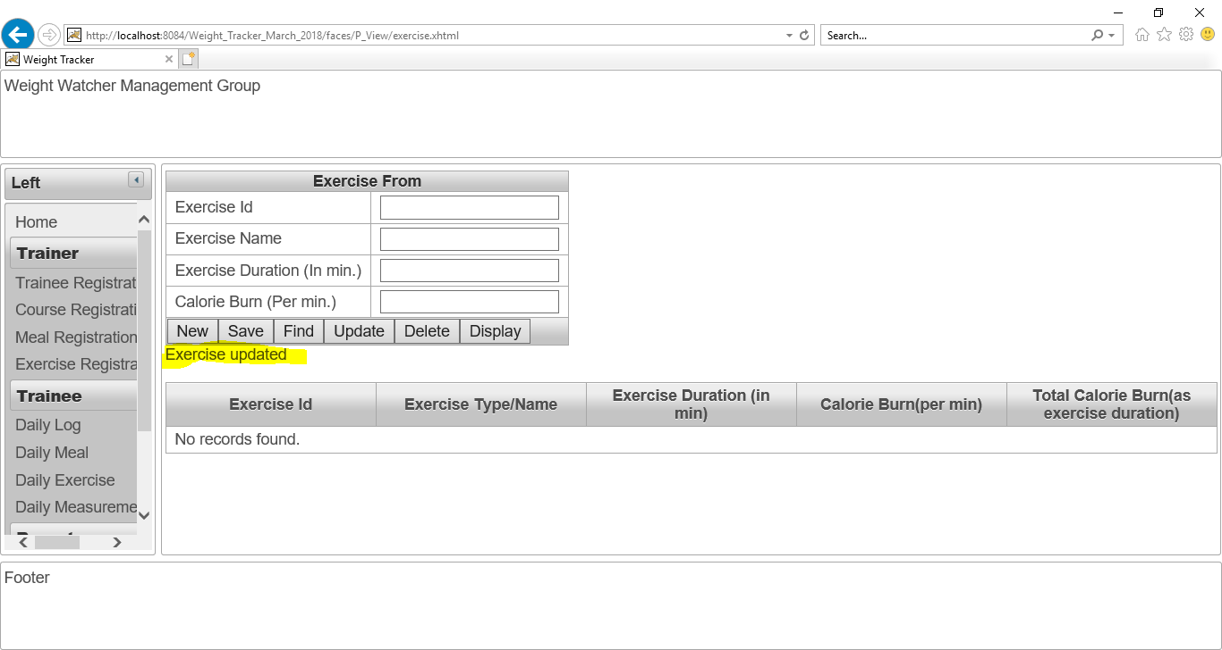

Figure No.90: Checking “Update” button of “Exercise Registration page”.

The updated detail of that exercise is given as screenshot:

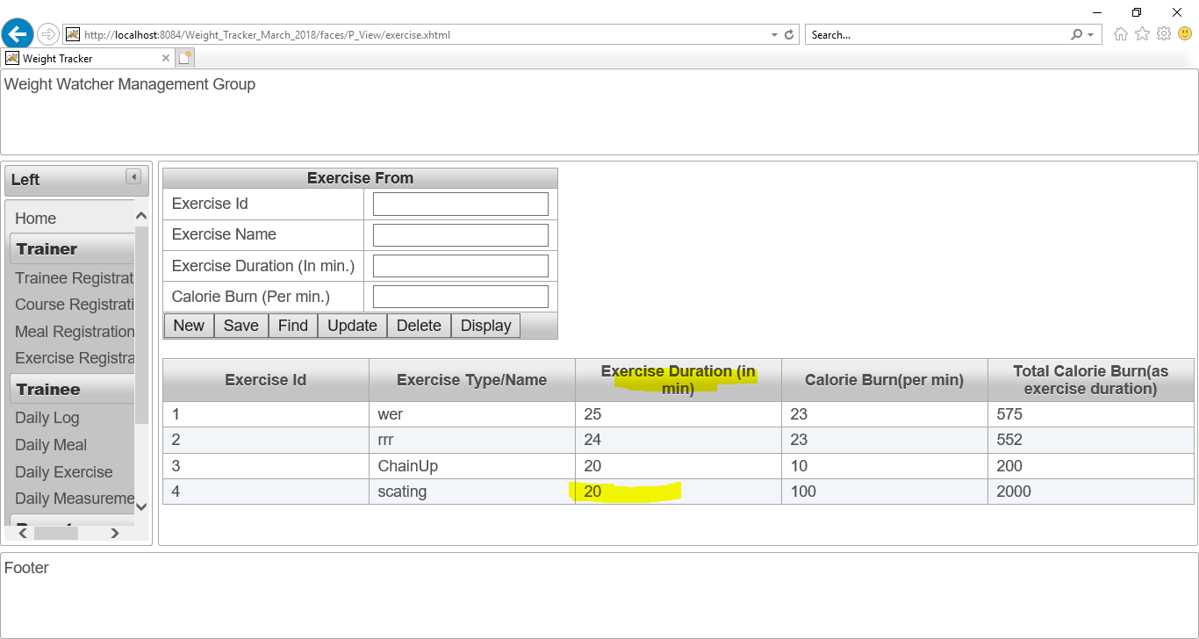

Figure No.91: Checking “Update” button of “Exercise Registration page”.

**Checking “Delete” button of “Exercise Registration page”:**

Now, I want to delete “Exercise ID” 4 from database in order to checking “Delete” action is working or not.

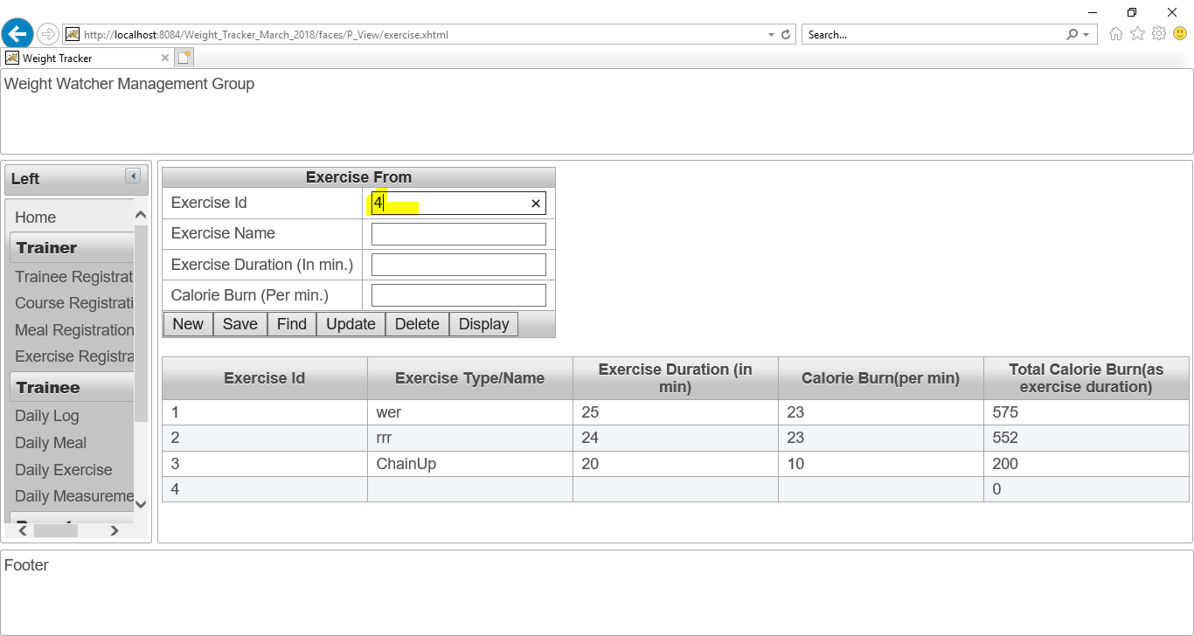

Figure No.92: Checking “Delete” button of “Exercise Registration page”.

I have written 4 as “Exercise ID” and clicked on “Delete” button. The delete button is working perfectly. The screenshot is given below:

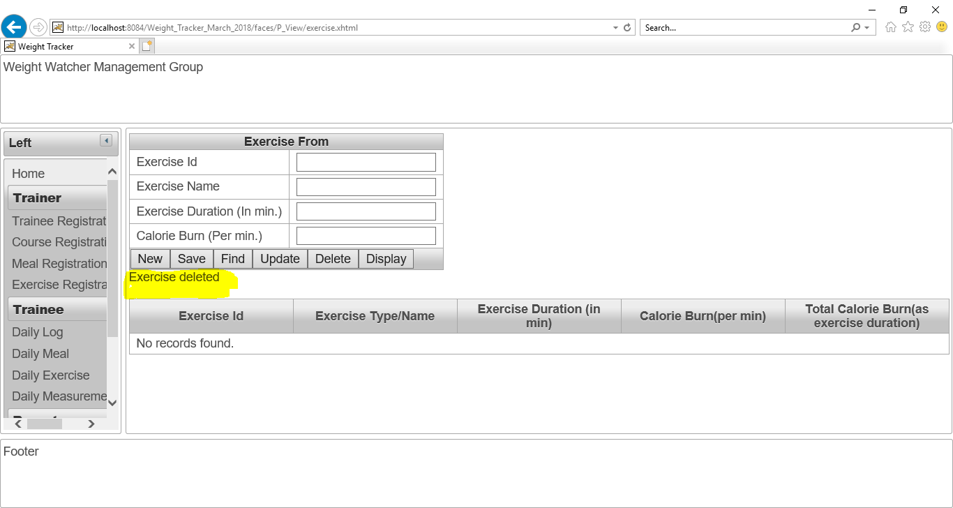

Figure No.93: Checking “Delete” button of “Exercise Registration page”.

Now, all exercise data is shown for proving this delete action. Now, there is no “Exercise Id” 4. The screenshot is given below:

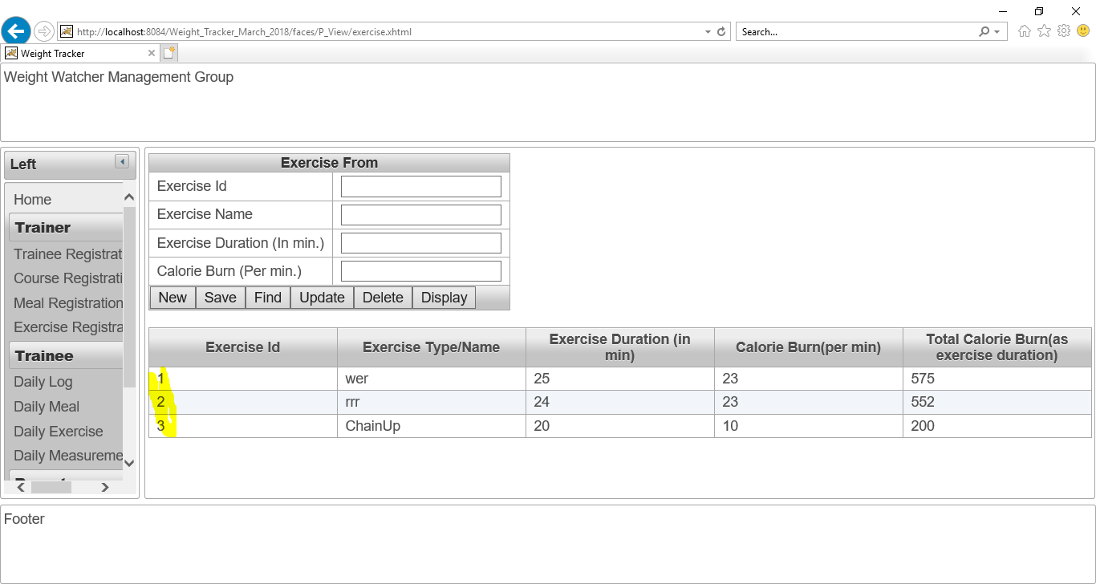

Figure No.94: Checking “Update” button of “Exercise Registration page”.

## Daily log page:

After click on “Dailylog” button. This dailylog page will show. The screenshot is given below:

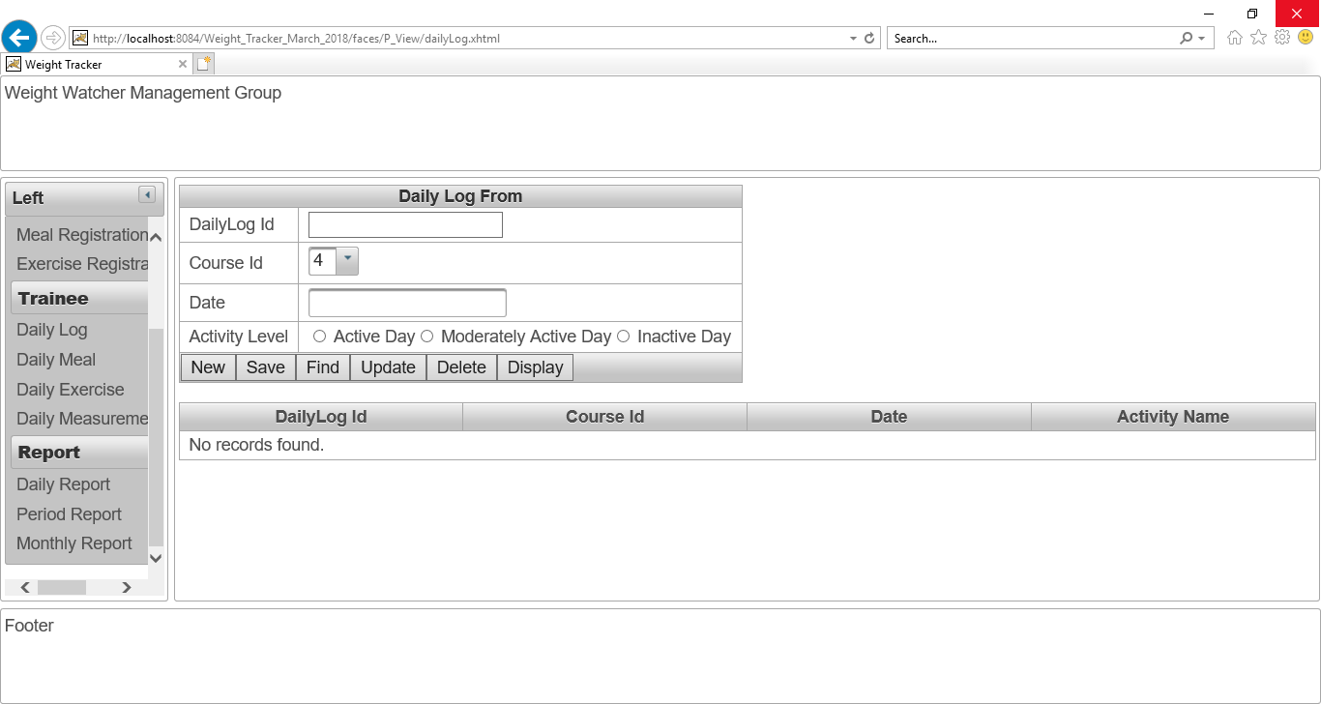

Figure No.95: The daily log page.

All course id is shown in the combo box “Course ID”. The screenshot is given below:

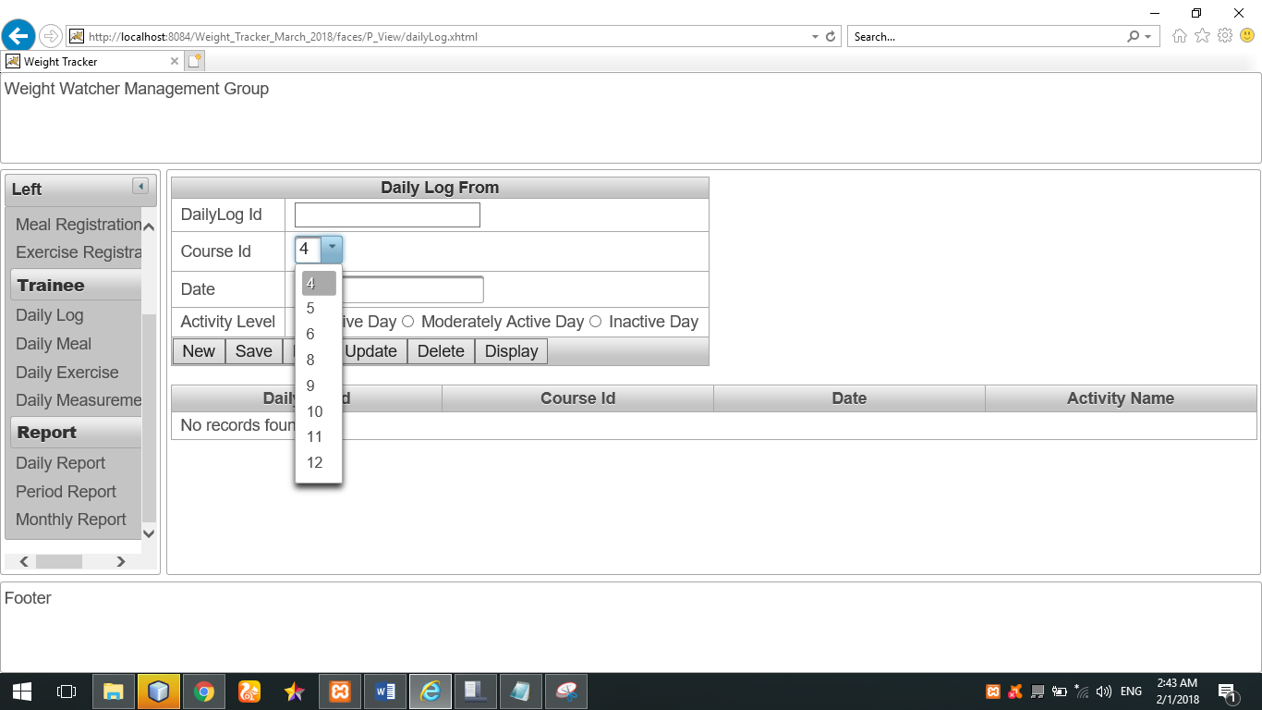

Figure No.96: All course id is shown in the combo box “Course ID”.

The calendar for date selection is also working. The screenshot is given below:

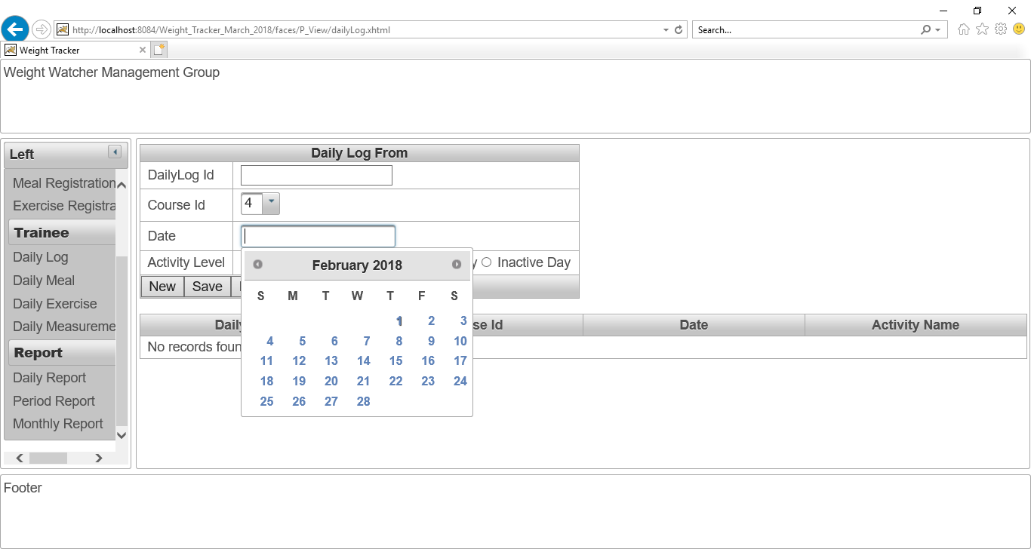

Figure No.97: The calendar for date selection is working perfectly.

**Checking “Save” button of daily log page:**

I have select and written this data for storing them in database as daily log information. The screenshot is given below:

After clicked on “Save” button, the dailylog information has been saved. The screenshot is given below:

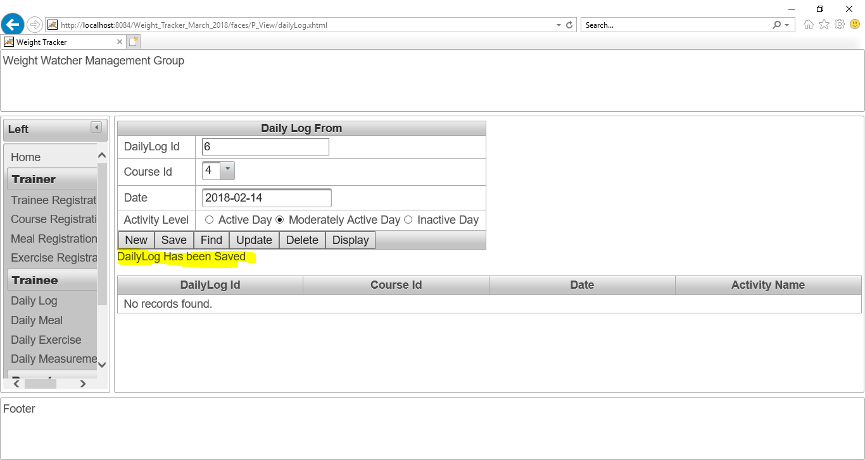

Figure No.98: Checking “Save” button of daily log page.

After click on “Display” button, all the dailylog information is shown. The screenshot is given below:

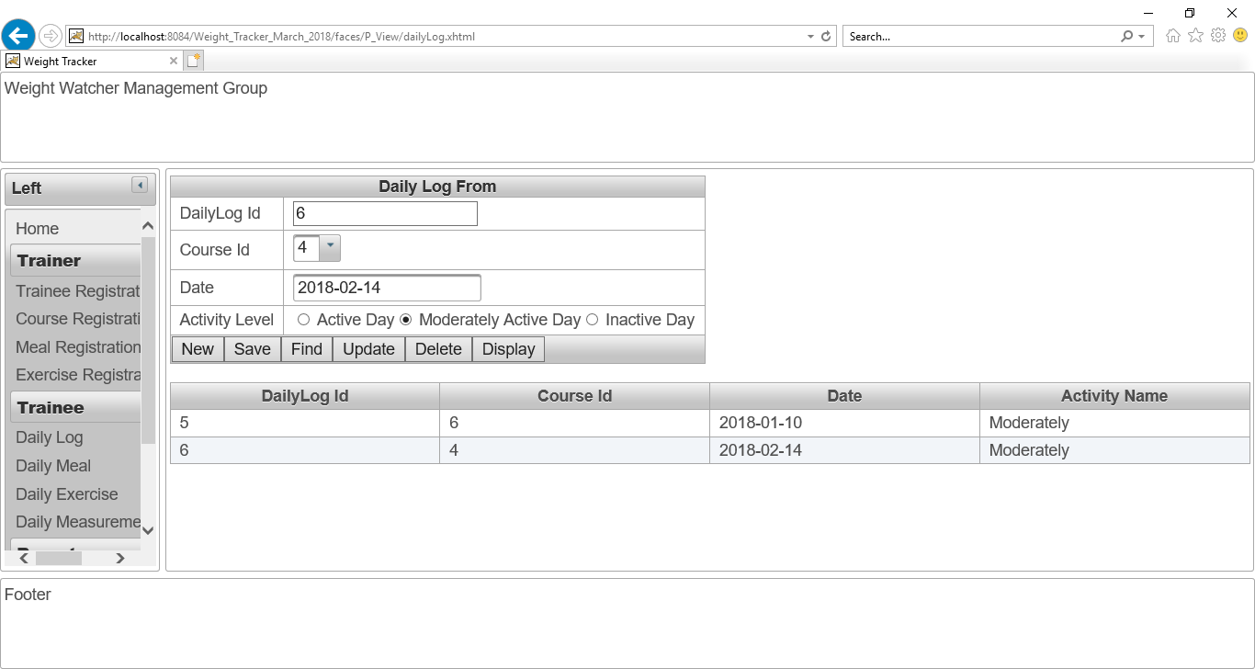

Figure No.99: Checking “Save” button of daily log page.

**Checking “Find” button of “Dailylog page”.**

I have written 6 as dailylog Id and then click on “Find” button. The find button is working perfectly. The screenshot is given below:

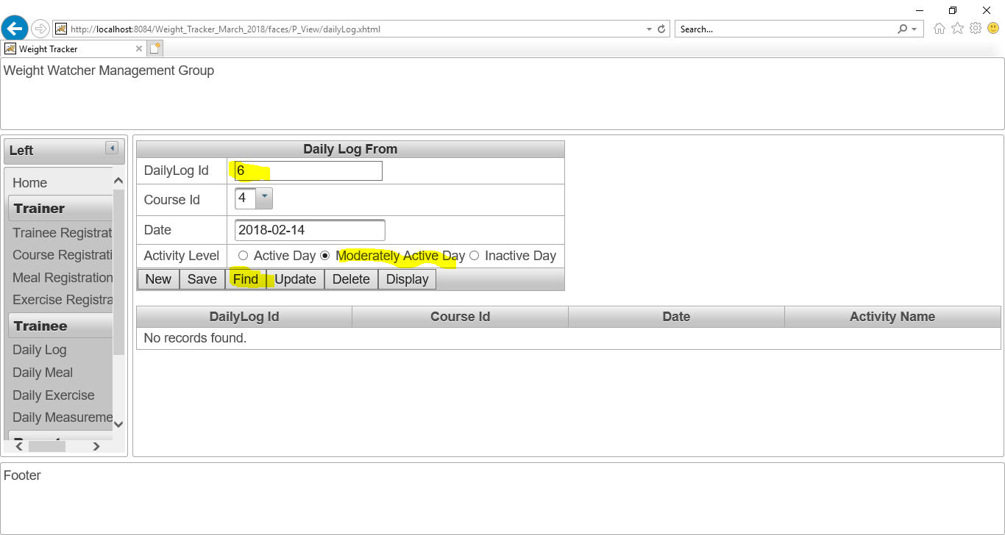

Figure No.100: Checking “Find” button of daily log page.

**Checking “Update” button of “Dailylog page”:**

I have changed the course Id as “6” instead of “4” and then click on update button.

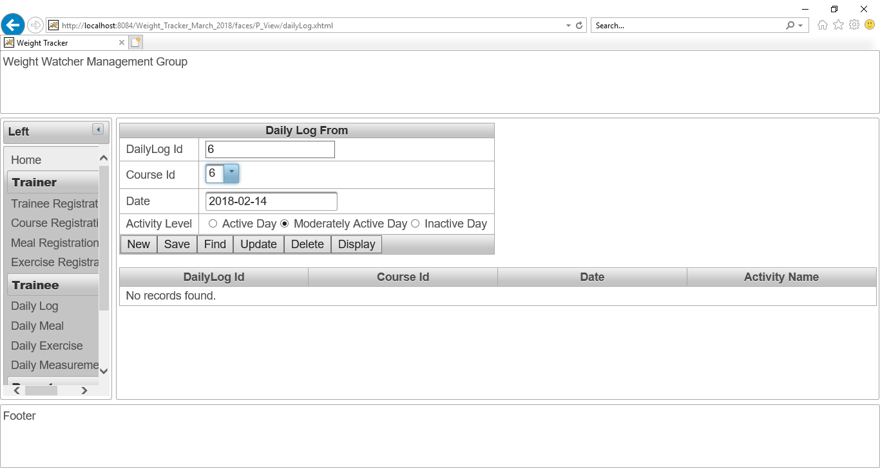

Figure No.100: Checking “Update” button of daily log page.

**Checking “Delete” button of “Dailylog page”:**

Now, I want to delete “Dailylog ID” 5 from database in order to checking “Delete” action is working or not.

I have written 5 as “Dailylog ID” and clicked on “Delete” button. The delete button is working perfectly. The screenshot is given below:

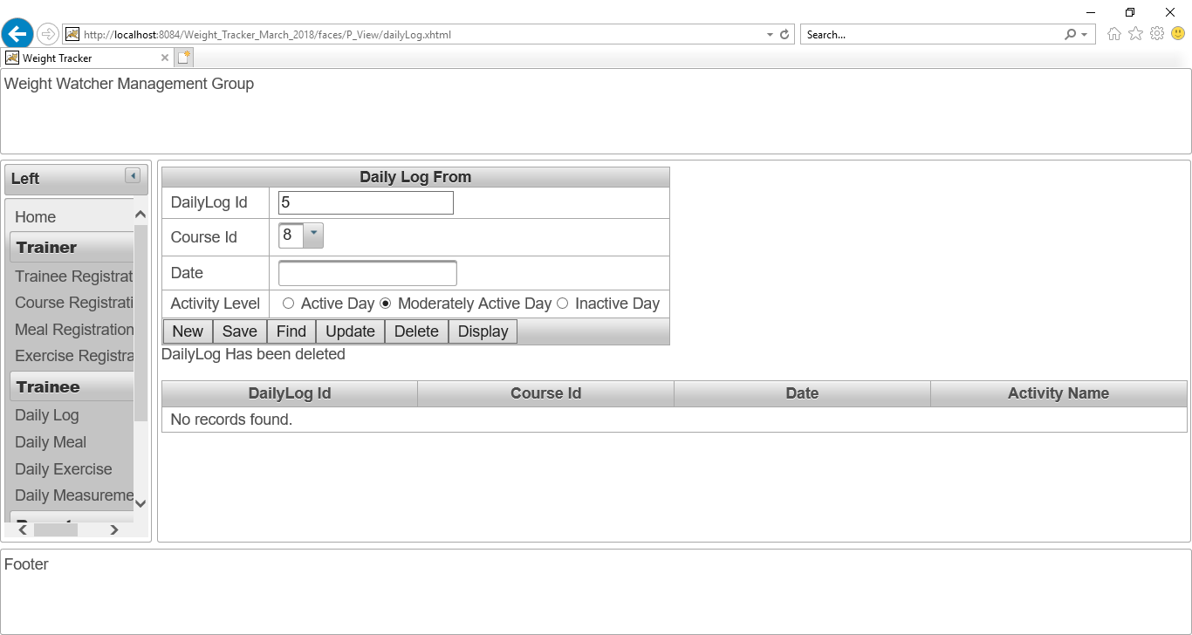

Figure No.101: Checking “Delete” button of daily log page.

Now, all Dailylog data is shown for proving this delete action. Now, there is no “Dailylog Id” 5. The screenshot is given below:

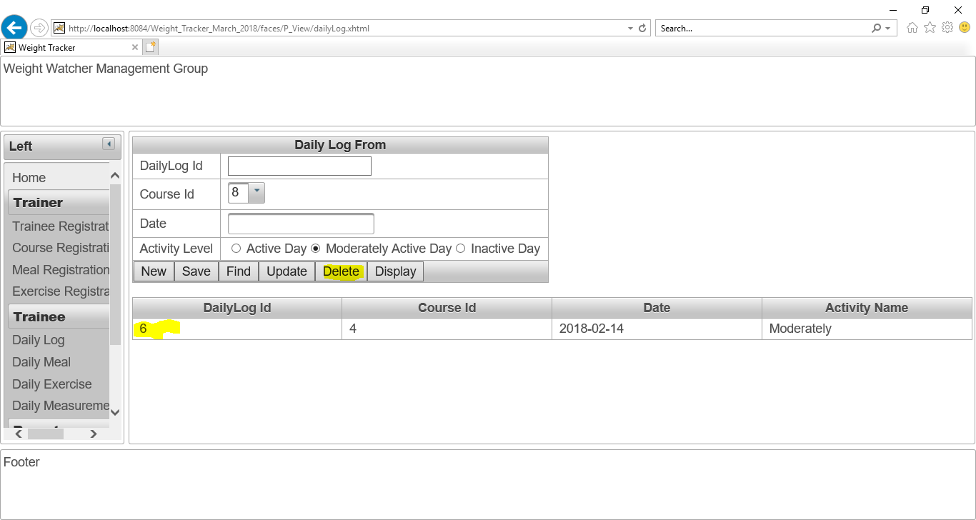

Figure No.104: Checking “Delete” button of daily log page.

**Checking “Display” button of “Dailylog page”:**

After clicking on “Display” button, all the details of dailylog has shown.

The “Display” button is working perfectly. The screenshot is given below:

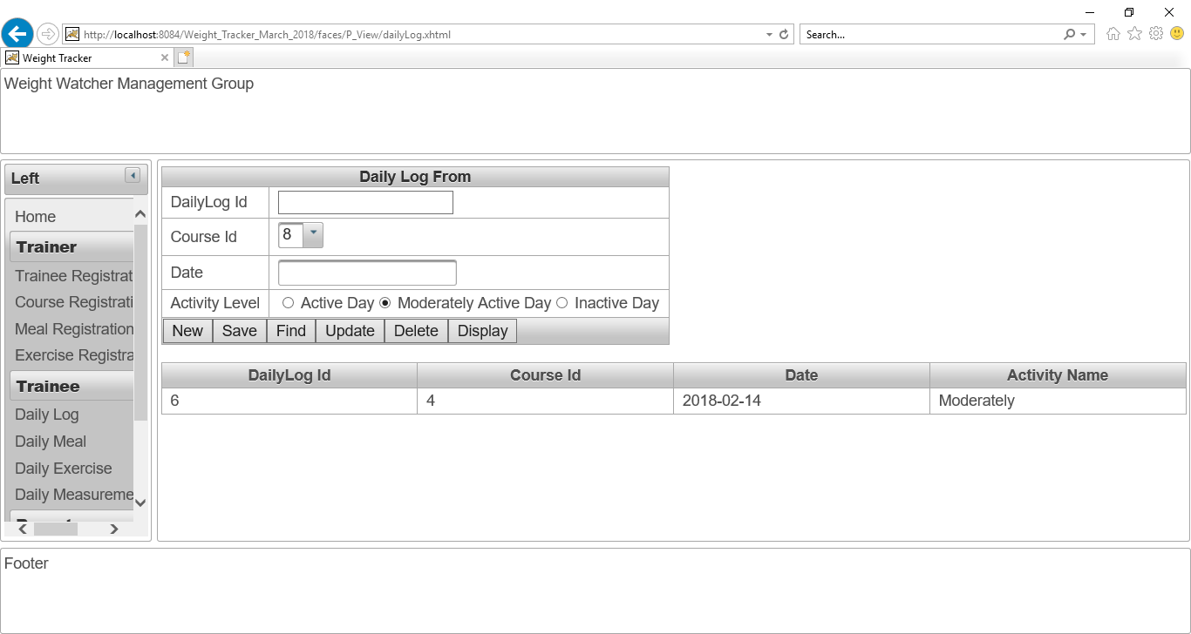

Figure No.105: Checking “Display” button of daily log page.

## Daily Meal page:

After click on “Daily Meal” button, this daily Meal page will show. The screenshot is given below:

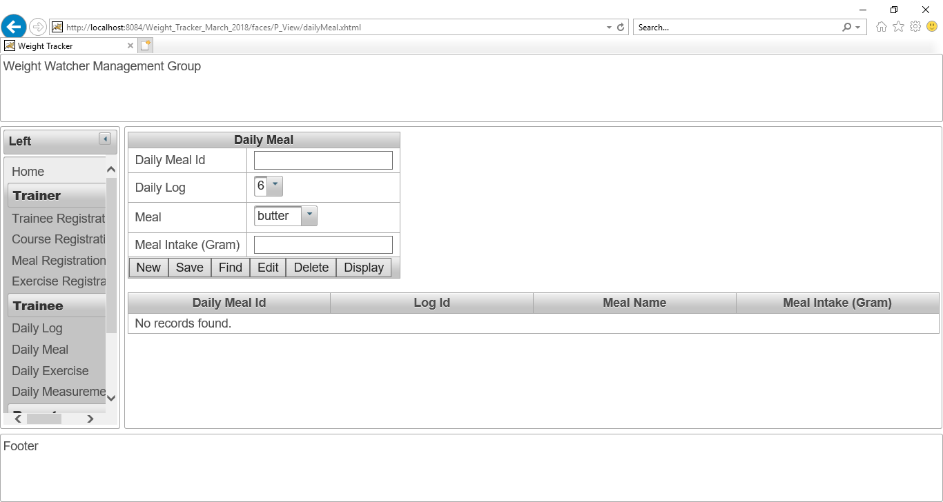

Figure No.106: The view of “Daily Meal page**”**.

**The meal list is shown in the com box perfectly. The screenshot is given below:**

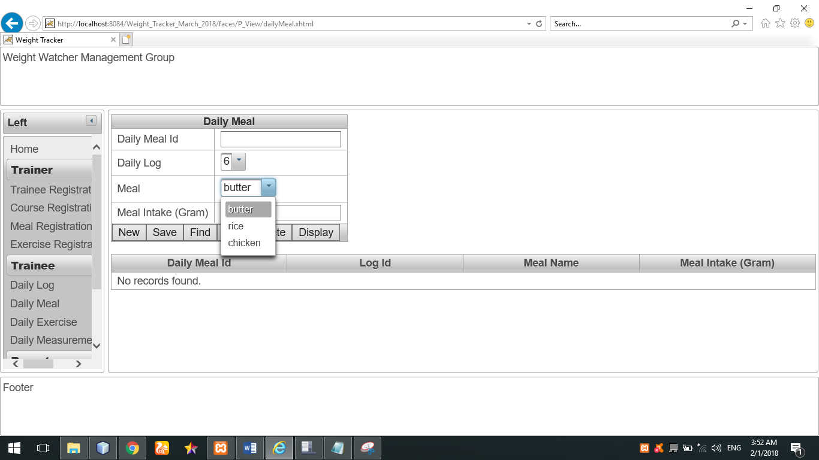

Figure No.107: The meal list is shown in the com box perfectly.

The daily log list is shown in the com box perfectly. The screenshot is given below:

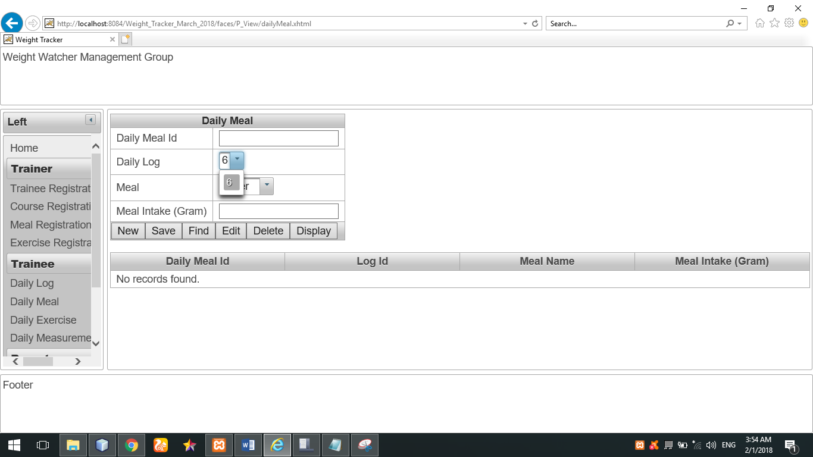

Figure No.108: The daily log list is shown in the com box perfectly.

**Checking “Save” button of “Daily Meal page”:**

These daily meal detail is given as input in order to save data.

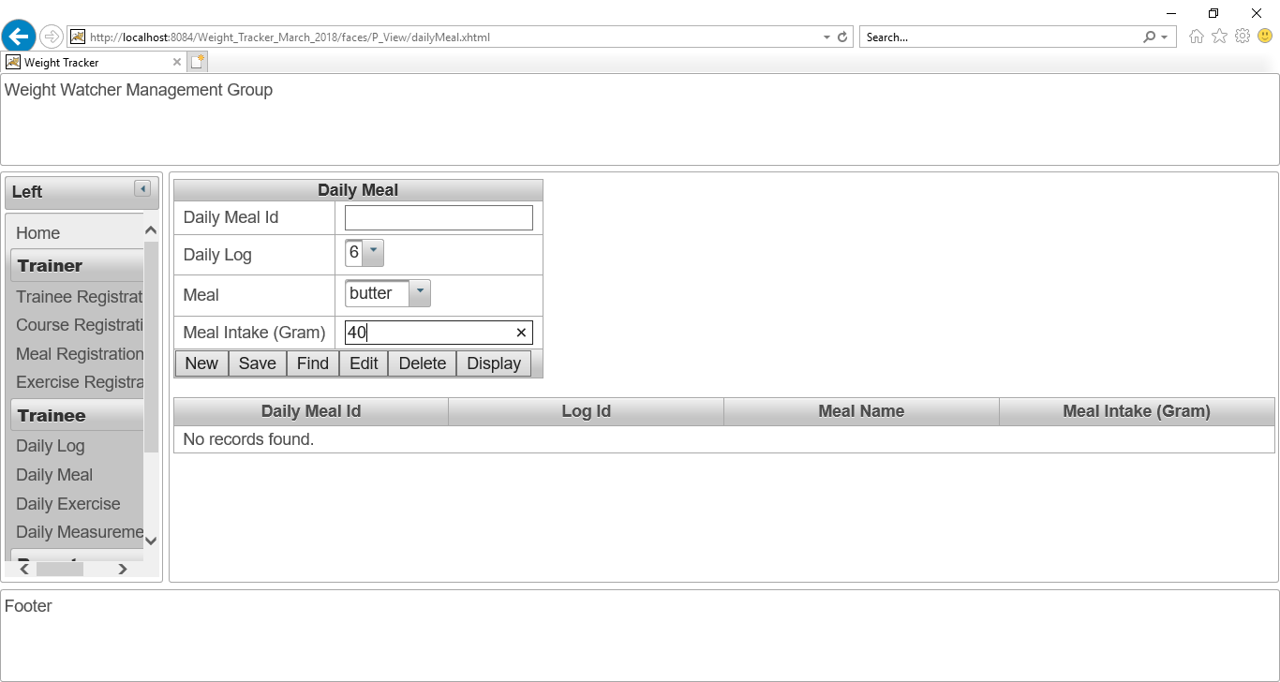

Figure No.109: Checking “Save” button of “Daily Meal page”.

After that, I have clicked on save button in order to save these above data.

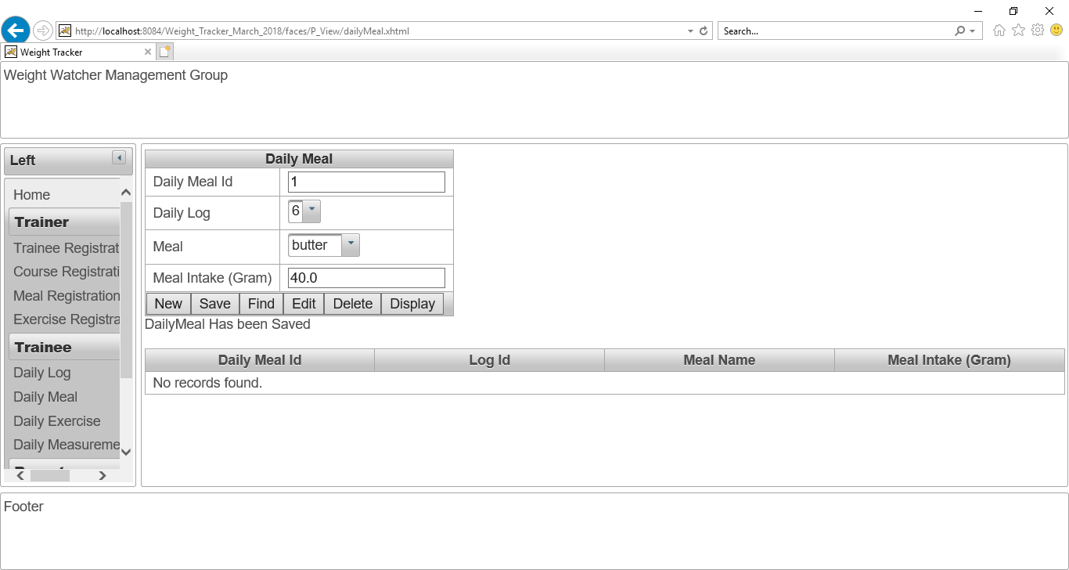

Figure No.110: Checking “Save” button of “Daily Meal page”.

The daily meal’s data has been saved. After click on “display” button, all daily meal information is shown successfully. The screenshot is given below:

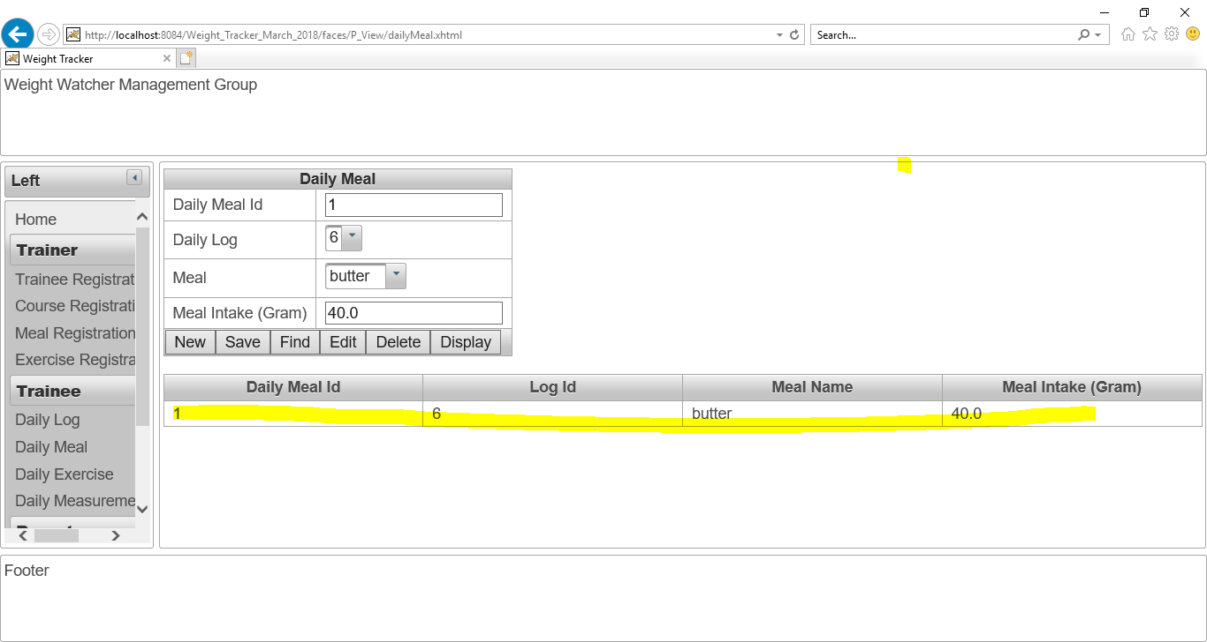

Figure No.111: Checking “Save” button of “Daily Meal page”.

Checking “Find” button’s action of “Daily meal page”:

I have written 3 as “Daily meal Id” and then click on “Find” button. The find button is working perfectly. The screenshot is given below:

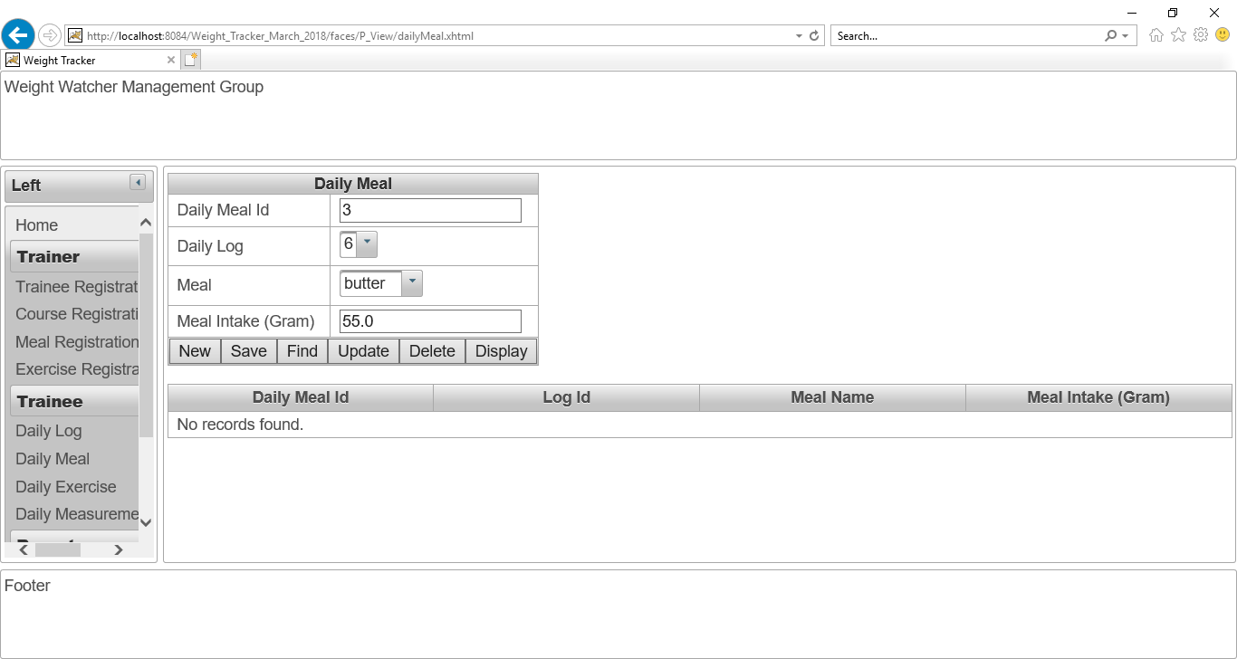

Figure No.112: Checking “Find” button of “Daily Meal page”.

Checking “Update” button of “Daily Meal page”:

I have changed the meal in take as “65g” instead of “55g” and then click on update button.

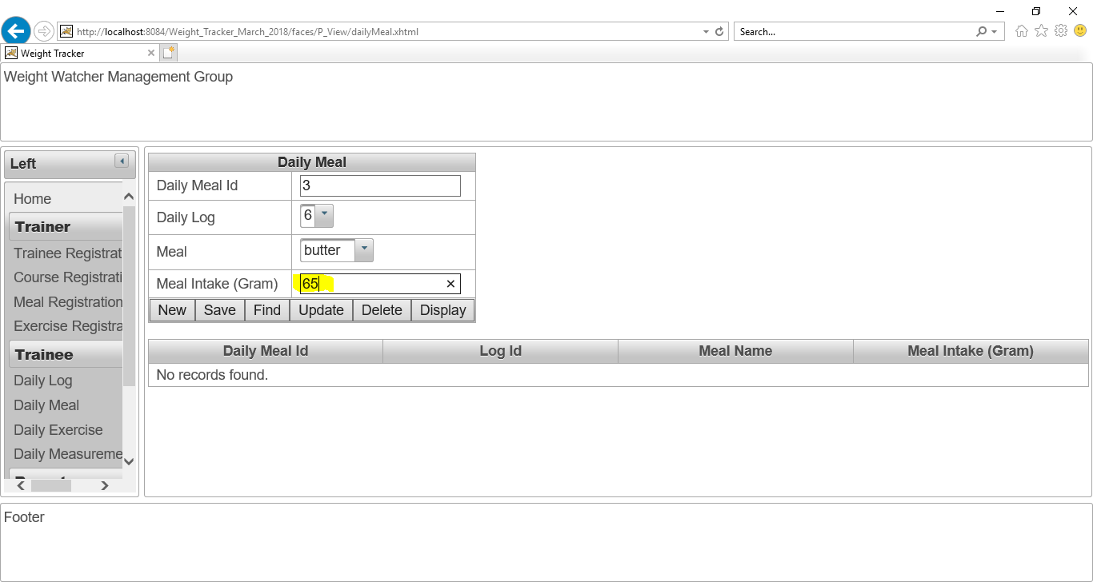

Figure No. 113: Checking “Update” button of “Daily Meal page”.

After click on “Update” button. The “Meal in take “has updated. The “Update” button is working perfectly. The screenshot is given below:

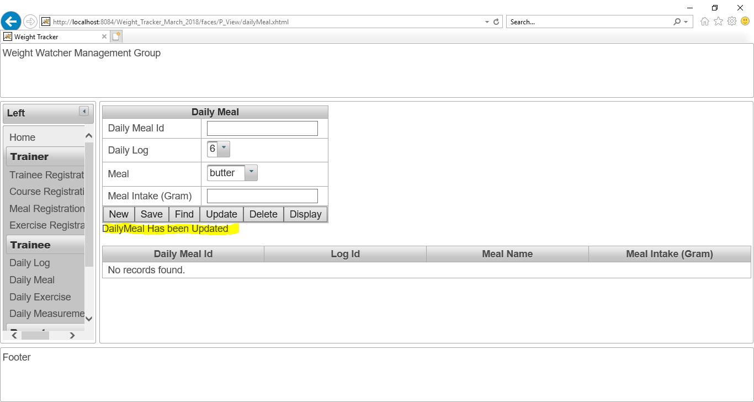

Figure No. 114: Checking “Update” button of “Daily Meal page”.

The updated detail of that “Daily meal” is given as screenshot:

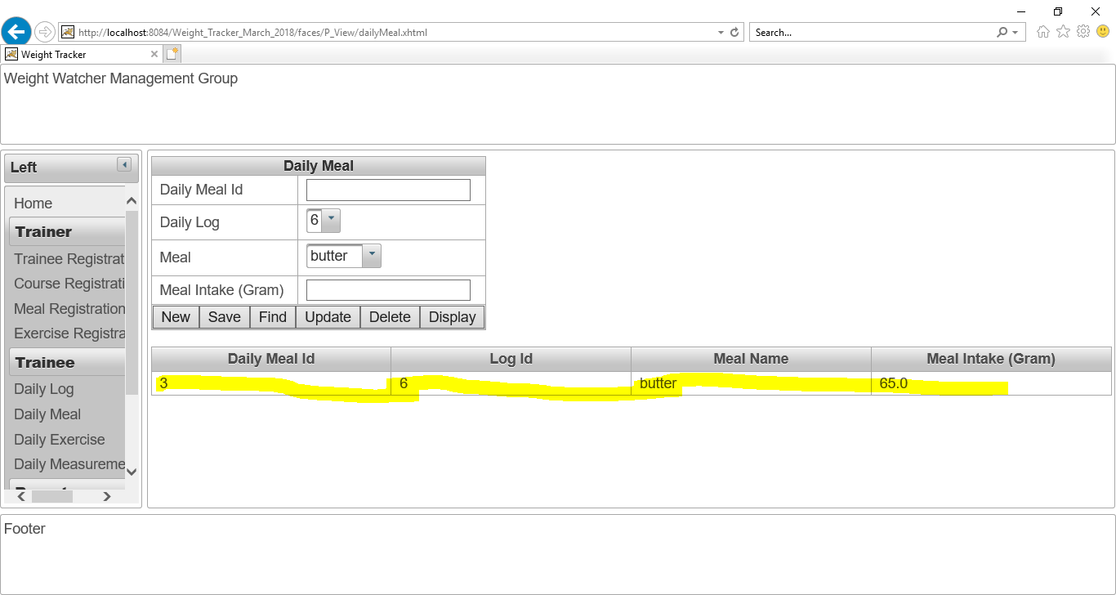

Figure No.115: Checking “Update” details of “Daily Meal”.

**Checking “New” button of “Daily Meal page”:**

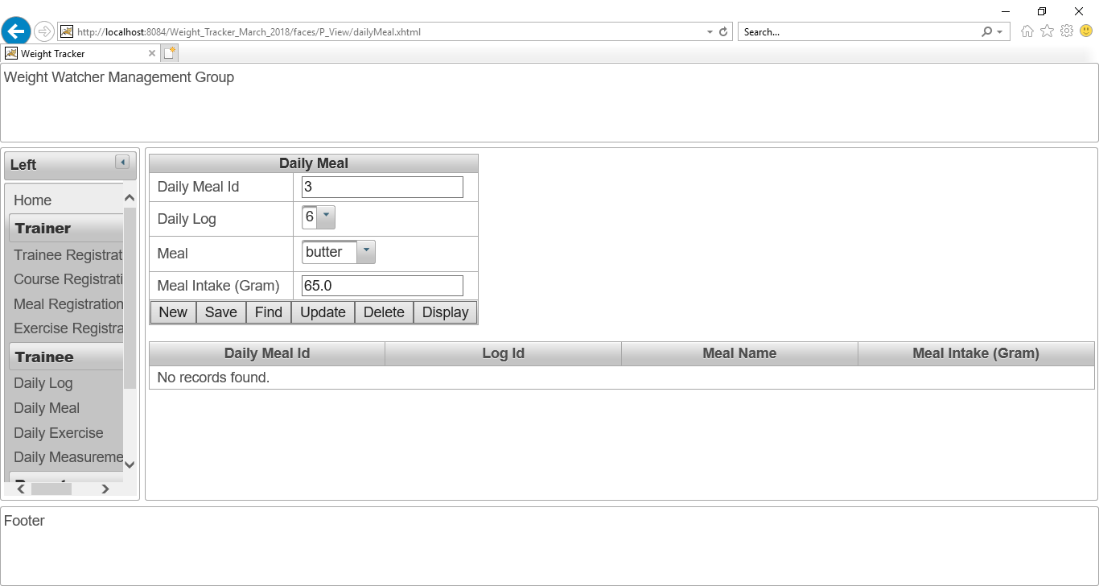

Figure No. 116: Checking “New” button of “Daily Meal page”.

After click on “New” button, all data is cleared. The screenshot is given below:

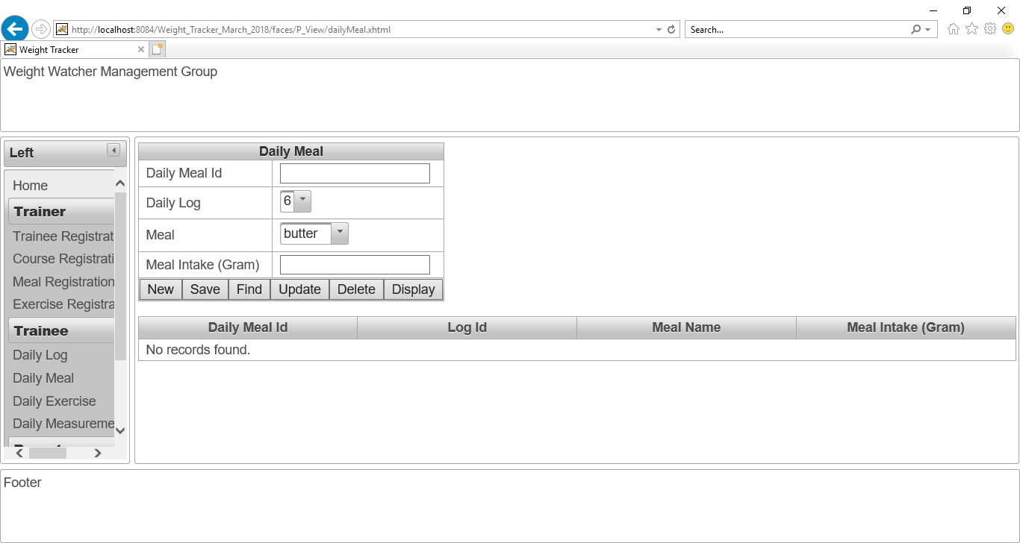

Figure No. 117: Checking “New” button of “Daily Meal page”.

**Checking “Delete” button of “Daily Meal page”:**

Now, I want to delete “Daily Meal ID” 3 from database in order to checking “Delete” action is working or not.

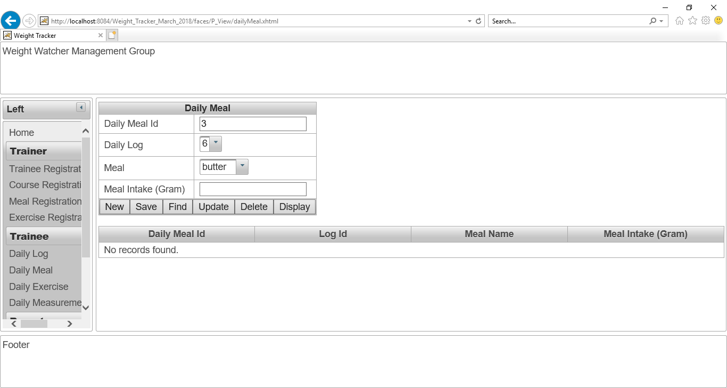

Figure No. 118: Checking “Delete” button of “Daily Meal page”.

I have written 3 as “Daily Meal ID” and clicked on “Delete” button. The delete button is working perfectly. The screenshot is given below:

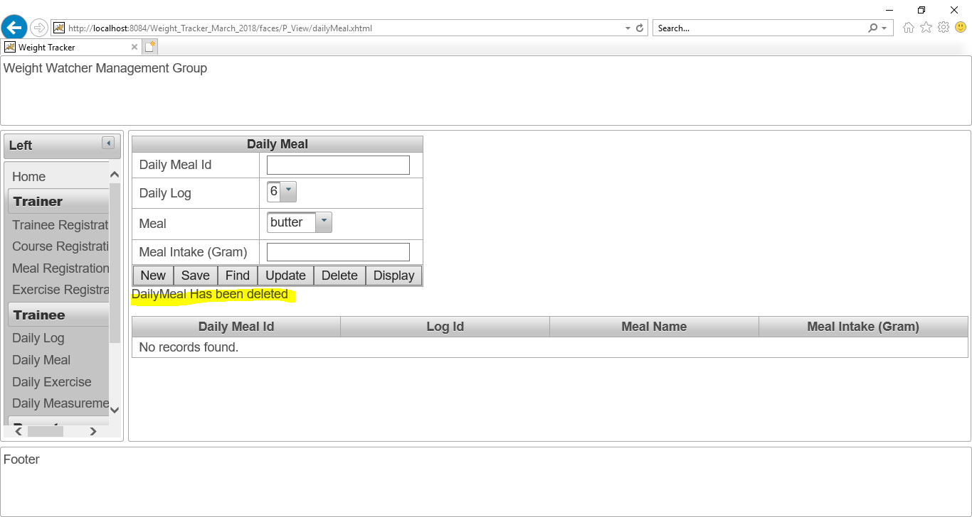

Figure No.119: Checking “Delete” button of “Daily Meal page”.

Now, all daily meal data is shown for proving this delete action. Now, there is no “Daily Meal Id” 3. The screenshot is given below:

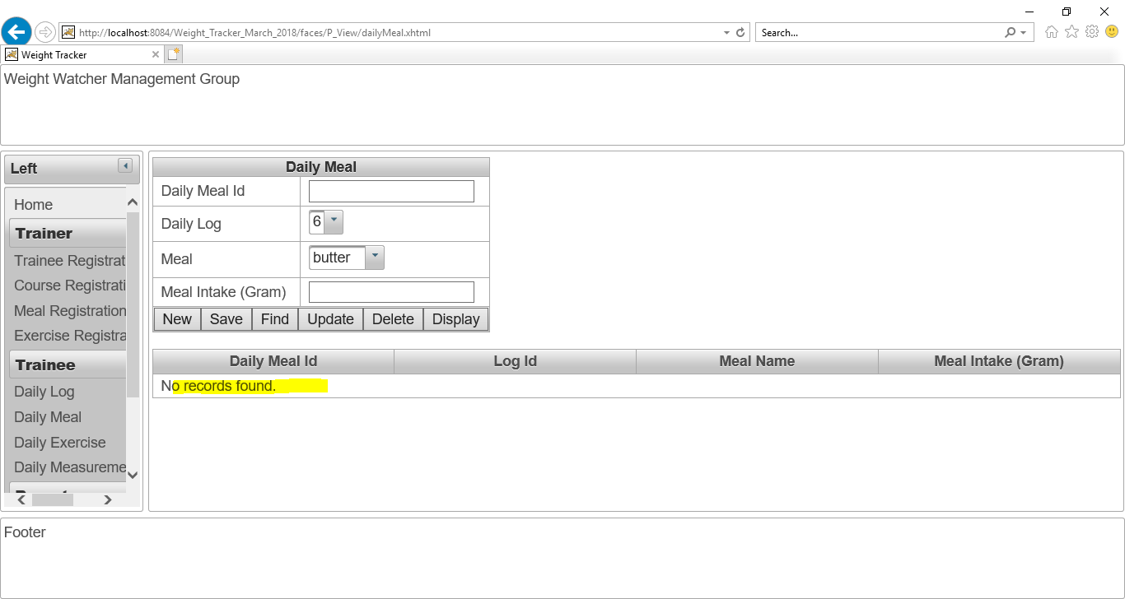

Figure No.120: Checking “Delete” button of “Daily Meal page”.

## Daily Exercise page:

After click on “Daily exercise” button. This “**Daily Exercise page”** will show. The screenshot is given below:

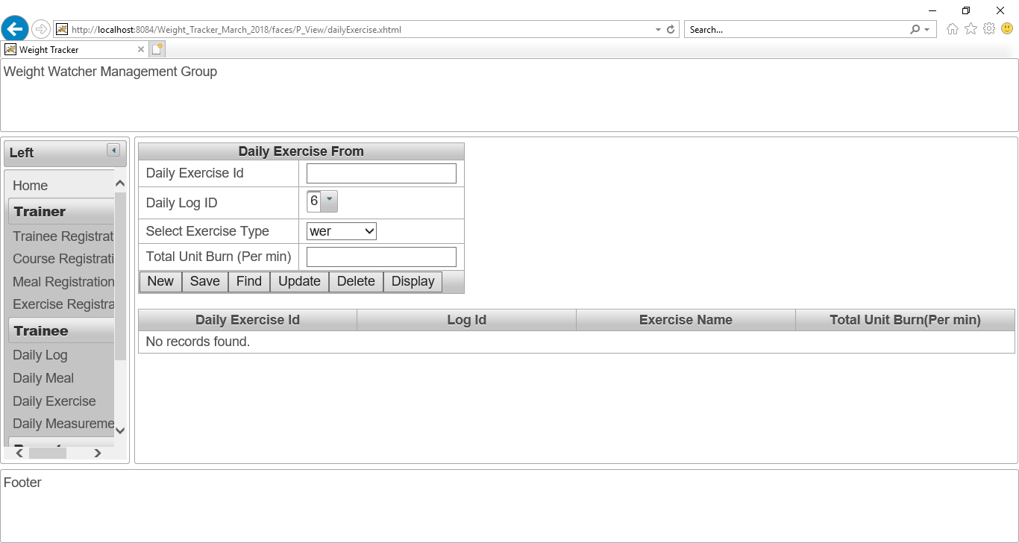

Figure No.121: The Daily Exercise page.

The combo box for selecting exercise type is working. All exercise type list is shown. The screenshot is given below:

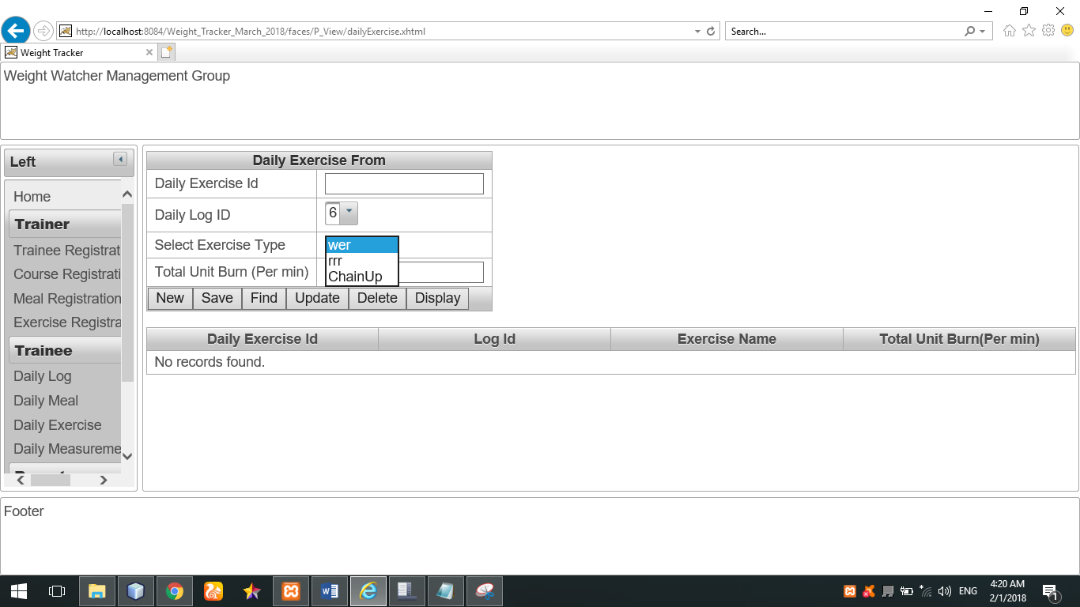

Figure No.122: The combo box for selecting exercise type is working.

The combo box for daily log Id is working perfectly. All daily log list is show in that combo box. The screenshot is given below:

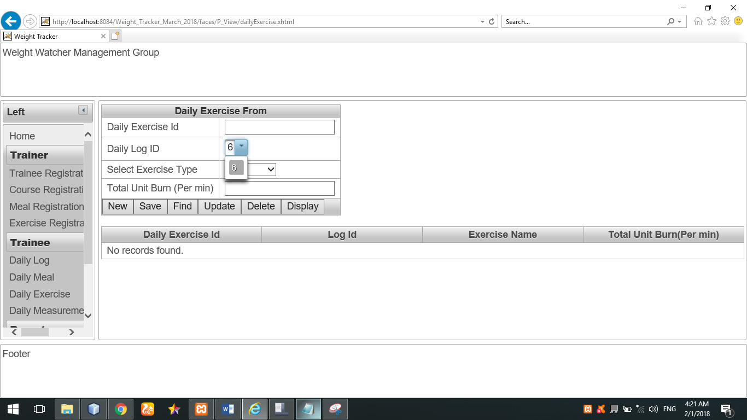

Figure No.123: The combo box for daily log Id is working perfectly.

**Checking “Save” button of “Daily Exercise page”:**

The “Daily exercise Id” and it’s all details is entered as input in order to save data.

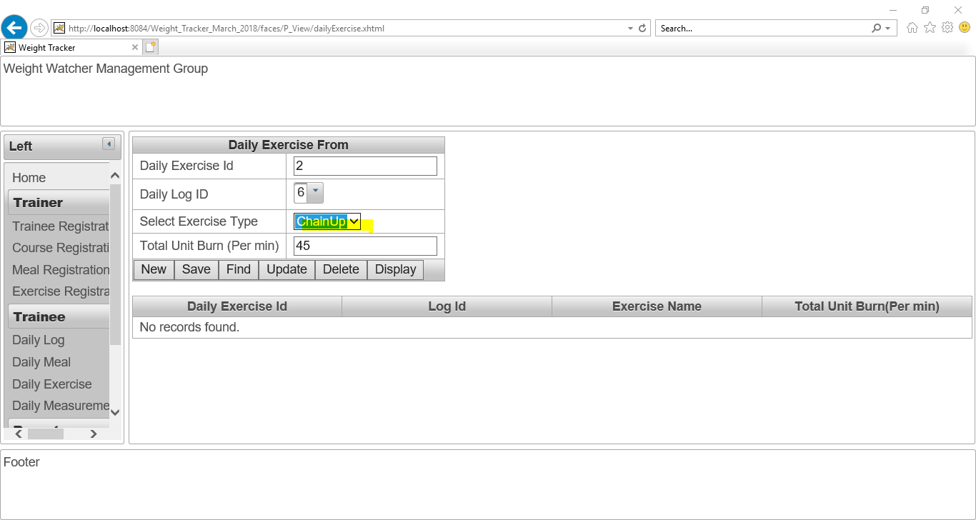

Figure No.124: Checking “Save” button of “Daily Exercise page”.

After that, I have clicked on save button in order to save these above data.

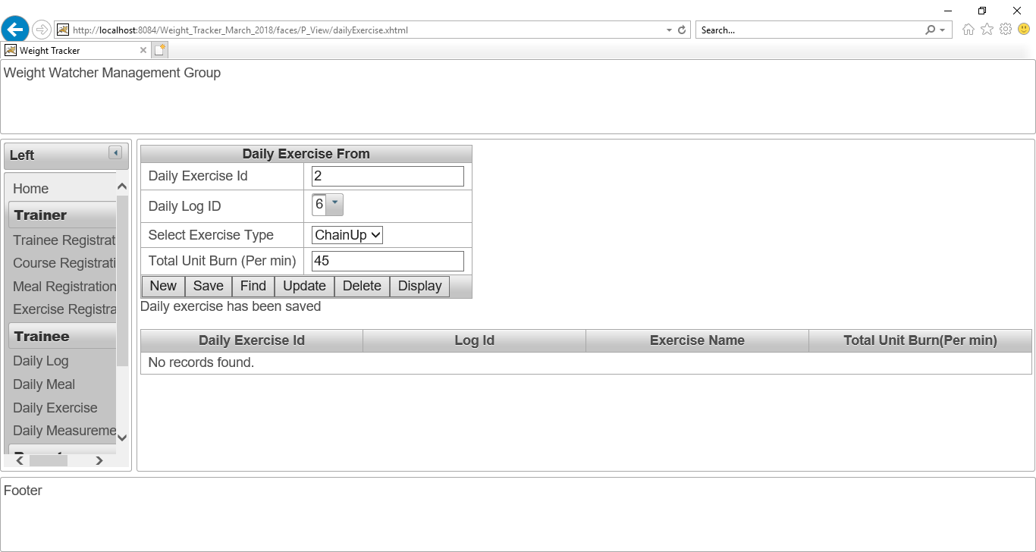

Figure No.125: Checking “Save” button of “Daily Exercise page”.

The daily exercise’s data has been saved. I have clicked on “display” button to show all daily exercise information. The screenshot is given below:

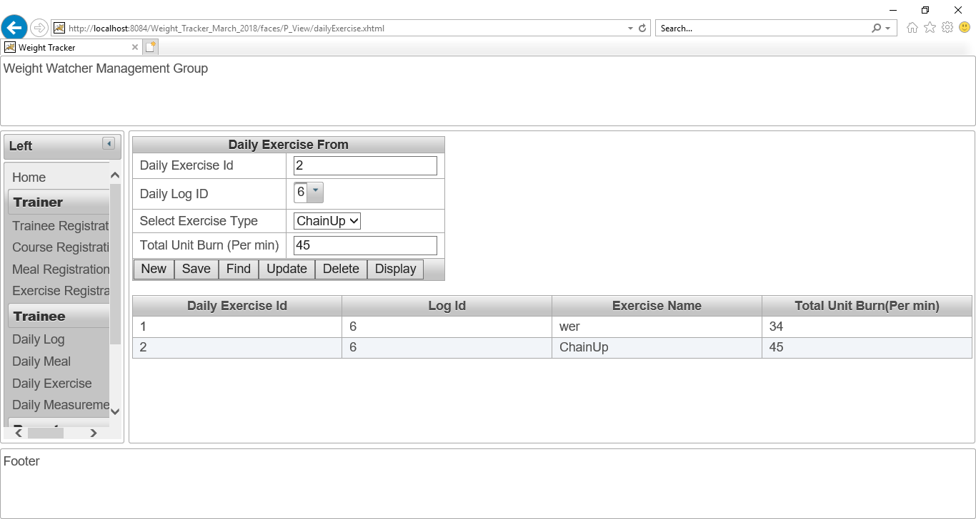

Figure No.126: Checking “Save” button of “Daily Exercise page”.

**Checking “Find” button of “Daily exercise page”:**

I have written 2 as “Daily exercise Id” and then click on “Find” button. The find button is working perfectly. The screenshot is given below:

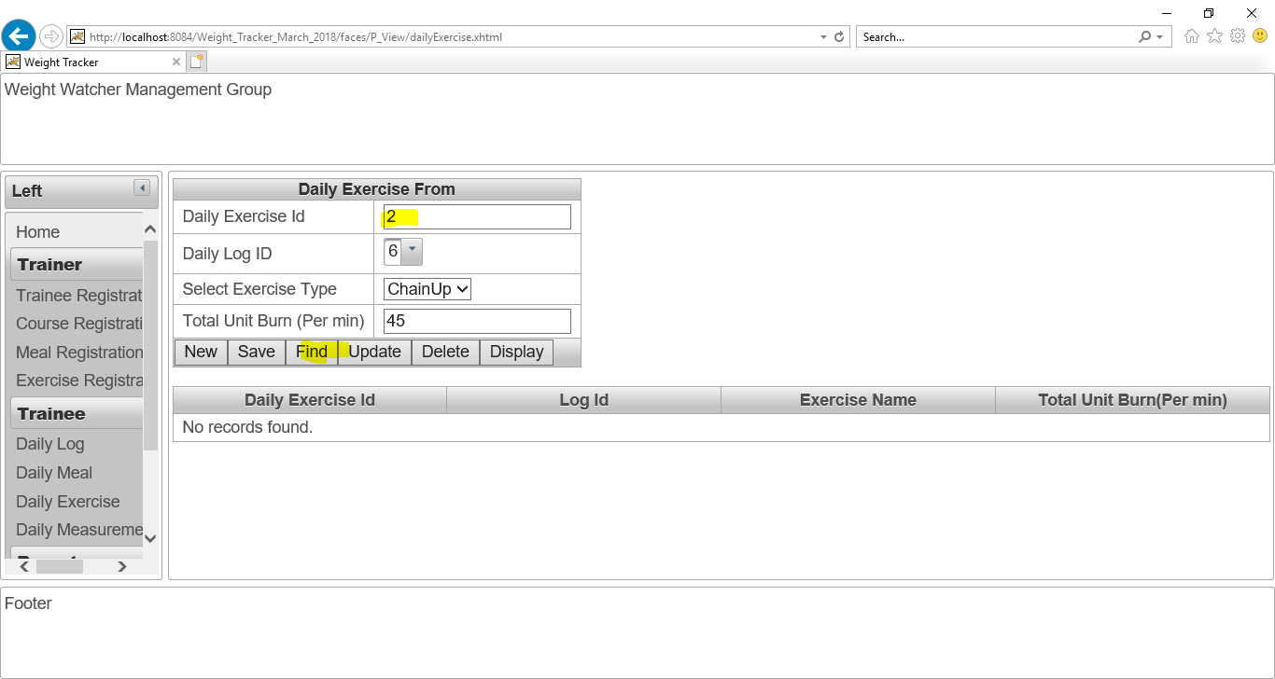

Figure No.127: Checking “Find” button of “Daily Exercise page”.

**Checking “Update” button of “Daily Exercise page”:**

I have changed the “Total unit burnt per min” as “55” instead of “45” and then click on update button.

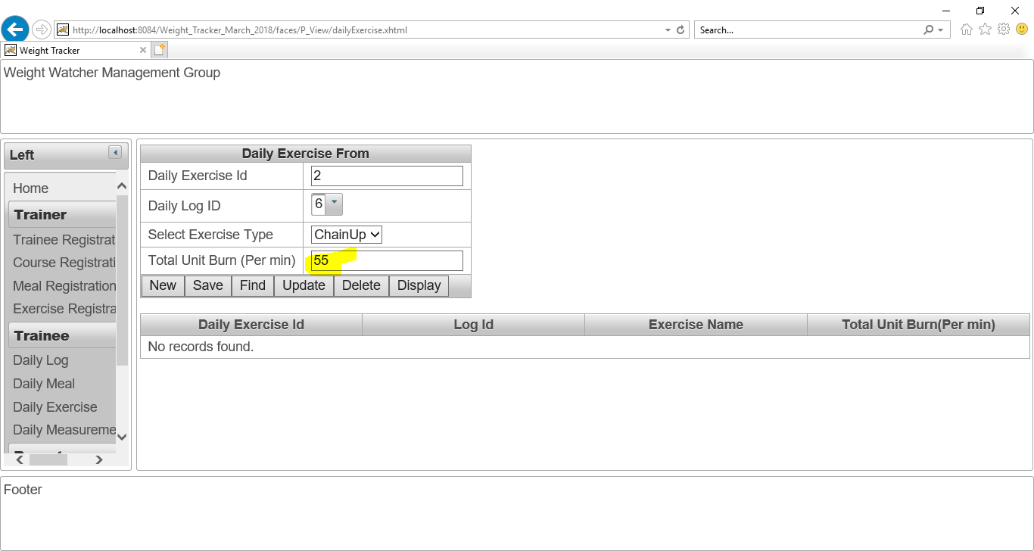

Figure No.128: Checking “Update” button of “Daily Exercise page”.

After click on “Update” button. The “Total unit burnt per min” has updated. The “Update” button is working perfectly. The screenshot is given below:

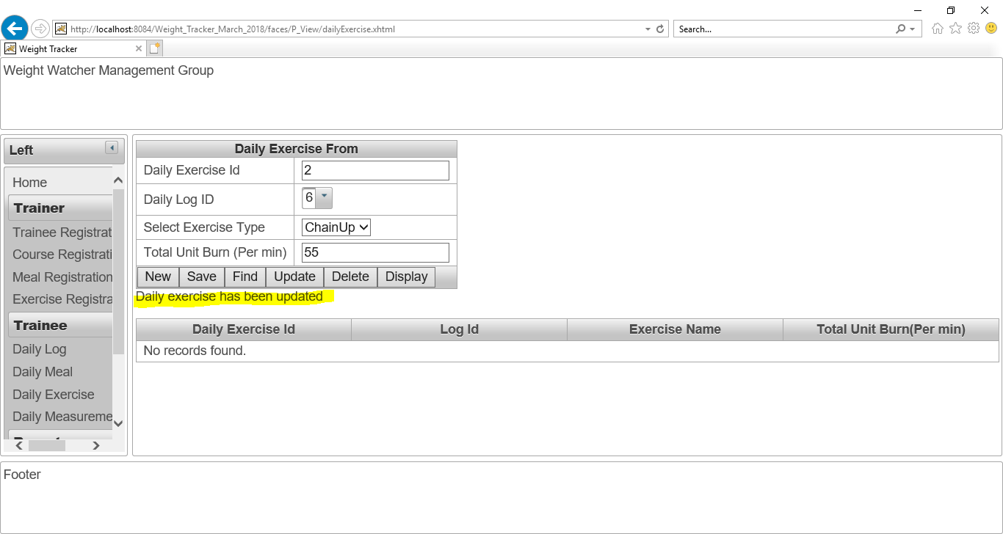

Figure No.129: Checking “Update” button of “Daily Exercise page”.

The updated detail of that daily exercise’s information is given as screenshot:

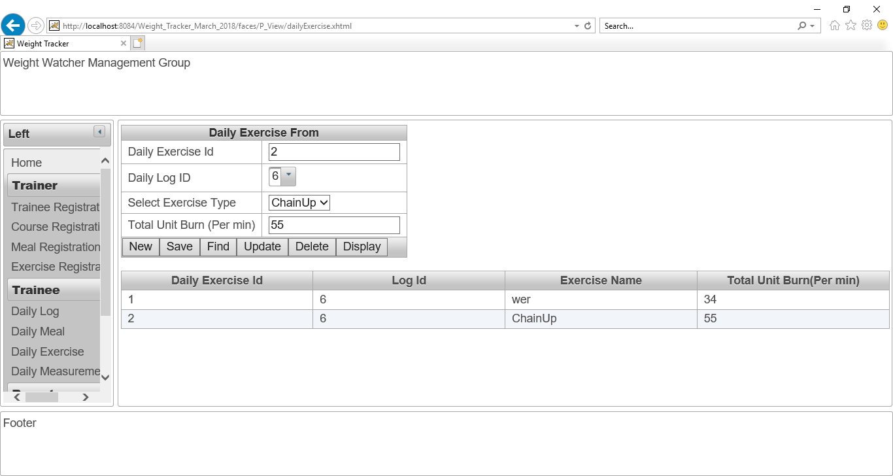

Figure No.130: Checking “Update” button of “Daily Exercise page”.

**Checking “Delete” button of “Daily Exercise page”:**

Now, I want to delete “Daily Exercise ID” 1 from database in order to checking “Delete” action is working or not.

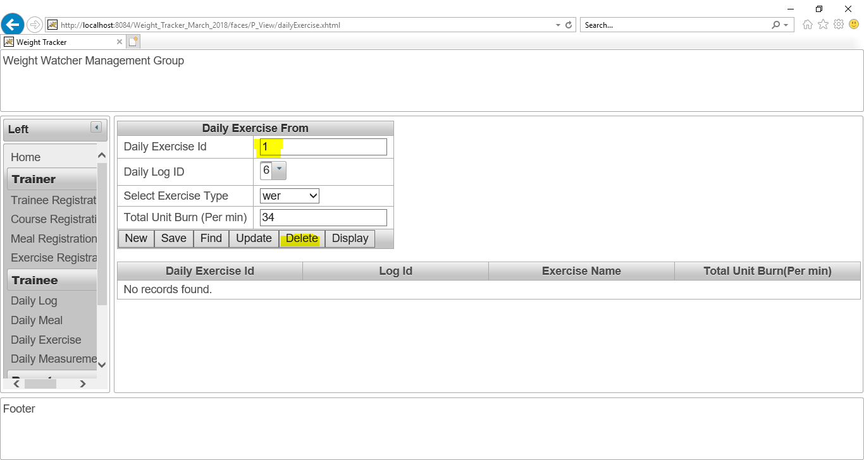

Figure No.131: Checking “Delete” button of “Daily Exercise page”.

I have written 1 as “Daily Exercise ID” and clicked on “Delete” button. The delete button is working perfectly. The screenshot is given below:

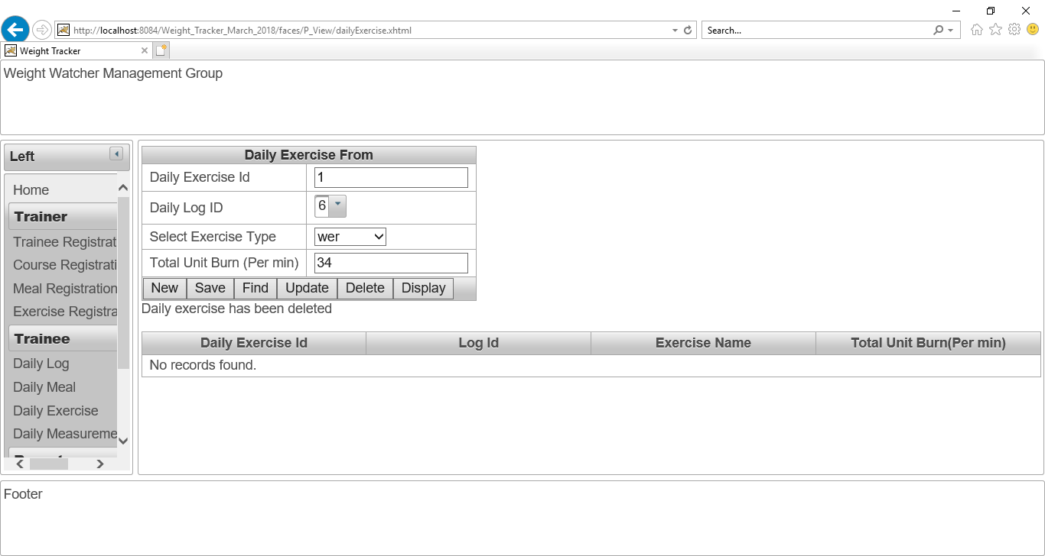

Figure No.132: Checking “Delete” button of “Daily Exercise page”.

Now, all daily exercise’s data is shown for proving this delete action. Now, there is no “Daily Exercise Id” 1. The screenshot is given below:

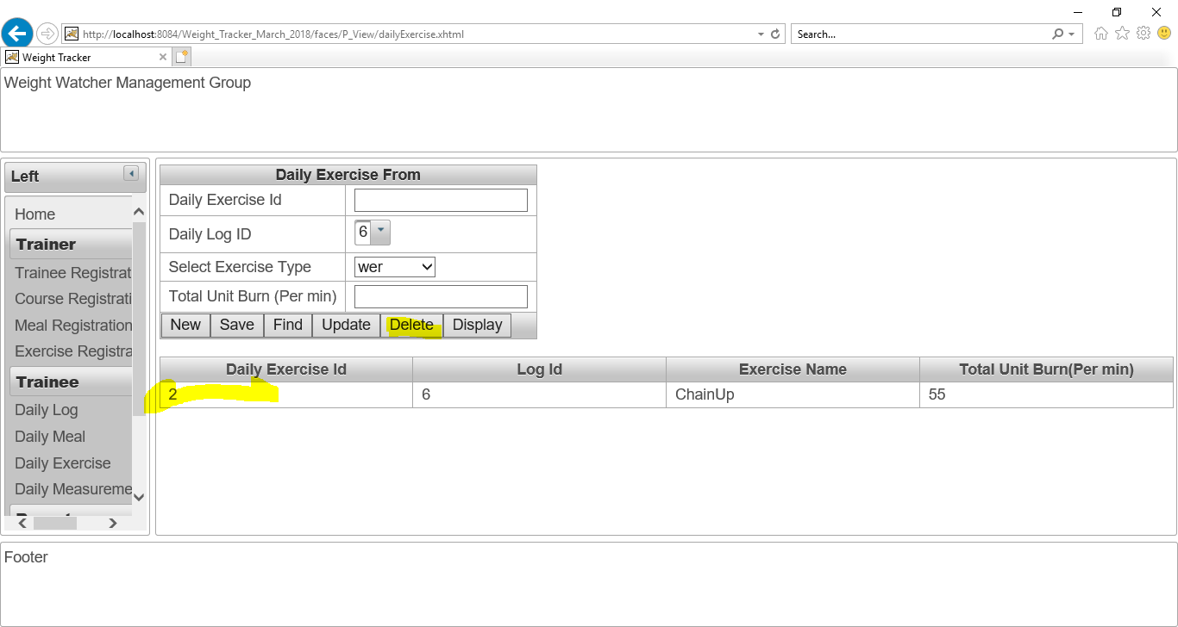

Figure No.133: Checking “Delete” button of “Daily Exercise page”.

**Checking “New” button of “Daily Exercise page”:**

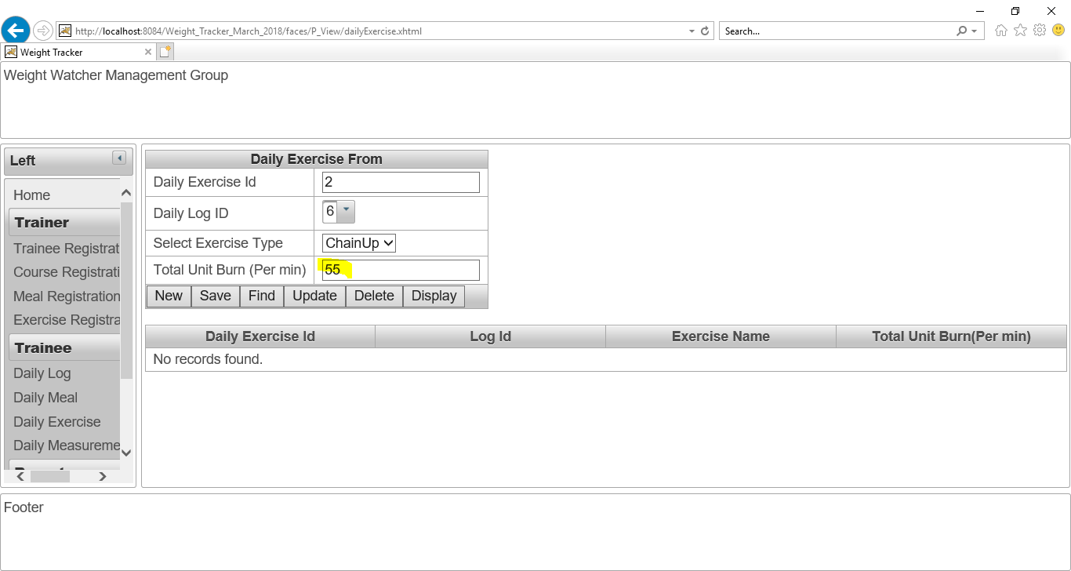

Figure No. 134: Checking “New” button of “Daily Exercise page”.

After click on “New” button, all data is cleared. The screenshot is given below:



Figure No.135: Checking “New” button of “Daily Exercise page”.

## Daily Measurement page:

After click on “**Daily Measurement**” button. This **Daily Measurement page** will show. The screenshot is given below:

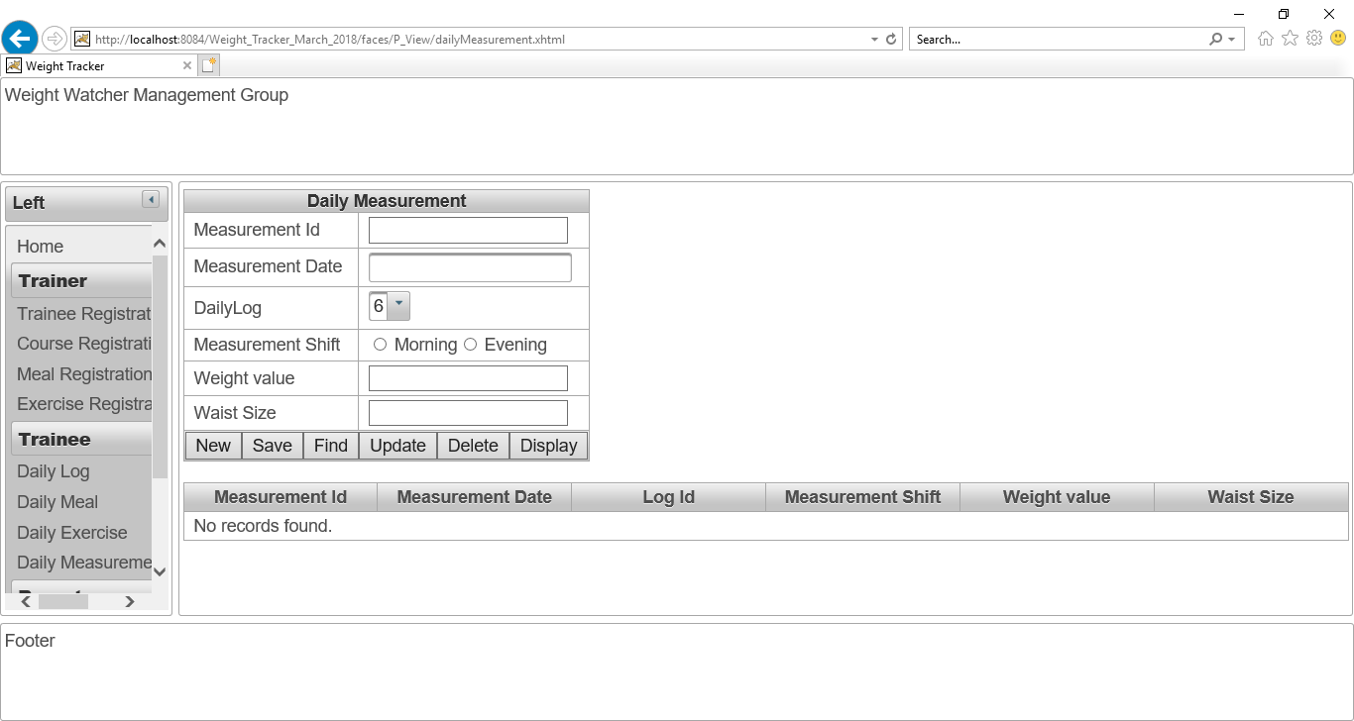

Figure No.136: The Daily Measurement page.

All the daily log id is shown successfully in the com box as a list. The screenshot is given below:

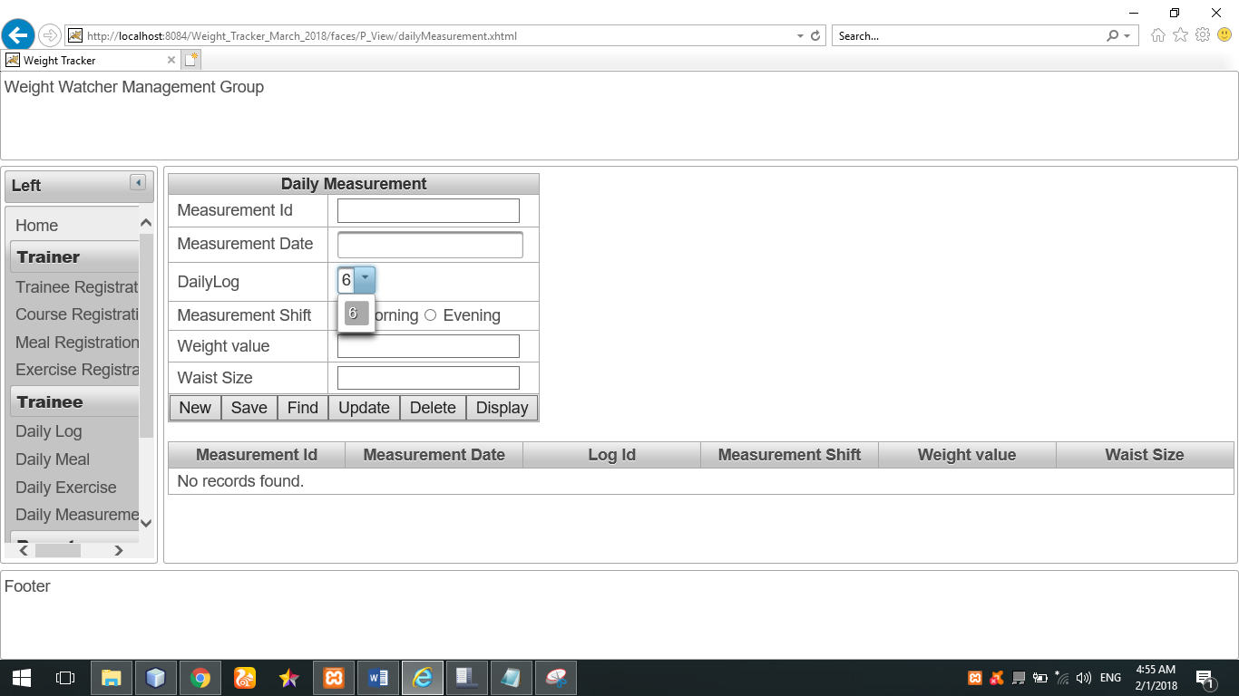

Figure No.137: All the daily log id is shown successfully in the com box as a list.

The calendar for selecting date is also working perfectly. The screenshot is given below:

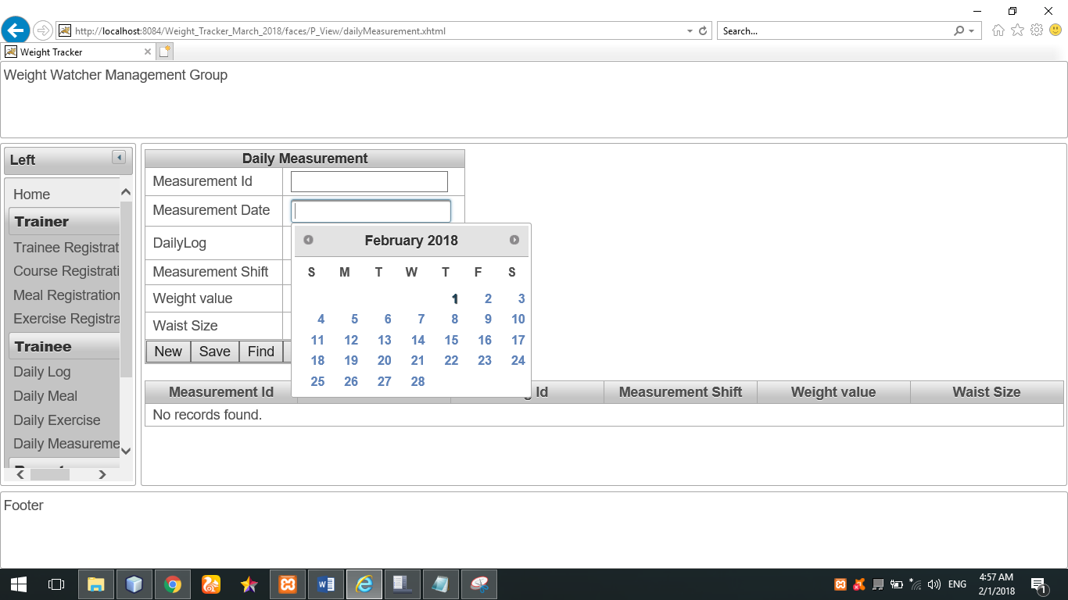

Figure No.138: The calendar for selecting date is also working perfectly.

**Checking “Save” button of “Daily Measurement page”:**

The all information of daily measurement is given as input in order to save data.

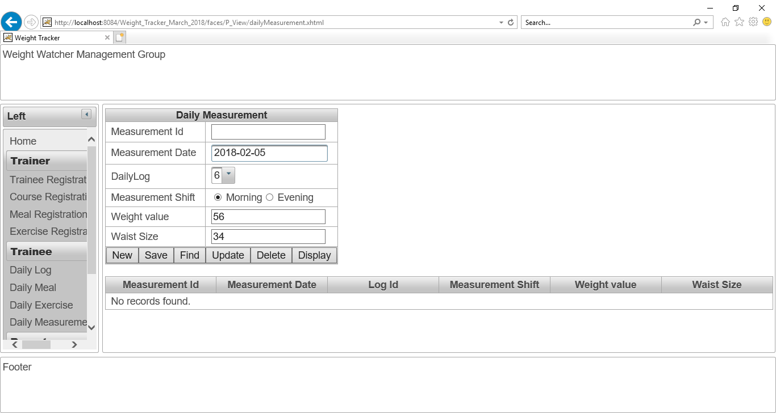

Figure No.139: Checking “Save” button of “Daily Measurement page”.

After that, I have clicked on save button in order to save these above data.

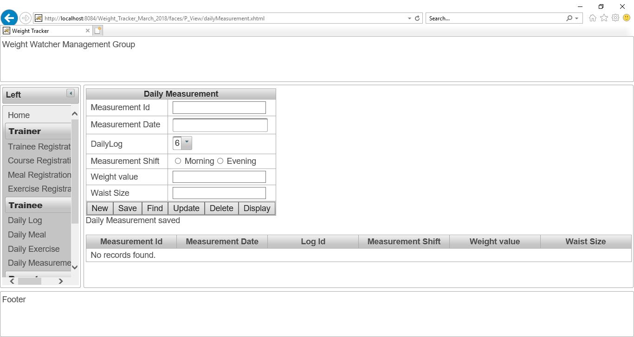

Figure No.140: Checking “Save” button of “Daily Measurement page”.

The daily measurement’s data has been saved. After that, I have clicked on “Display” button for displaying all daily measurement data. The button “Display” is also working perfectly. The screenshot is given below:

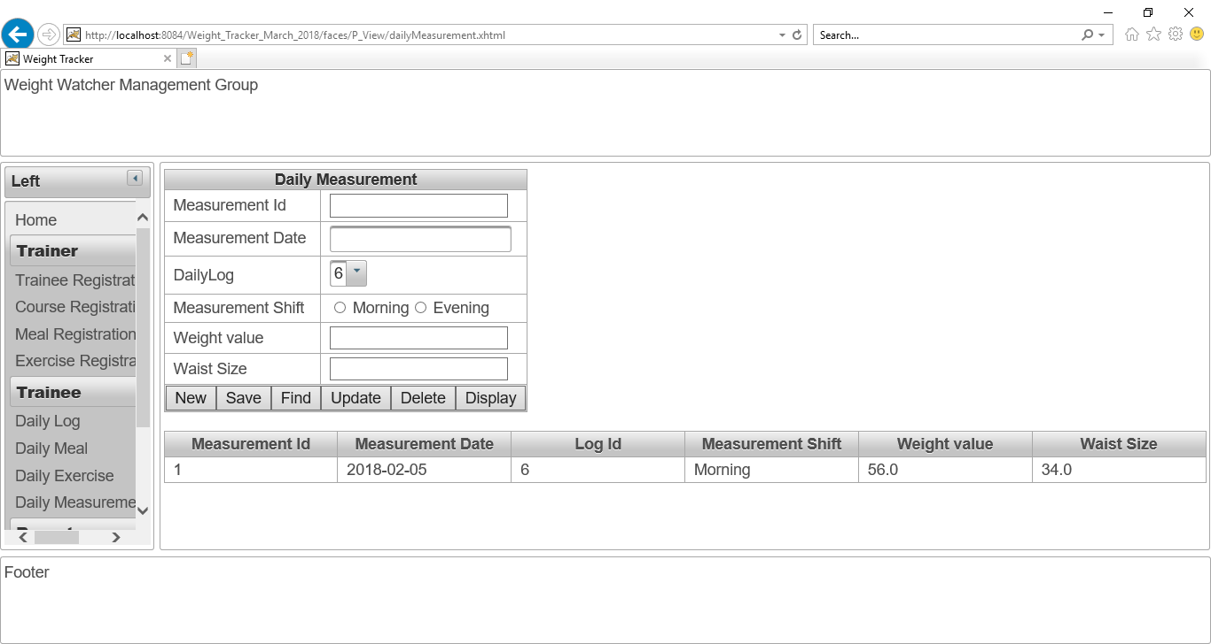

Figure No.141: Checking “Display” button of “Daily Measurement page”.

**Checking “Find” button of “Daily Measurement page”.**

I have written 1 as “daily measurement Id” and then click on “Find” button. The find button is working perfectly. The screenshot is given below:

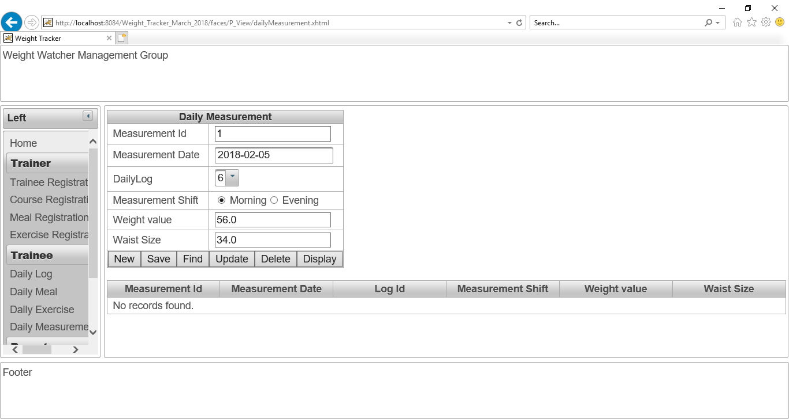

Figure No.142: Checking “Find” button of “Daily Measurement page”.

**Checking “Update” button of “Daily Measurement page”:**

I have changed the “weight value” as “60” instead of “56” and then click on update button.

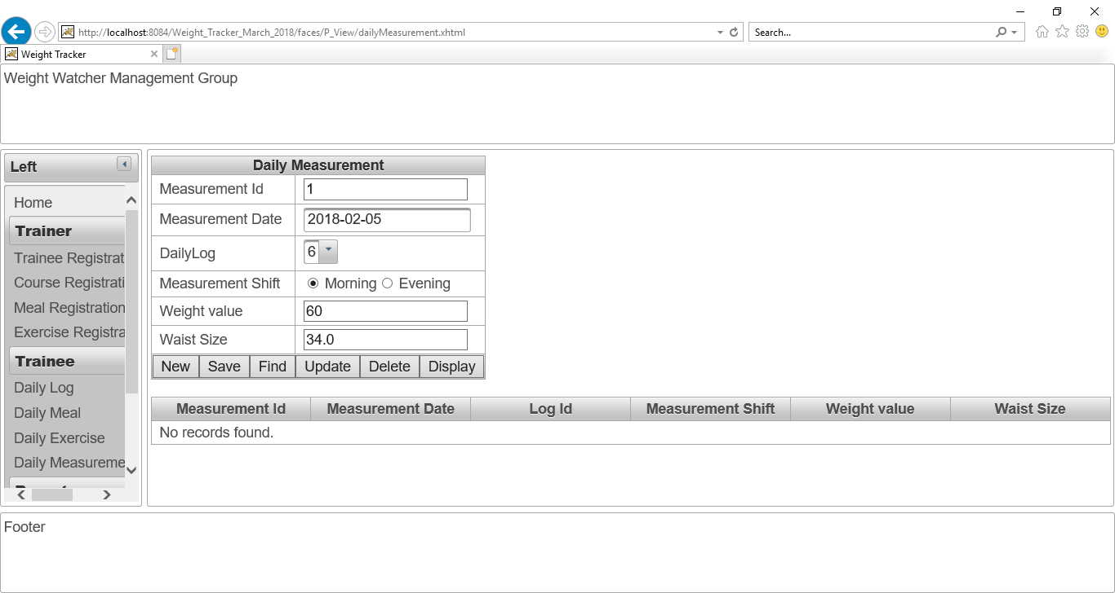

Figure No.143: Checking “Update” button of “Daily Measurement page”.

After click on “Update” button. The “weight value” has updated. The “Update” button is working perfectly. The screenshot is given below:

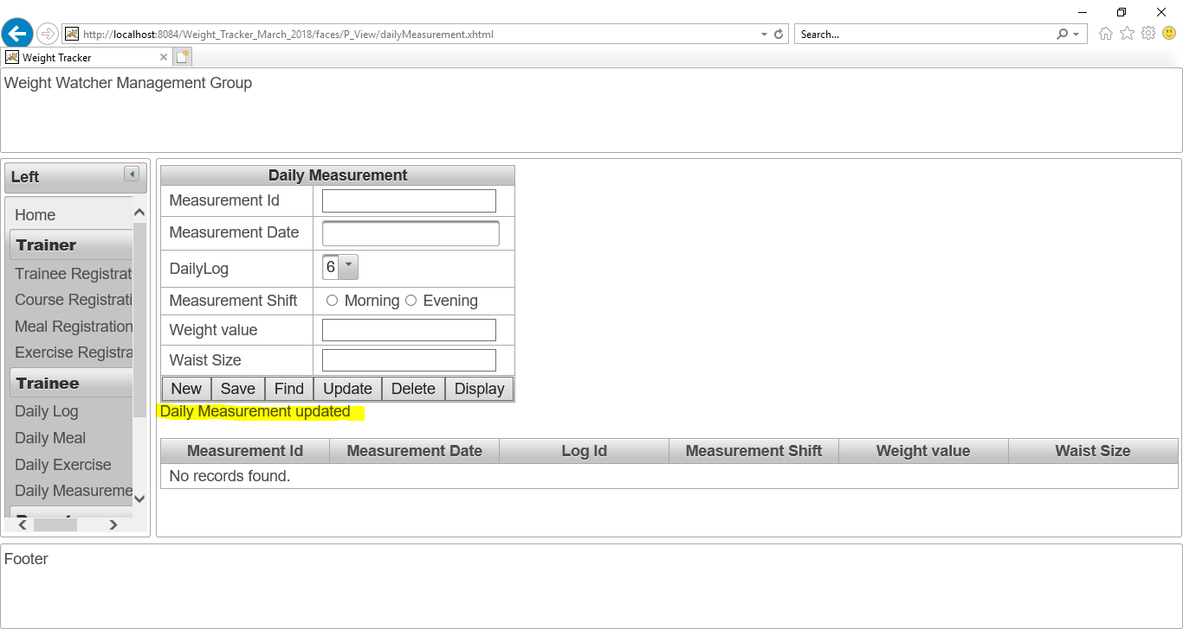

Figure No.144: Checking “Update” button of “Daily Measurement page”.

**The updated detail of that daily measurement information is given as screenshot:**

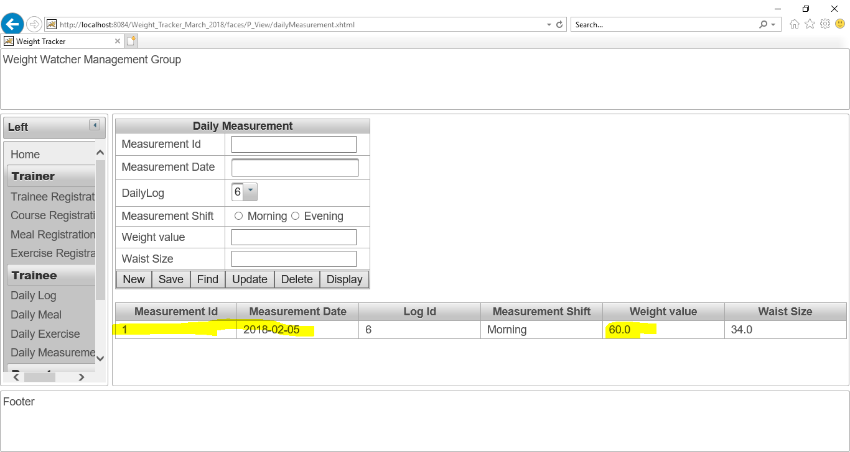

Figure No.145: Checking “Update” button of “Daily Measurement page”.

**Checking “New” button of “Daily Measurement page”:**

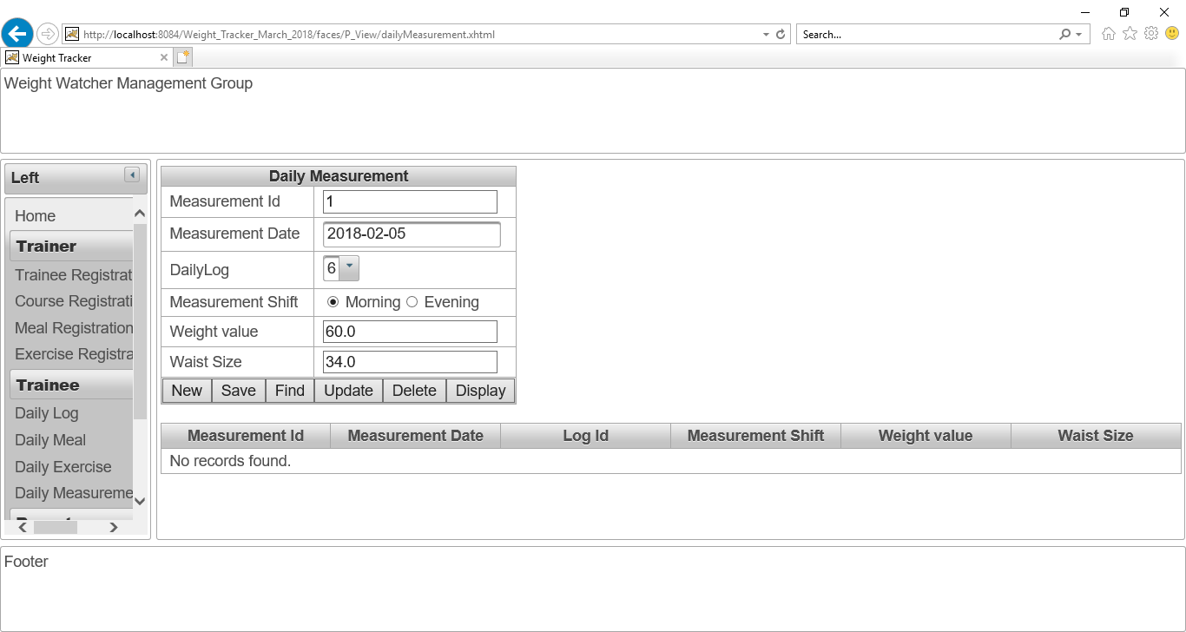

Figure No.146: Checking “New” button of “Daily Measurement page”.

After click on “New” button, all data is cleared. The screenshot is given below:

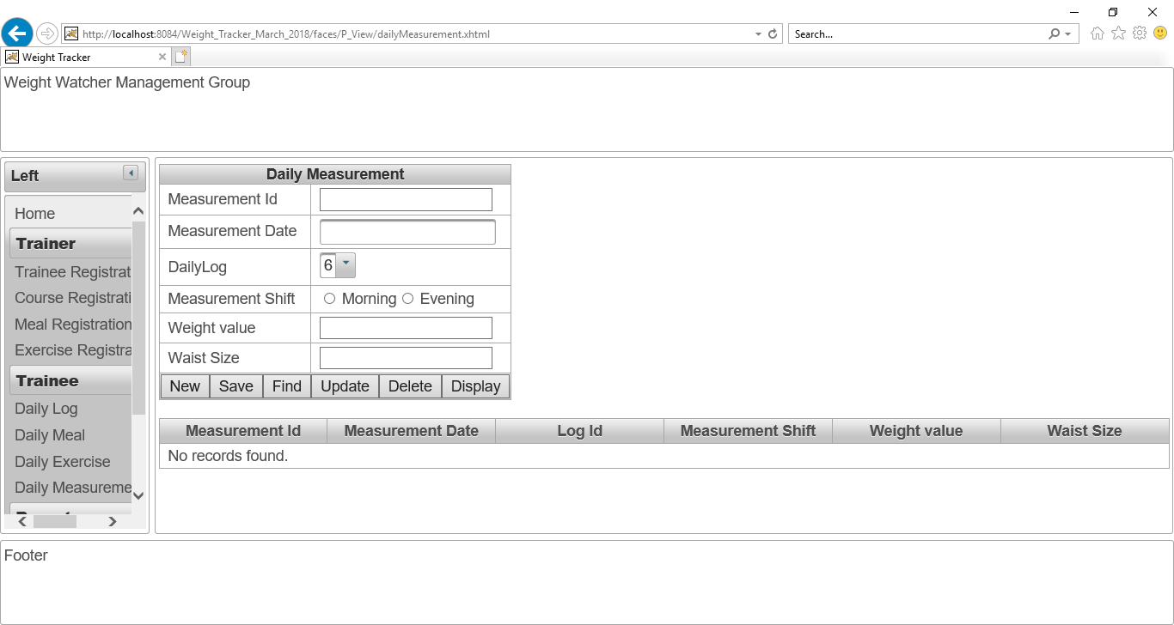

Figure No.147: Checking “New” button of “Daily Measurement page”.

**Checking “Delete” button of “Daily Measurement page”:**

Now, I want to delete “Daily Measurement ID” 1 from database in order to checking “Delete” action is working or not.

I have written 1 as “Daily Measurement ID” and clicked on “Delete” button. The delete button is working perfectly. The screenshot is given below:

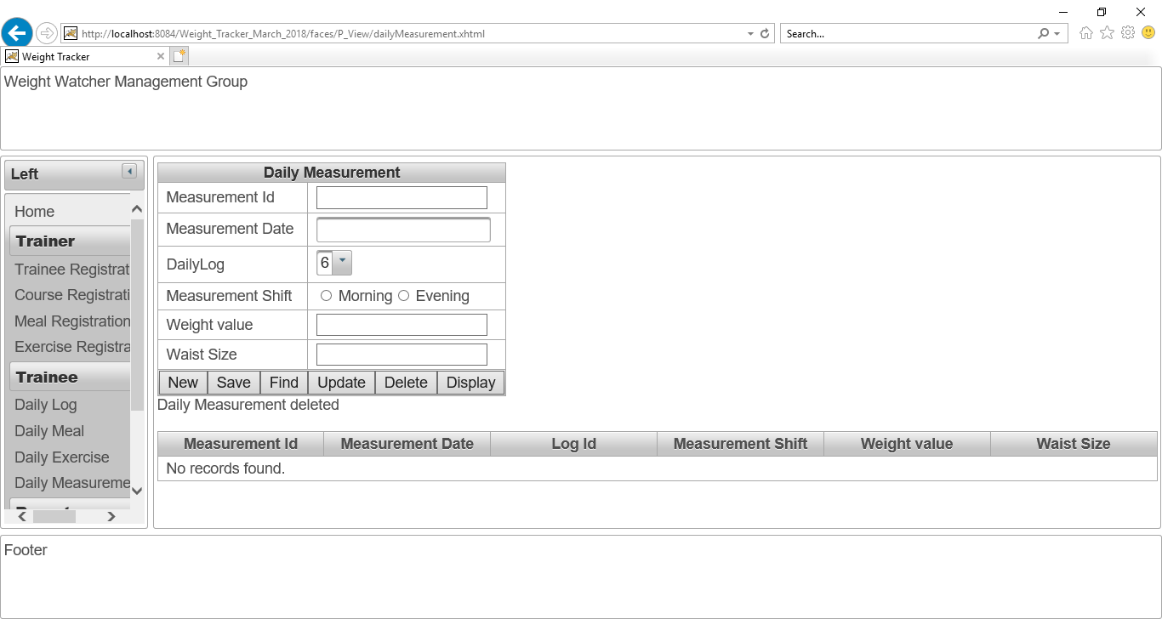

Figure No.148: Checking “Delete” button of “Daily Measurement page”.

Now, all daily Measurement data is shown for proving this delete action. Now, there is no “Daily Measurement id” 1. The screenshot is given below:

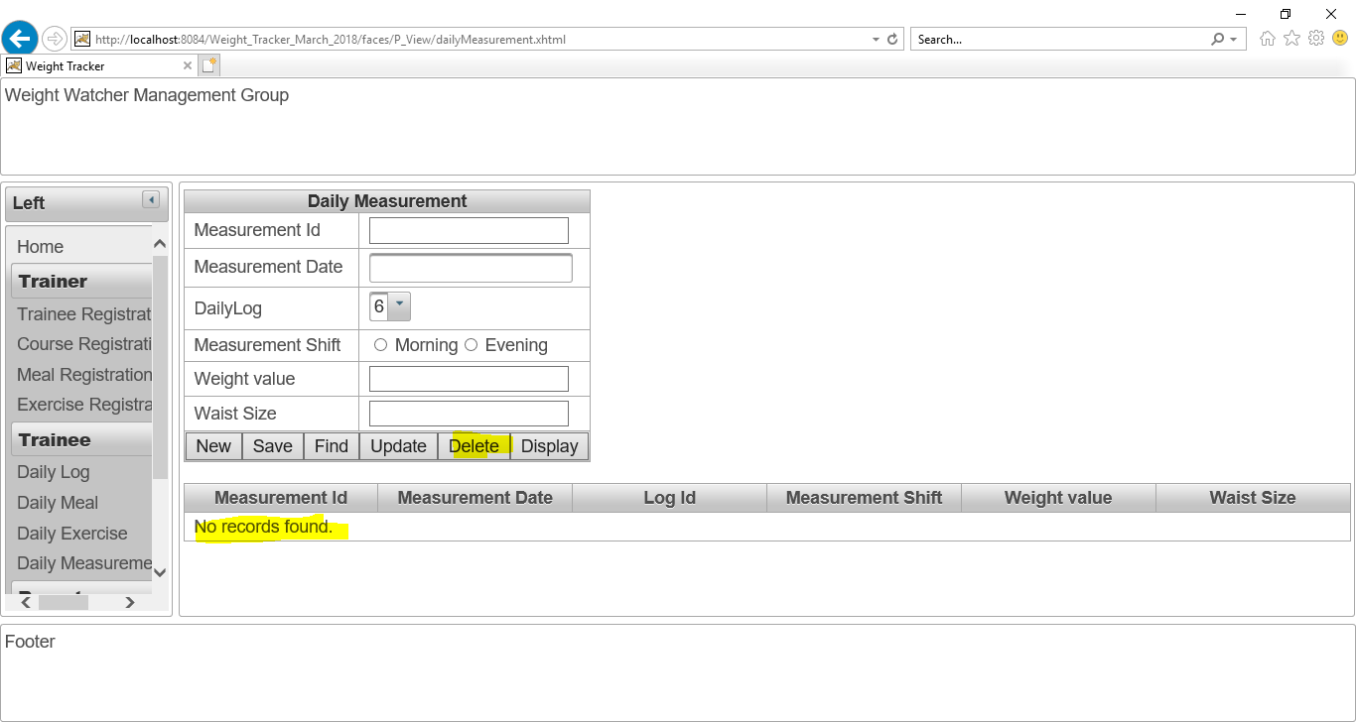

Figure No.149: Checking “Delete” button of “Daily Measurement page”.

## Daily Report page:

After click on “Daily report” button, this daily report page will show to the user. The screenshot is given below:

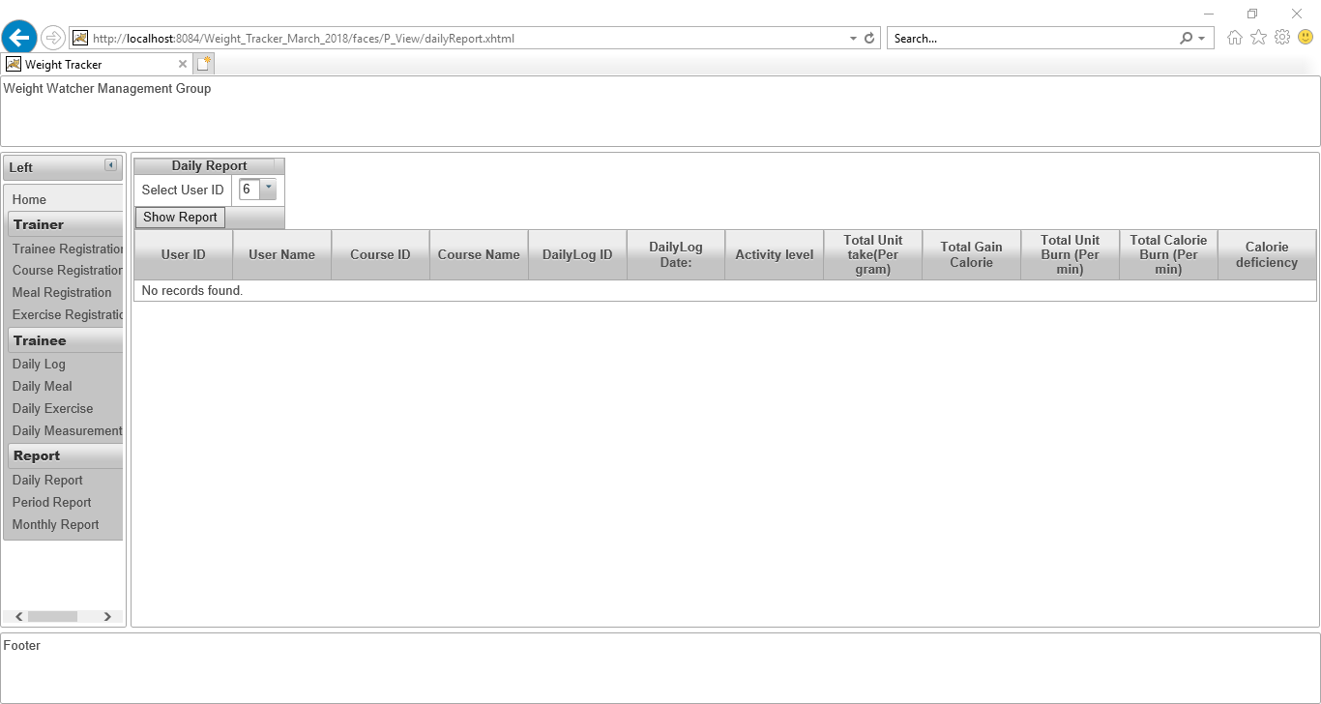

Figure No.150: The “Daily Report Page”.

In order to generate a report, I have select one user Id 18 from user combo box and then click on “show report” button. The result also shown about the **“Total Calorie Gain”** and **“Total Calorie Burn”** and also shown the **“Calorie Deficiency”.**

The result is shown as a screenshot below:

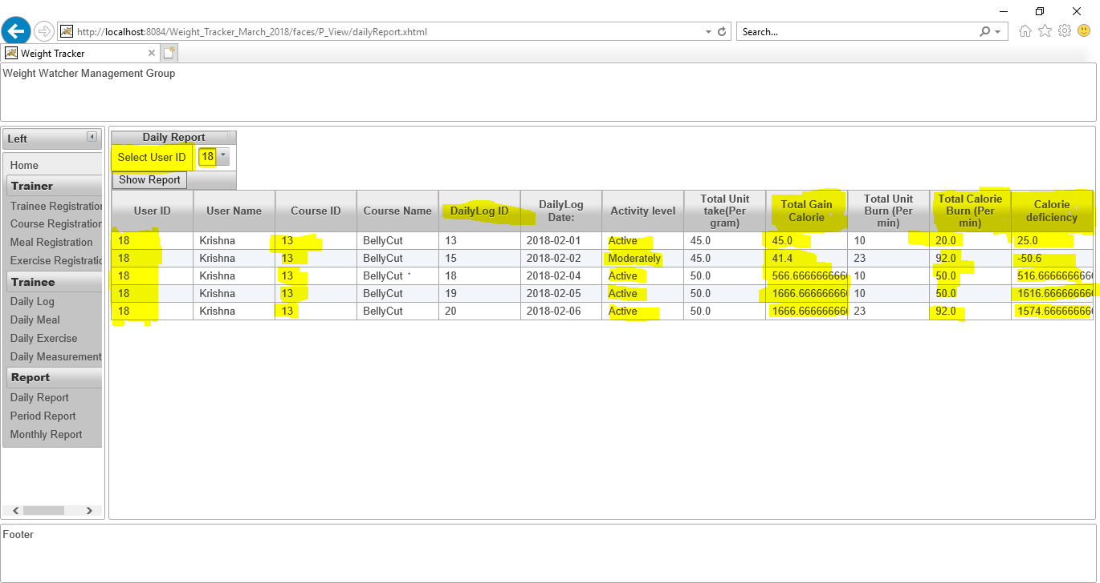

Figure No.151: The “Show report” button is working in “Daily Report Page”.

## Periodic Report page:

After click on “**Periodic Report”** button, this “**Periodic Report page**” will show to the user. The Line chart of the report will generate in this page. The screenshot is given below:

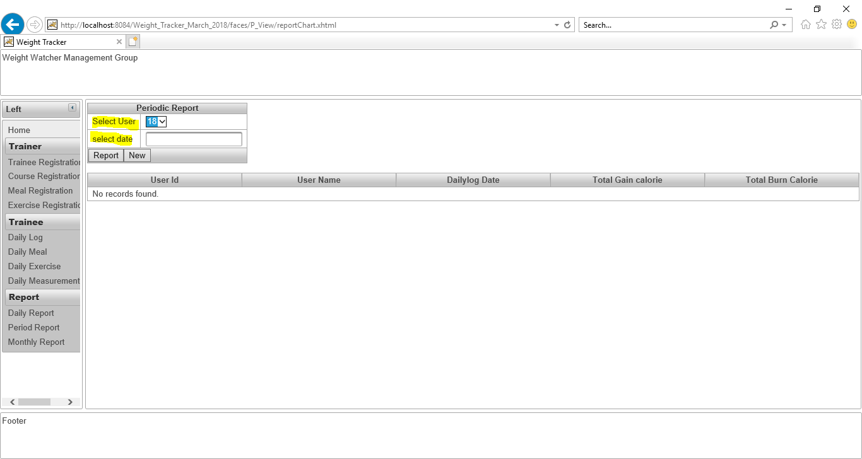

Figure No.152: The “Daily report page” is working perfectly.

In order to generate a **periodic report** **and the line chart**, I have select one user Id 18 from user combo box and then click on **“Report”** button. The result also shown about the **“Total Calorie Gain”**, **“Total Calorie Burn”** and also shown the **“Calorie Deficiency”** of per day **and also generate a “line chart” for this report.**

The result is shown as a screenshot below:

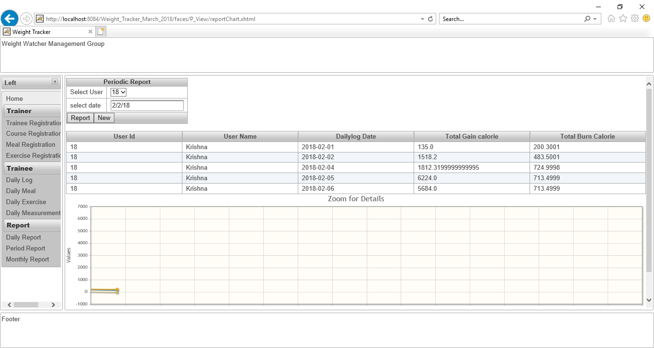

Figure No.152: The data of per day is showed in the above line chart.

Another screenshot of **“Line chart”** as Periodic report for **user id “19”**:

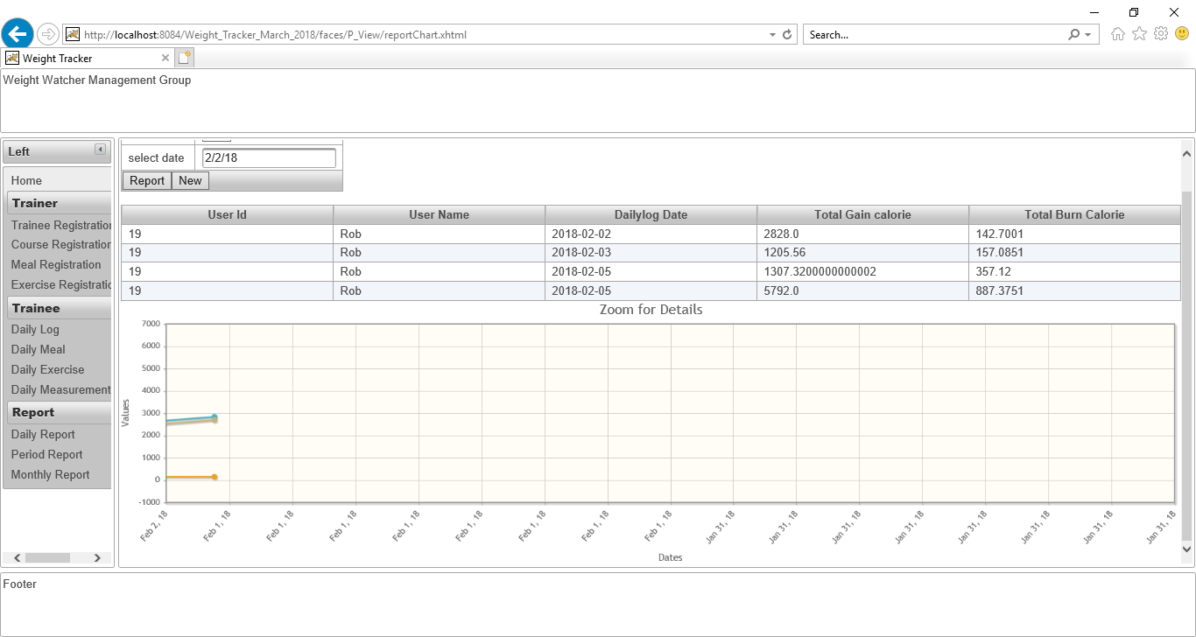

Figure No.153: The data of per day is showed in the above line chart.